****

**S-1 MPC**

S1-A & S1-B Annual Performance Report for 2016

|  |  |
| --- | --- |
| Reference: | MPC-0366 |
| Nomenclature: | DI-MPC-APR |
| Issue: | 0. 1 |
| Date: | 2017,Jan.23 |

Chronology Issues:

| Issue: | Date: | Reason for change: | Author |
| --- | --- | --- | --- |
| 0.1 | xx.01.17 | First Draft | ESLs |
|  |  |  |  |
|  |  |  |  |
|  |  |  |  |

People involved in this issue:

|  |  |  |
| --- | --- | --- |
| Written by (\*): | Peter Meadows | Date + Initials:( visa or ref) |
| Checked by (\*): | G.Hajduch | Date + Initial:( visa ou ref)  [Checker] |
| Approved by (\*): | G.Hajduch | Date + Initial:( visa ou ref)  [Approver] |
| Application authorized by (\*): |  | Date + Initial:( visa ou ref) |

*\*In the opposite box: Last and First name of the person + company if different from CLS*

Index Sheet:

|  |  |
| --- | --- |
| Context: | Sentinel-1 Mission Performance Centre |
| Keywords: | Sentinel-1, Mission Performance Centre, Annual Report |
| Hyperlink: |  |

Distribution:

| Company | Means of distribution | Names |
| --- | --- | --- |
| CLS  ESA | Notification |  |

List of tables and figures

List of tables:

Table 1 Noise power stability (3-sigma): period JAN 2016 – DEC 2016 11

Table 2 Average bitrate for each acquisition mode. 14

Table 3 SM Azimuth and Slant Range Spatial Resolutions 17

Table 4 IW Azimuth and Slant Range Spatial Resolutions 17

Table 5 EW Azimuth and Slant Range Spatial Resolutions 18

Table 6 SM & IW Sidelobe Ratios 19

Table 7: SLC Relative Radar Cross-Section for the DLR transponders (dB) 20

Table 8: SM SLC Relative Radar Cross-Section for the DLR transponders (dB) 21

Table 9: IW & EW SLC Relative Radar Cross-Section for the DLR transponders (dB) 22

Table 10: IW SLC Relative Radar Cross-Section for the DLR transponders (dB) 22

Table 11: EW SLC Relative Radar Cross-Section for the DLR transponders (dB) 22

Table 12: IW SLC Relative Radar Cross-Section for the Australian Corner Reflectors (dB) 23

Table 13: Gain Imbalance using the DLR transponders 26

Table 14: Gain Imbalance using the DLR transponders 26

Table 15: Phase Imbalance using the DLR transponders 27

Table 16 Polarimetric Calibration Measurements 27

Table 17 S1-A/Radarsat-2 Mutual Interference during 2016 32

Table 18 Radar Data Base Changes History. 51

Table 19 Noise power stability (3-sigma): period JUN 2016 – DEC 2016 55

Table 20 Average bitrate for each acquisition mode. 57

Table 21: Pointing results on Elevation Notch products 57

Table 22: Pointing results on Elevation Notch products 58

Table 23 SM Azimuth and Slant Range Spatial Resolutions 61

Table 24 IW Azimuth and Slant Range Spatial Resolutions 61

Table 25 EW Azimuth and Slant Range Spatial Resolutions 62

Table 26 SM & IW Sidelobe Ratios 62

Table 27: Azimuth Ambiguity Ratios 64

Table 28: SLC Relative Radar Cross-Section for the DLR transponders (dB) 67

Table 29: Post IOCR SLC Relative Radar Cross-Section 68

Table 30: IW SLC Relative Radar Cross-Section for the Australian Corner Reflectors (dB) 69

Table 31: Gain Imbalance using the DLR transponders 72

Table 32: Gain Imbalance using the DLR transponders 73

Table 33: Phase Imbalance using the DLR transponders 74

Table 34: SLC Polarimetric Co-registration 75

Table 35: SLC Cross-talk 77

List of figures:

Figure 1: H (top) and V (bottom) polarization error matrixes computed the 15-06-2016, before tile 11 issue happened. 3

Figure 2: H (top) and V (bottom) polarization error matrixes computed the 27-06-2016, after SAR operation successful recovery. 4

Figure 3 Gain (*top)* and phase (*bottom)* stability of the SAR antenna tiles (average of the RFC coefficients in TX H over rows). The Tile#11 event on June can be recognized. 5

Figure 4 Gain (top) and phase (bottom) stability of the SAR antenna tiles (average of the RFC coefficients in TX V over rows). The Tile#11 event on June can be recognized. 5

Figure 5 Gain (top) and phase (bottom) stability of the SAR antenna tiles (average of the RFC coefficients in RX H over rows). 6

Figure 6 Gain (top) and phase (bottom) stability of the SAR antenna tiles (average of the RFC coefficients in RX V over rows). 6

Figure 7 S1A Burst synchronization monitoring. 8

Figure 8 Internal calibration parameters over time. The color represents the sub-swath. 9

Figure 9 Internal calibration parameters over time. The color represents the polarization. 9

Figure 10 EW HH (left) and HV (right) PG gain divided by sub-swath. 10

Figure 11 IW VV (left) and VH (right) PG gain divided by sub-swath. 10

Figure 12 Noise power versus time. The color represents the different beams. 11

Figure 13 (Left) Noise power histogram for IW1 VV data. (Right) Geographical noise power distribution. 12

Figure 14 I/Q channel imbalance. 13

Figure 15 Doppler Centroid versus time. Average on a data-take basis (dots) and daily average (red line). The star-trackers reconfigurations events are marked by the vertical black lines. The STT calibration campaign are marked by the vertical green lines. 15

Figure 16 SM Azimuth and Slant Range Spatial Resolutions 17

Figure 17 IW Azimuth and Slant Range Spatial Resolutions 17

Figure 18 EW Azimuth and Slant Range Spatial Resolutions 18

Figure 19 Improvement in IW Azimuth Spatial Resolution with IPF v2.70 18

Figure 20: IW SLC DLR Transponder IRF and Azimuth Ambiguity 20

Figure 21: SM SLC Relative Radar Cross-Section for the DLR transponders 21

Figure 22: IW SLC Relative Radar Cross-Section for the DLR transponders 21

Figure 23: EW SLC Relative Radar Cross-Section for the DLR transponders 22

Figure 24: IW SLC Relative Radar Cross-Section for the BAE Corner Reflector 23

Figure 25 Permanent Scatter Calibration time series for TopSAR IW V/V (left) and V/H (right) over Paris. 24

Figure 26: ALE estimates for S1-A StripMap and IW SLC product time series acquired over the Swiss test sites using precise state vectors (AUX\_POEORB). Product date ranges are given in brackets (N.B. no S1-A SM acquisitions were made over Switzerland during the 2016 campaign). Point colours represent beam/subswath. The S1-A SWST (range) bias (output of the commissioning and calibration phase) was applied in both cases. 25

Figure 27: IW Gain Imbalance using the DLR transponders. 26

Figure 28: Phase Imbalance using the DLR transponders. 27

Figure 29: NESZ measures for IW. Blue is the measured NESZ and the red lines are the predicted NESZ at minimum orbital altitude. 28

Figure 30: NESZ measures for EW. Blue is the measured NESZ and the red lines are the predicted NESZ at minimum orbital altitudes. 29

Figure 31: S1-A solar panel before and after debris collision on 23 August 2016 (red arrow indicates panel damage). 29

Figure 32: S1-A solar panel before and after debris collision on 23 August 2016 (detail). 30

Figure 33: An example of Radio Frequency Interference over Japan 31

Figure 34: S1-A/Satellite Interference 8th December 2016 over Florida, USA 33

Figure 35: SAR Wind speed compared with reference wind speed for IW mode VV polarization. 35

Figure 36: SAR-derived wind estimation provided in the Level-1 OWI products showing the coastal margin introduced by the ice mask update. This margin is a side effect of the raw coastal polygon used in the ice border information provided in the ancillary ice information. 36

Figure 37: Sea surface roughness of a Sentinel-1 product acquired over Greenland on 2016/04/29 (left) and the associated ice masked OWI produdct with background ice concentration (right). 37

Figure 38: Significant wave height for the long waves performances for December 2015 in Wave Mode 1 (left) and Wave Mode 2 (right). The model outputs from WW3 are considered as reference here. This is only valid from a statistical point of view. 41

Figure 39: Monthly performances for WV1 (top-left) and WV2 (top-right) and number of acquisitions co-located to reference data for validation for WV1 (bottom-left) and WV2 (bottom-right). Thick solid lines stand for the mean difference between Sentinel-1 and WW3 model significant wave height. 41

Figure 40: Geophysical Doppler as included in the Level 2 products as a function of radial wind speed (wind speed projected in the line of sight of the radar) for WV1 (left) and WV2 (right). The colour code indicates the latitude. 42

Figure 41: Doppler bias as a function of latitude estimated over ocean (blue) and land (brown). 43

Figure 42: a) Doppler anomaly and b) radial velocity field from Sentinel 1A IW RVL product acquired over Agulhas in ascending mode. Here land areas are used to calibrate the Doppler anomaly before computing the radial velocity. C) Scatterplot of radial surface current component derived from S1A data and surface drifters acquired over Agulhas. 44

Figure 43: S1A EM DC offset computed from antenna model (full line) with error matrix corresponding to the day of acquisition, and estimated from rain forest data using the Level 2 processor (\*\*\*). A) EW mode in HH-polarisation, B) EW mode in VV-polarisation, C) IW mode in HH-polarisation, D) IW mode in VV-polarisation 45

Figure 44 S1B antenna status on the 31/12/2016. The top charts refer to RX elements and the bottom charts refer to TX elements 48

Figure 45 Gain (*top)* and phase (*bottom)* stability of the SAR antenna tiles (average of the RFC coefficients in TX H over rows). 49

Figure 46 Gain (top) and phase (bottom) stability of the SAR antenna tiles (average of the RFC coefficients in TX V over rows). 49

Figure 47 Gain (top) and phase (bottom) stability of the SAR antenna tiles (average of the RFC coefficients in RX H over rows). 50

Figure 48 Gain (top) and phase (bottom) stability of the SAR antenna tiles (average of the RFC coefficients in RX V over rows). 50

Figure 49 S1B burst synchronization since the end of the Commissioning Phase. 52

Figure 50 Burst synchronization statistics for IW (left) and EW (right). 52

Figure 51 Internal calibration parameters over time. The color represents the sub-swath. 53

Figure 52 Internal calibration parameters over time. The color represents the polarization. 53

Figure 53 EW HH (left) and HV (right) PG gain divided by sub-swath. 54

Figure 54 IW VV (left) and VH (right) PG gain divided by sub-swath. 54

Figure 55 Noise power versus time. The colour represents the different beams. 55

Figure 56 I/Q channel imbalance. 56

Figure 57 Doppler Centroid versus time. Average on a data-take basis (dots) and daily average (red line). The star-trackers reconfigurations events are marked by the vertical black lines. 59

Figure 58 SM Azimuth and Slant Range Spatial Resolutions 61

Figure 59 IW Azimuth and Slant Range Spatial Resolutions 61

Figure 60 EW Azimuth and Slant Range Spatial Resolutions 62

Figure 61: SM SLC Early Azimuth Ambiguity, DLR Transponder IRF and Late Ambiguity 63

Figure 62: IW Early Azimuth Ambiguity, DLR Transponder IRF and Late Ambiguity 63

Figure 63: IW Early Azimuth Ambiguity, ESTEC Transponder IRF and Late Ambiguity 64

Figure 64: S1-B IW Image of SE England and N France with the location of range ambiguities indicated (acquisition 5th August 2016, 17:40:17 UT). 65

Figure 65: Extract of ambiguity region showing various range ambiguities plus other point targets. 66

Figure 66: Detail of ambiguity region (left) and the source of the ambiguity in Rotterdam (right). 66

Figure 67: Post IOCR SM SLC Relative Radar Cross-Section 67

Figure 68: Post IOCR IW SLC Relative Radar Cross-Section 68

Figure 69: Post IOCR EW SLC Relative Radar Cross-Section 68

Figure 70: IW SLC Relative Radar Cross-Section for the BAE Corner Reflector 69

Figure 71: ALE estimates for S1-B StripMap, IW and EW SLC product time series acquired over the Swiss test sites using precise state vectors (AUX\_POEORB). Product date ranges are given in brackets. Point colours represent beam/subswath. The SWST (range) bias (output of the commissioning and calibration phase) was applied in all cases. 72

Figure 72: Gain Imbalance using the DLR transponders. 73

Figure 73: Phase Imbalance using the DLR transponders. 73

Figure 74: SLC Co-registration Examples 75

Figure 75: SLC Cross-talk Examples 77

Figure 76: NESZ measures for SM. Blue is the measured NESZ and the red lines are the predicted NESZ at minimum and maximum orbital altitudes. 82

Figure 77: NESZ measures for IW. Blue is the measured NESZ and the red lines are the predicted NESZ at the minimum orbital altitude. 82

Figure 78: NESZ measures for EW. Blue is the measured NESZ and the red lines are the predicted NESZ at the minimum orbital altitude. 83

Figure 79: NESZ measures for WV . Blue is e measured NESZ and the red lines are the predicted NESZ at minimum and maximum orbital altitudes. 84

Figure 80: An example of Radio Frequency Interference 85

Figure 81: An example of Radarsat-2/Sentinel1-A Interference (2nd July 2016) 85

Figure 82: SAR Wind speed compared with reference wind speed for IW mode VV polarization. 87

Figure 83: Significant wave height for the long waves performances for December 2015 in Wave Mode 1 (left) and Wave Mode 2 (right). The model outputs from WW3 are considered as reference here. This is only valid from a statistical point of view. 91

Figure 84: Monthly performances for WV1 (top-left) and WV2 (top-right) and number of acquisitions co-located to reference data for validation for WV1 (bottom-left) and WV2 (bottom-right). Thick solid lines stand for the mean difference between Sentinel-1 and WW3 model significant wave height. 91

Figure 85: Geophysical Doppler as included in the Level 2 products as a function of radial wind speed (wind speed projected in the line of sight of the radar) for WV1 (left) and WV2 (right). The colour code indicates the latitude. 92

Figure 86: Doppler bias as a function of latitude estimated over ocean (blue) and land (brown). 92

Figure 87: Scatterplot of total DC model versus measured DC from the period of 26-31 October 2016 from S1b acquired in WV1. The green dots are data acquired over land areas. 93

Figure 88: Upper: Geometric Doppler computed from data (red) and from restituted attitude data (pink) for 28 October 2016 for Sentinel 1b WV1. Lower: Location of tracks. The green points are data acquired over land areas. 94

Figure 89: Doppler anomaly field from Sentinel 1B IW OCN RVL product acquired over Agulhas in ascending mode. Here land areas are used to calibrate the Doppler. A clear signature of the Agulhas current is observed. 95

Figure 90: S1B IW OCN RVL mean DC bias as function of azimuth pixel. Data acquired over ocean areas. 96

Figure 91: S1B EM DC offset computed from antenna model (full line) with error matrix corresponding to the day of acquisition, and estimated from rain forest data using the Level 2 processor (\*\*\*). A) EW mode in HH-polarisation, B) EW mode in VV-polarisation, C) IW mode in HH-polarisation, D) IW mode in VV-polarisation 97

Figure 92 PSCAL time series for IW DV acquisitions over Paris. The color represents the sensor. 101

Figure 93 S1B vs. S1A burst synchronization since the end of the Commissioning Phase. 102

Figure 94 S1B vs. S1A burst synchronization statistics for IW (left) and EW (right). 102

Applicable documents

|  |  |
| --- | --- |
| [AD-01] | Sentinel-1 Product Specification, S1 RS-MDA-52-7441, Issue 3/2, March 2016 |
| [AD-02] | Sentinel-1 Product Definition, S1-RS-MDA-57-7440, Issue 2/7, March 2016 |
| [AD-03] | Sentinel-1 IPF Detailed Algorithm Definition, S1-TN-MDA-52-7445, Issue 2/0, February 2016 |
| [AD-04] | Sentinel-1 IPF Auxiliary Product Specification, S1-RS-MDA-52-7443, Issue 3/0, July 2015 |

Reference documents

|  |  |
| --- | --- |
| [S1-RD-01] | S1-A Performance Report for 2015, DI-MPC-CPR MPC-0139, Issue 1.0, March 2016. |
| [S1-RD-02] | S1-B MPC Commissioning Phase Report DI-MPC-CPR MPC-0326, Issue 1.1, January 2017. |
| [S1-RD-03] | Sentinel-1A Performance Status and Sentinel-1B Preliminary Performance Results, Nuno Miranda, Peter Meadows, Alan Pilgrim, Guillaume Hajduch, Romain Husson, Pauline Vincent, Riccardo Piantanida, Davide Giudici, Andrea Recchia, David Small, Alexis Mouche, Harald Johnsen, Proceedings of the ESA Living Planet Symposium, 9-13 May 2016, Prague, Czech Republic. |
| [S1-RD-04] | Results for calibration of Sentinel-1A using the Australian corner reflector array, Medhavy Thankappan, Matthew Garthwaite , Peter Meadows, Nuno Miranda, Adrian Schubert, David Small, , Proceedings of the ESA Living Planet Symposium, 9-13 May 2016, Prague, Czech Republic. |
| [S1-RD-05] | The Copernicus Sentinel-1 Constellation Product Quality and Preliminary Calibration Results, Nuno Miranda, Peter Meadows, Alan Pilgrim, Guillaume Hajduch, Riccardo Piantanida, Davide Giudici, Andrea Recchia, David Small, Adrian Schubert, Alexis Mouche (CLS, France) & Harad Johnsen, European Conference on Synthetic Aperture Radar (EUSAR), 6-9 June 2016, Hamburg, Germany. |
| [S1-RD-06] | Calibration of Sentinel-1 using the Australian Geophysical Observing System Corner Reflector Array, Medhavy Thankappan, Matthew Garthwaite, Peter Meadows, Nuno Miranda, Adrian Schubert & David Small, Proceedings of the CEOS SAR Workshop, 7-9 September 2016, Tokyo, Japan. |
| [S1-RD-07] | Sentinel-1B Preliminary Results Obtained During the Orbit Acquisition Phase, Nuno Miranda, Peter J. Meadows, Alan Pilgrim, Riccardo Piantanida, Andrea Recchia, Davide Giudici, David Small and Adrian Schubert, SARWatch: Advances in the Science and Applications of SAR Interferometry, 5-7 October 2016, Porto, Portugal. |
| [S1-RD-08] | Sentinel-1A Tile #11 Failure, OI-MPC-OTH-0324, Issue 1.2, October 2016 |
| [S1-RD-09] | Sentinel-1A Debris Collision, DI-MPC-ACR-0352, Issue 1.0, October 2016 |
|  |  |
| [S1-RD-01] | S1-A MPC Commissioning Phase Report DI-MPC-CPR MPC-0184, Issue 1.3, March 2015 |
| [S1-RD-02] | Sentinel-1 A Instrument Processing Facility and Operational Product Status After One Year of Operation. Nuno Miranda, Peter Meadows, Adrian Schubert, Alan Pilgrim, David Small, Davide Giudici, Riccardo Piantanida & Guillaume Hajduch. Proceedings of the CEOS SAR Workshop, October 27-29, 2015, ESTEC, Noordwijk, The Netherlands. (<http://sarcv.ceos.org/documents/doc/154/>). |
| [S1-RD-03] | Sentinel-1A Radiometric Calibration. Peter Meadows, Alan Pilgrim, Riccardo  Piantanida, Davide Riva & Nuno Miranda. Proceedings of the CEOS SAR Workshop, October 27-29, 2015, ESTEC, Noordwijk, The Netherlands. (<http://sarcv.ceos.org/documents/doc/156/>). |
| [S1-RD-04] | Calibration with Trihedral Corner Relectors: A Case Study using Satellite-based X, C and L- Band Frequency Synthetic Aperture Radar Data over Queensland. Australia. Medhavy Thankappan, Matthew Garthwaite, Peter Meadows,  Nuno Miranda, Adrian Schubert and David Small. Proceedings of the CEOS SAR Workshop, October 27-29, 2015, ESTEC, Noordwijk, The Netherlands. (<http://sarcv.ceos.org/documents/doc/193/>). |
| [S1-RD-05] | Joint Investigations on Radarsat-2‚/Sentinel-1 A Mutual RFI. Bjorn Rommen, Itziar Barat, Marielle Chabot, Casey Lambert, Dan Williams. Proceedings of the CEOS SAR Workshop, October 27-29, 2015, ESTEC, Noordwijk, The Netherlands. |
| [S1-RD-06] | Schubert, A., D. Small, N. Miranda, D. Geudtner, E. Meier. Sentinel-1A Product Geolocation Accuracy: Commissioning Phase Results. Remote Sens. 2015, 7, 9431–9449. doi: 10.3390/rs70709431. |
| [S1-RD-07] | Schubert, A., D. Small, N. Miranda, D. Geudtner, E. Meier. Sentinel-1A Product Geolocation Accuracy: Beyond the Calibration Phase. Presented at CEOS SAR Calibration & Validation Workshop; Noordwijk, The Netherlands, 2015. |
| [S1-RD-08] | Small, D., A. Schubert. Guide to ASAR Geocoding, UZH technical note for ESA-ESRIN, Contract No. 20907/07/I-EC, RSL-ASAR-GC-AD, Iss. 1.01; University of Zurich: Zurich, Switzerland, 2008, 36p. |
| [S1-RD-09] | GMES Sentinel-1 Team. GMES Sentinel-1 System Requirements Document, Ref. S1-RS-ESA-SY-0001, Iss. 3, Rev. 3, 2010. |
| [S1-RD-10] | Pietro Guccione, Michele Belotti, Davide Giudici, Andrea Monti Guarnieri, Ignacio Navas-TraverSentinel-1A: Analysis of FDBAQ Performance on Real Data, IEEE TRANSACTIONS ON GEOSCIENCE AND REMOTE SENSING, 2015. |
| [S1-RD-11] | Harald Johnsen, Fabrice Collard, “Sentinel-1 ocean swell wave spectra  (OSW) algorithm development”, [S1-AD-20]-S1-TN-NRT-52-7450, Issue 1,  Revision 1, November 2010. |

List of Contents

[1. Introduction 1](#_Toc474233290)

[1.1. Purpose of the document 1](#_Toc474233291)

[1.2. Structure of the document 1](#_Toc474233292)

[2. Executive Summary 2](#_Toc474233293)

[3. S1-A Instrument Status 3](#_Toc474233294)

[3.1. S1-A Antenna Status 3](#_Toc474233295)

[3.2. S1-A Instrument Unavailability 7](#_Toc474233296)

[3.3. S1-A Auxiliary Date File Updates 7](#_Toc474233297)

[3.4. S1-A Radar Data Base Updates 7](#_Toc474233298)

[3.5. S1-A Orbit Manoeuvres 7](#_Toc474233299)

[3.6. S1-A Burst synchronization 7](#_Toc474233300)

[3.7. S1-A Internal Calibration 8](#_Toc474233301)

[3.7.1. PG monitoring 8](#_Toc474233302)

[3.7.2. Noise power monitoring 10](#_Toc474233305)

[4. S1-A Products Status 13](#_Toc474233306)

[4.1. S1-A Level 0 Products 13](#_Toc474233307)

[4.1.1. Timeline and missing lines 13](#_Toc474233308)

[4.1.2. I/Q statistics 13](#_Toc474233309)

[4.1.3. FDBAQ 13](#_Toc474233310)

[4.1.4. Instrument Pointing 14](#_Toc474233311)

[4.2. S1-A Level 1 Products 15](#_Toc474233312)

[4.2.1. Level 1 Processor Updates 15](#_Toc474233313)

[4.2.2. Image Quality 16](#_Toc474233314)

[4.2.2.1. Spatial Resolution 16](#_Toc474233315)

[4.2.2.2. Sidelobe Ratios 18](#_Toc474233316)

[4.2.2.3. ENL and Radiometric Resolution 19](#_Toc474233317)

[4.2.2.4. Ambiguity Analysis 19](#_Toc474233318)

[4.2.2.4.1. Azimuth Ambiguities 19](#_Toc474233319)

[4.2.2.4.2. Range Ambiguities 20](#_Toc474233320)

[4.2.3. Radiometric Calibration 20](#_Toc474233321)

[4.2.3.1. Absolute Radiometric Calibration 20](#_Toc474233322)

[4.2.3.2. Permanent Scatter Calibration 23](#_Toc474233323)

[4.2.4. Geometric Validation 24](#_Toc474233324)

[4.2.5. Polarimetric Calibration 26](#_Toc474233325)

[4.2.5.1. Gain Imbalance 26](#_Toc474233326)

[4.2.5.2. Phase Imbalance 26](#_Toc474233327)

[4.2.5.3. Coregistration 27](#_Toc474233328)

[4.2.5.4. Cross-talk 27](#_Toc474233329)

[4.2.6. Elevation Antenna Patterns 28](#_Toc474233330)

[4.2.7. Azimuth Antenna Patterns 28](#_Toc474233331)

[4.2.8. Noise Equivalent Radar Cross-section 28](#_Toc474233332)

[4.2.9. S1-A Tile 11 Failure 29](#_Toc474233333)

[4.2.10. S1-A Debris Collision 29](#_Toc474233334)

[4.2.11. Summary of Anomalies 30](#_Toc474233335)

[4.2.11.1. Radio Frequency Interference 30](#_Toc474233336)

[4.2.11.2. Radarsat-2/Sentinel1-A Mutual Interference 31](#_Toc474233337)

[4.2.11.3. Other S1-A/Satellite Interference 32](#_Toc474233338)

[4.2.12. Quality Disclaimers 33](#_Toc474233339)

[4.3. S1-A Level 2 products 33](#_Toc474233340)

[4.3.1. Wind measurement 33](#_Toc474233341)

[4.3.1.1. Image Mode (SM-IW-EW) 33](#_Toc474233342)

[4.3.1.2. Wave Mode 38](#_Toc474233343)

[4.3.2. Swell Measurement 39](#_Toc474233344)

[4.3.2.1. Wave Mode 39](#_Toc474233345)

[4.3.3. Radial Velocity Measurement 41](#_Toc474233346)

[4.3.3.1. Wave Mode 41](#_Toc474233347)

[4.3.3.2. TOPS Mode 43](#_Toc474233348)

[4.3.4. Geophysical Calibration 46](#_Toc474233349)

[4.3.4.1. Wave Mode 46](#_Toc474233350)

[5. S1-B Instrument Status 48](#_Toc474233351)

[5.1. S1-B Antenna Status 48](#_Toc474233352)

[5.2. S1-B Instrument Unavailability 50](#_Toc474233353)

[5.3. S1-B Auxiliary Date File Updates 51](#_Toc474233354)

[5.4. S1-B Radar Data Base Updates 51](#_Toc474233355)

[5.5. S1-B Orbit Manoeuvres 51](#_Toc474233356)

[5.6. S1-B Burst synchronization 51](#_Toc474233357)

[5.7. S1-B Internal Calibration 52](#_Toc474233358)

[5.7.1. PG monitoring 52](#_Toc474233359)

[5.7.2. Noise power monitoring 54](#_Toc474233362)

[6. S1-B Products Status 56](#_Toc474233363)

[6.1. S1-B Level 0 Products 56](#_Toc474233364)

[6.1.1. Timeline and missing lines 56](#_Toc474233365)

[6.1.2. I/Q statistics 56](#_Toc474233366)

[6.1.3. FDBAQ 56](#_Toc474233367)

[6.1.4. Instrument Pointing 57](#_Toc474233368)

[6.2. S1-B Level 1 Products 59](#_Toc474233369)

[6.2.1. Level 1 Processor Updates 59](#_Toc474233370)

[6.2.2. Image Quality 60](#_Toc474233371)

[6.2.2.1. Spatial Resolution 60](#_Toc474233372)

[6.2.2.2. Sidelobe Ratios 62](#_Toc474233373)

[6.2.2.3. ENL and Radiometric Resolution 62](#_Toc474233374)

[6.2.2.4. Ambiguity Analysis 63](#_Toc474233375)

[6.2.2.4.1. Azimuth Ambiguities 63](#_Toc474233376)

[6.2.2.4.2. Range Ambiguities 64](#_Toc474233377)

[6.2.3. Radiometric Calibration 67](#_Toc474233378)

[6.2.3.1. Absolute Radiometric Calibration 67](#_Toc474233379)

[6.2.3.2. Permanent Scatter Calibration 69](#_Toc474233380)

[6.2.4. Geometric Calibration 69](#_Toc474233381)

[6.2.5. Polarimetric Calibration 72](#_Toc474233409)

[6.2.5.1. Gain Imbalance 72](#_Toc474233410)

[6.2.5.2. Phase Imbalance 73](#_Toc474233411)

[6.2.5.3. Coregistration 74](#_Toc474233412)

[6.2.5.4. Cross-talk 76](#_Toc474233413)

[6.2.6. Elevation Antenna Patterns 77](#_Toc474233414)

[6.2.7. Azimuth Antenna Patterns 77](#_Toc474233415)

[6.2.8. Noise Equivalent Radar Cross-section 77](#_Toc474233416)

[6.2.9. Summary of Anomalies 84](#_Toc474233417)

[6.2.9.1. Radio Frequency Interference 84](#_Toc474233418)

[6.2.9.2. Radarsat-2/Sentinel1-A Mutual Interference 85](#_Toc474233419)

[6.2.10. Quality Disclaimers 86](#_Toc474233420)

[6.3. S1-B Level 2 products 86](#_Toc474233421)

[6.3.1. Wind measurement 86](#_Toc474233422)

[6.3.1.1. Image Mode (SM-IW-EW) 86](#_Toc474233423)

[6.3.1.2. Wave Mode 88](#_Toc474233424)

[6.3.2. Swell Measurement 90](#_Toc474233425)

[Wave Mode 90](#_Toc474233426)

[6.3.2.1. 90](#_Toc474233427)

[6.3.3. Radial Velocity Measurement 91](#_Toc474233428)

[6.3.3.1. Wave Mode 91](#_Toc474233429)

[6.3.3.2. TOPS Mode 94](#_Toc474233430)

[6.3.4. Geophysical Calibration 98](#_Toc474233431)

[6.3.4.1. Wave Mode 98](#_Toc474233432)

[7. S1-A and S1-B Cross-comparison 101](#_Toc474233433)

[7.1. Cross-platform Permanent Scatter Calibration 101](#_Toc474233434)

[7.2. Cross-interferometry burst synchronization 101](#_Toc474233435)

[7.3. Absolute Calibration 102](#_Toc474233436)

[Appendix A - List of Acronyms 103](#_Toc474233437)

[Appendix B - ESA S1-A & S1-B Technical Reports 104](#_Toc474233438)

[Appendix C - S1-A Orbit Cycles 105](#_Toc474233439)

[Appendix D - S1-A Transmit Receive Module Failures 106](#_Toc474233440)

[Appendix E - S1-A Instrument Unavailability 107](#_Toc474233441)

[Appendix F - S1-A Auxiliary Data Files 109](#_Toc474233442)

[Appendix G - S1-A Orbit Manoeuvres 111](#_Toc474233443)

[Appendix H - S1-A Quality Disclaimers 114](#_Toc474233444)

[Appendix I - S1-A Antenna Pointing 115](#_Toc474233445)

[Appendix J - S1-B Orbit Cycles 122](#_Toc474233446)

[Appendix K - S1-B Transmit Receive Module Failures 123](#_Toc474233447)

[Appendix L - S1-B Instrument Unavailability 124](#_Toc474233448)

[Appendix M - S1-B Auxiliary Data Files 126](#_Toc474233449)

[Appendix N - S1-B Orbit Manoeuvres 127](#_Toc474233450)

[Appendix O - S1-B Quality Disclaimers 130](#_Toc474233451)

[Appendix P - S1-B Antenna Pointing 131](#_Toc474233452)

# Introduction

## Purpose of the document

The purpose of this document is to provide the status on the S1-A instrument and product performance during 2016 and the S1-B instrument and product performance since the start of the routine phase in September 2016.

## Structure of the document

The outline of this report is given below:

* Chapter 1 : this introduction
* Chapter 2 : Executive Summary
* Chapter 3 : S1-A Instrument Status
* Chapter 4 : S1-A Products Status
* Chapter 5 : S1-B Instrument Status
* Chapter 6 : S1-B Products Status
* Chapter 7 : S1-A and S1-B Cross-comparison

The following appendices are also provided:

* Appendix A : List of Acronyms
* Appendix B : ESA S1-A & S1-B Technical Reports
* Appendix C : S1-A Orbit Cycles
* Appendix D : S1-A Transmit Receive Module Failures
* Appendix E : S1-A Instrument Unavailability
* Appendix F : S1-A Auxiliary Data Files
* Appendix G : S1-A Orbit Manoeuvres
* Appendix H : S1-A Quality Disclaimers
* Appendix I : S1-A Antenna Pointing
* Appendix J : S1-B Orbit Cycles
* Appendix K : S1-B Transmit Receive Module Failures
* Appendix L : S1-B Instrument Unavailability
* Appendix M : S1-B Auxiliary Data Files
* Appendix N : S1-B Orbit Manoeuvres
* Appendix O : S1-B Quality Disclaimers
* Appendix P : S1-B Antenna Pointing

# Executive Summary

This report gives the status of the Sentinel1-A instrument and products during 2015, the first full year of routine operations since the launch of the satellite in April 2014 and the subsequent commission phase. A summary of this status can also be found in a paper presented at the CEOS SAR workshop at ESTEC in October 2015 (see [S1-RD-02]).

As will be seen in Chapters 3 and 4 many aspects of the instrument and products are considered with the aim of ensuring user’s receive high quality products.

# S1-A Instrument Status

Here the status of the S1-A instrument during 2016:

## S1-A Antenna Status

The Antenna status is routinely monitored using the dedicated RFC calibration mode. The RFC products are processed in order to generate the Antenna Error Matrix from which it is possible to retrieve the failure and drift of each TRM.

Figure 1 shows the antenna Transmit/Receive Module (TRM) status at June 2016. Ten (10) failures are counted in total among TX-RX and H-V. A full list of all TRM failures so far is given in Appendix D. Since mid-2015, after switch to redundancy for tile 5, no antenna events were recorded.

|  |  |
| --- | --- |
|  |  |
|  |  |

Figure 1: H (top) and V (bottom) polarization error matrixes computed the 15-06-2016, before tile 11 issue happened.

On the 16-06-2016 SAR went to pause refuse mode for the first time due to a current/voltage anomaly on TPSU-1 within tile 11. After several attempts to recover SAR operations, the SAR was definitely available again since the 27-06-2016 June. In order to ensure SAR operation a reduction of the Tx power for half tile 11 was necessary. This can be clearly noticed in the figure below, reporting the error matrixes computed on the 27-06-2016 June. The figure represents the status of the S1A antenna at the end of 2016.





Figure 2: H (top) and V (bottom) polarization error matrixes computed the 27-06-2016, after SAR operation successful recovery.

A further effect of the instrument configuration change was a drop of the phase of all the TRMs of tile 11 (not only the ones with reduced TX power). This can be clearly noticed in the following plots, showing the TX excitation coefficients (averaged per tile) obtained processing RFC products of 2016. Tile 11 shows an average gain reduction of about 4 dB and an average phase drop of about 30 deg. Please note that other tiles show a small increase of the gain due to the fact that, during RFC processing, the coefficients are normalized. The plots showing the RX excitation coefficients have also been reported. Tile 11 coefficients shows an average gain increase of about 1 dB. For more details on the anomaly please refer to [S1-RD-08].

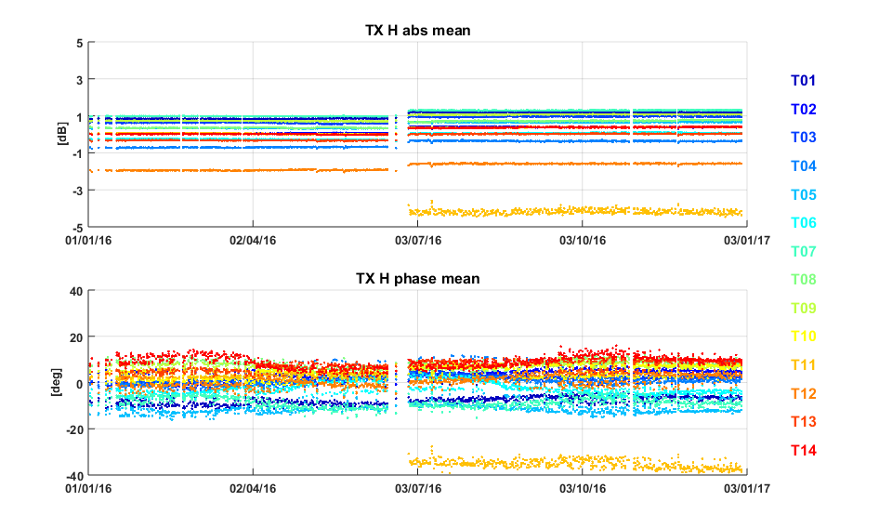

Figure 3 Gain (*top)* and phase (*bottom)* stability of the SAR antenna tiles (average of the RFC coefficients in TX H over rows). The Tile#11 event on June can be recognized.

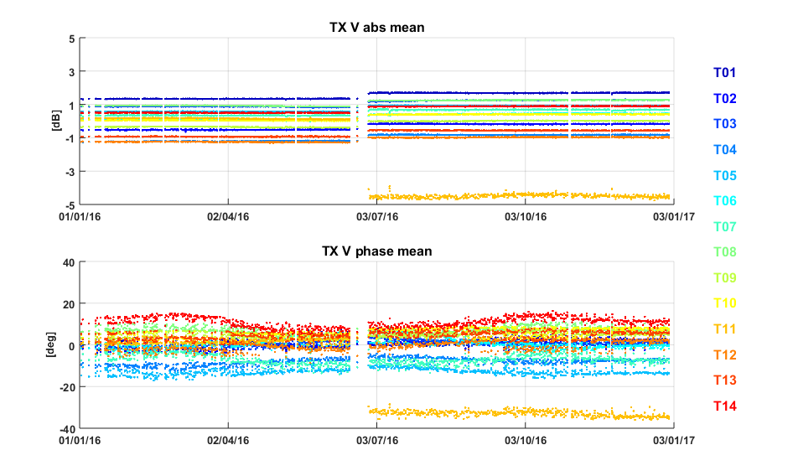

Figure 4 Gain (top) and phase (bottom) stability of the SAR antenna tiles (average of the RFC coefficients in TX V over rows). The Tile#11 event on June can be recognized.

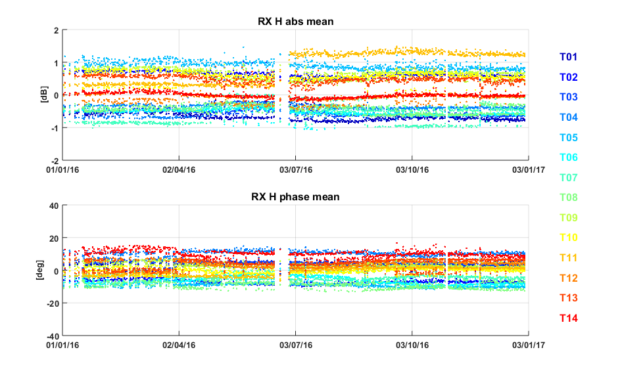

Figure 5 Gain (top) and phase (bottom) stability of the SAR antenna tiles (average of the RFC coefficients in RX H over rows).

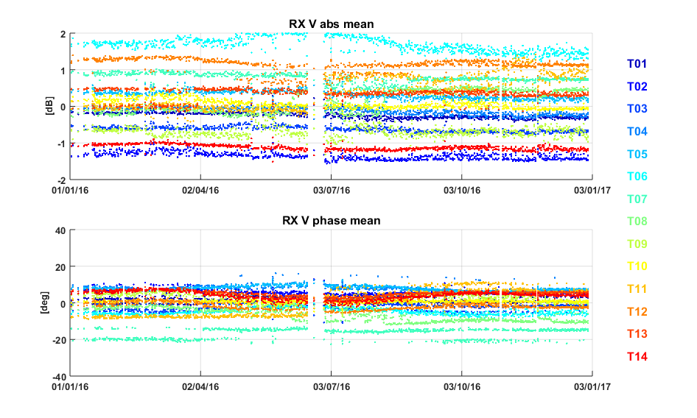

Figure 6 Gain (top) and phase (bottom) stability of the SAR antenna tiles (average of the RFC coefficients in RX V over rows).

Excluding the tile 11 issue, the antenna shows overall a stable behaviour: 0.4 dB of average temporal stability for the gain and 5° for the phase have been computed.

## S1-A Instrument Unavailability

A list of S1-A instrument unavailabilities during 2016 is given in Appendix E.

## S1-A Auxiliary Date File Updates

A list of S1-A Auxiliary Data Files (ADFs) updates during 2016 is given in Appendix F.

## S1-A Radar Data Base Updates

No RDB updates occurred during 2016. The current RDB version is #5 endorsed on 22 July 2015

## S1-A Orbit Manoeuvres

A list of all S1-A orbit manoeuvres during 2016is given in Appendix G.

## S1-A Burst synchronization

The burst synchronization between repeat pass interferometric acquisitions is relevant for the TOPSAR modes (IW and EW) to provide an indication of the quality of the interferometric phase that can be expected. The SAR acquisition start time is planned over a discrete set of points round orbit with precision down to milliseconds. The performance of the synchronization is monitored by the PDGS OBS tool.

**Figure 7** shows the burst synchronization over time for IW and EW mode. Each dot represents a repeat pass acquisition, considering as reference cycle number 60 (30 September - 12 October 2015). It can be noticed that the synchronization is always very high, above 98% for most of the time. Only few EW acquisitions show lower synchronization values (always better than 95% in any case).

It is interesting to note a small seasonal trend in the burst synchronization, with lower values between November and February. This small periodicity should be further investigated and could be originated by some long term orbit perturbation.

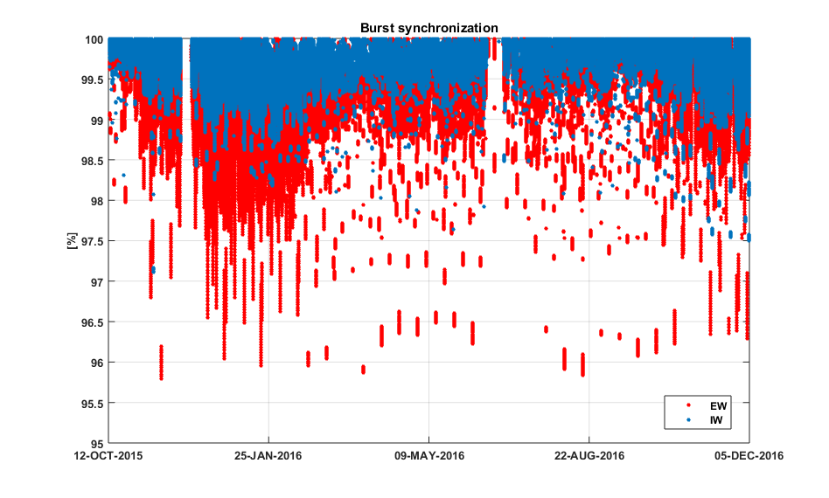



Figure 7 S1A Burst synchronization monitoring.

## S1-A Internal Calibration

### PG monitoring

The instrument stability over time is monitored through the internal calibration signals. The following plots show the main parameters monitored: PG gain and phase, instrument delay and Rx gain offset. In Figure 8 the colour represents the sub-swath whereas in Figure 9 the colour represents the polarization.

All the monitored parameters are quite stable in the reporting period except for the PG gain which, following the tile 11 anomaly on June 2016, is decreased of about 0.4 dB. This is an expected behaviour allowing to radiometrically compensate the reduced TX gain of half tile 11. Figure 10 and Figure 11 show a more detailed picture of the PG trend during the reporting period for EW DH and IW DV acquisitions. No particular trends can be identified during the reporting period even if some long slow fluctuations can be observed in particular for RX H beams (EW HH and IW VH). Such fluctuations are in any case quite small with a peak to peak variation around 0.1 dB.

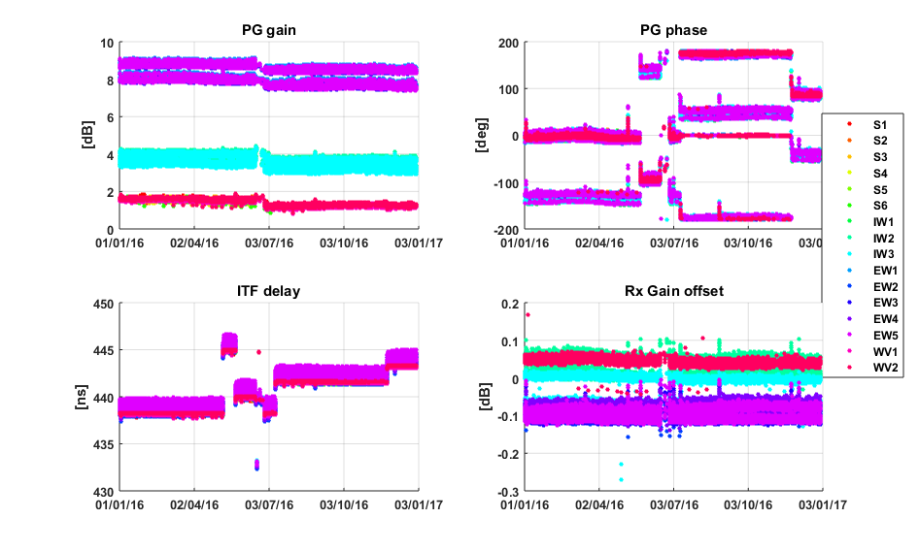

Figure 8 Internal calibration parameters over time. The color represents the sub-swath.

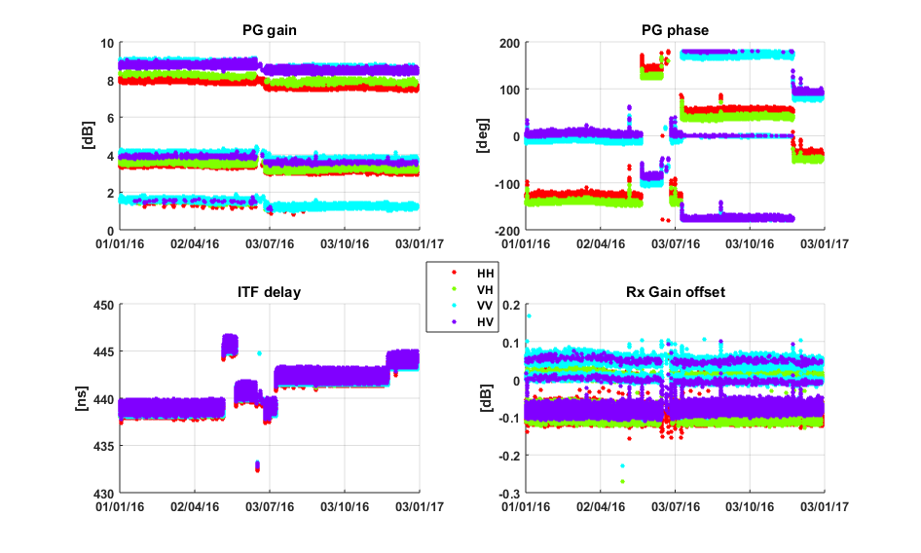

Figure 9 Internal calibration parameters over time. The color represents the polarization.

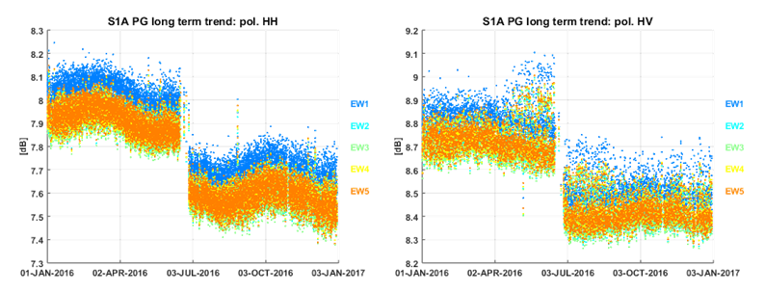

Figure 10 EW HH (left) and HV (right) PG gain divided by sub-swath.

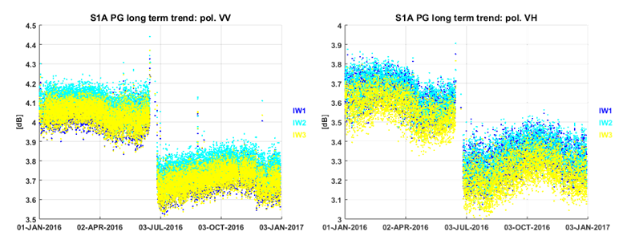







Figure 11 IW VV (left) and VH (right) PG gain divided by sub-swath.

### Noise power monitoring

The noise power is monitored through the dedicated internal calibration pulses processing embedded at the start/stop of each data-take. Figure below shows the noise power versus time in the period January-December 2016. Overall, the noise power has a good stability, with a standard deviation of approximately 1 dB in the short term. Table below reports the noise power stability (3σ) averaged over the full reporting period. The number in the parenthesis represents the number of products considered.

|  |  |
| --- | --- |
| **Acquisition mode** | **Noise power stability [dB]** |
| SM | HH: 5.5±0.9 (114) VV: 4.7±0.9 (530) HV: 5.6±0.9 (114) VH: 4.9±1.1 (244) |
| IW | HH: 6.6±1.1 (10413) VV: 7.4±1.4 (84006) HV: 7.3±1.0 (3138) VH: 6.7±1.5 (48930) |
| EW | HH: 5.2±1.0 (109760) VV: 6.0±1.0 (6080) HV: 6.3±0.9 (58934) VH: 4.9±1.1 (4675) |
| WV | HH: 6.0±1.1 (1344) VV: 6.2±0.9 (42410) |

**Table 1 Noise power stability (3-sigma): period JAN 2016 – DEC 2016**

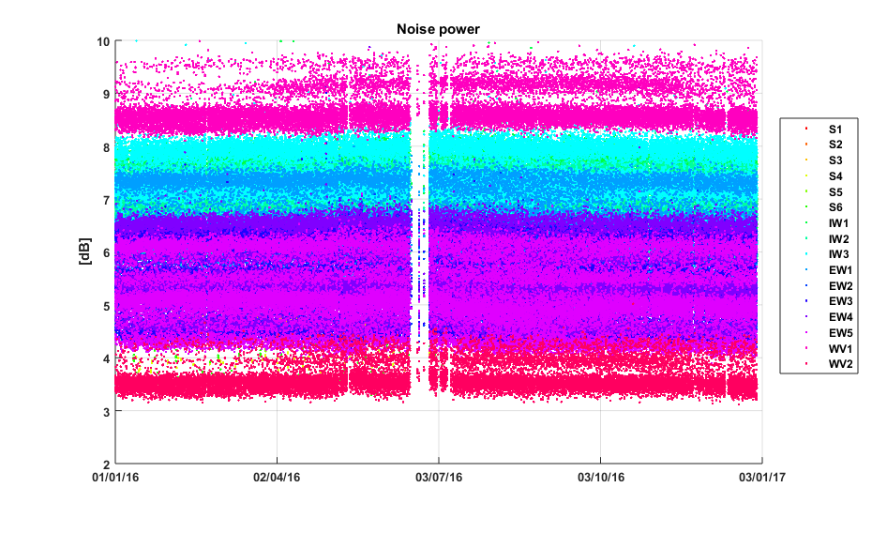

**Figure 12 Noise power versus time. The color represents the different beams.**

Further analyses on noise power have shown that the noise power distribution is bi-modal for all beams and polarizations, as reported in the following figure on the left. This noise behaviour is observed for both S1A and S1B. It is originated by the scene underlying the sensor at the moment of the noise acquisition. Indeed Earth emissivity is different between land and sea. The S1A and S1B instruments are good enough to capture the different emissivity of the Earth as clearly shown in the following figure on the right, where noise power samples are plotted according to the location where they have been acquired. Blue dots (low noise power) are mostly located over the sea whereas yellow dots (high noise power) are mostly located over land (Sahara desert is particularly bright).

|  |  |
| --- | --- |
| Noise_power_distribution.png | Noise_power_world.png |
|  |  |



**Figure 13 (Left) Noise power histogram for IW1 VV data. (Right) Geographical noise power distribution.**

# S1-A Products Status

## S1-A Level 0 Products

### Timeline and missing lines

The L0 quality monitoring is carried out as a routine task within the QCSS. The checks on the timeline and missing lines have not detected significant problems.

### I/Q statistics

The analysis of I/Q bias and standard deviation allow to state that the L0 data quality is nominal. Figure shows the channel imbalance analysis for IW, showing the standard deviation that the two channels are very well aligned along the bisector of the I/Q plane.

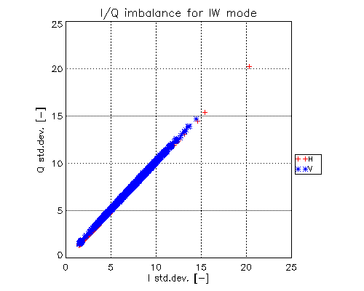

Figure 14 I/Q channel imbalance.

### FDBAQ

The FDBAQ quantization scheme performs nominally. A detailed analysis of the FDBAQ behaviour for the first year can be found in [S1-RD-10].

The long-term statistics over the acquired data show that the average Mbit/s are reported in the following table:

|  |  |
| --- | --- |
| **Acquisition mode/swath** | **Average bitrate [Mbit/s]** |
| S1 | 271.5 |
| S2 | 213.36 |
| S3 | 222.56 |
| S4 | 188.58 |
| S5 | 208.04 |
| S6 | 178.39 |
| IW | 194.89 |
| EW | 62.32 |
| WV1 | 11.8 |
| WV2 | 6.7 |

**Table 2 Average bitrate for each acquisition mode.**

### Instrument Pointing

The instrument pointing in elevation has been calibrated during the commissioning phase exploiting the availability of the elevation notch acquisitions over the Amazonian rain forest. The pointing was verified with further Elevation Notch acquisitions in 2015 and no relevant deviations were observed. No Elevation Notch acquisitions were performed in 2016.

Plots of the spacecraft attitude (yaw, pitch and roll) are shown in Appendix I.

The stability of the pointing in azimuth can be monitored through the Doppler Centroid, estimated directly from SAR data. Figure 15 shows the average Doppler Centroid on a data-take basis (dots) and on a daily basis (red line) versus time. The bias varies along time in correspondence of the different configurations of the star trackers (marked by the vertical black lines). Activities are on-going in order to reduce the DC dependency w.r.t. the STT configuration. A dedicated STT calibration campaign was performed on November (marked by the vertical green lines). Note that, in the second half of the year, usage of STT 1+2 led to daily average DC values up to 40 Hz. This can give a loss of about 10% of coherence in S1A/S1B cross-interferometry for IW acquisitions. The origin of this DC increase is under investigation and should be fixed with the final STT calibration.

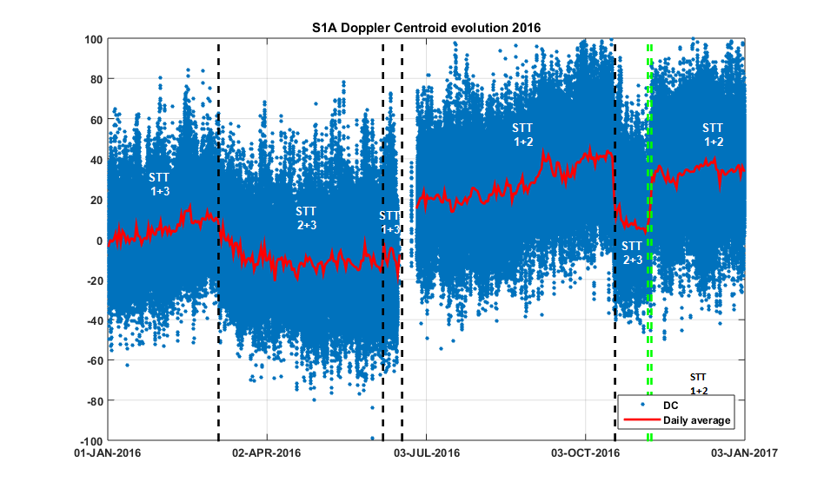



Figure 15 Doppler Centroid versus time. Average on a data-take basis (dots) and daily average (red line). The star-trackers reconfigurations events are marked by the vertical black lines. The STT calibration campaign are marked by the vertical green lines.

## S1-A Level 1 Products

A general summary of status of S1-A Level 1 products was presented at several conferences and workshops (see [S1-RD-03], [S1-RD-04], [S1-RD-05] and [S1-RD-06]).

### Level 1 Processor Updates

The main improvements introduced in the Level-1 Processor and impacting data quality are here below described, classified according to the release in which they have been included.

**IPF v2.4.3 (09/03/2015)**

* Improved Stripmap and Topsar radiometric normalization
* Improved management of SWST and SWL variations along orbit, in order to avoid issues (gaps, …) during merging of Topsar sub-swaths into GRD products

**IPF v2.5.0 (30/06/2015)**

* Support to slicing mode processing, adding the possibility to process L0S products also when the associated L0A/C/N ones are not available (e.g. in NRT scenarios)
* Improved management or orbital information contained in L0S products (better propagation accuracy), in order to support NRT processing
* Verification, improvement and calibration of de-noising step and related annotations
* Optimization of L1 SAFE products generation routine performances, in particular for the writing of measurement TIFF files

**IPF v2.6.0 (09/10/2015)**

* Improved orbital information annotation, reporting in the output L1 products the values really used for processing (e.g. external Restituted or Precise Orbit Files)
* Improved terrain height management during EAP correction, using one height value per sub-swath instead of only one for all the data
* Improved Quick Look scheme for dual polarization data, making it independent from the content of the acquired scene

In addition to the described L1 Processor upgrades, a summary of S1-A Auxiliary Data Files (ADFs) updates during the reporting period is provided, together with an explanation of the updates, in Appendix F. The main ones are here below summarized:

**AUX\_INS**

* Range-variant RxGain correction coefficients refinement
* Activation of SWST bias compensation
* Internal calibration default settings (time delay, PG model and reference) refinement
* Support to Stripmap modes without interleaved calibration pulses

**AUX\_PP1**

* Activation of range-variant RxGain correction
* Activation of internal calibration (i.e. PG) correction
* Processing gains and SAFE scaling LUT refinement

**AUX\_CAL**

* Introduction of complex EAP
* AAP update after TRM failures
* Noise calibration factors refinement

### Image Quality

The DLR Transponders & Corner Reflectors, the BAE Corner Reflector and the Australian Corner Reflector array have been used to assess various impulse response function parameters as described below. The products analysed were acquired in 2016 and processed with the Sentinel-1 IPF v2.60, v2.62, v2.70, v2.71 and v2.72.

#### Spatial Resolution

The Figures and Tables below give the azimuth and range spatial resolutions derived from SM, IW and EW SLC data. The numbers in brackets indicate the number of measurements.

|  |  |
| --- | --- |
|  |  |

Figure 16 SM Azimuth and Slant Range Spatial Resolutions

|  |  |  |
| --- | --- | --- |
| **Mode/Swath** | **Azimuth Spatial Resolution (m)** | **Slant Range Spatial Resolution (m)** |
| S1 | 4.33±0.02 (12) | 1.73±0.01 (12) |
| S2 | 4.86±0.02 (16) | 2.03±0.01 (16) |
| S5 | 3.97±0.06 (9) | 3.35±0.02 (9) |

Table 3 SM Azimuth and Slant Range Spatial Resolutions

|  |  |
| --- | --- |
|  |  |

Figure 17 IW Azimuth and Slant Range Spatial Resolutions

|  |  |  |
| --- | --- | --- |
| **Mode/Swath** | **Azimuth Spatial Resolution (m)** | **Slant Range Spatial Resolution (m)** |
| IW1 | 21.87±0.33 (729) | 2.65±0.03 (729) |
| IW2 | 21.84±0.21 (457) | 3.10±0.02 (457) |
| IW3 | 21.72±0.21 (291) | 3.51±0.01 (291) |

Table 4 IW Azimuth and Slant Range Spatial Resolutions

|  |  |
| --- | --- |
|  |  |

Figure 18 EW Azimuth and Slant Range Spatial Resolutions

|  |  |  |
| --- | --- | --- |
| **Mode/Swath** | **Azimuth Spatial Resolution (m)** | **Slant Range Spatial Resolution (m)** |
| EW1 | 42.40±0.85 (31) | 7.95±0.24 (31) |

Table 5 EW Azimuth and Slant Range Spatial Resolutions

The issue with the azimuth filter length being too short resulting in higher than expected IW & EW spatial resolutions was fixed with an IPF update during 2016 (v2.70 in April 2016). Lengthening the azimuth filter resulted in the IW & EW azimuth spatial resolution being closer to theoretical values as shown in Figure 19 for IW mode. Otherwise the measured spatial resolutions match the predicted resolutions as indicated by the red horizontal lines.

|  |  |
| --- | --- |
|  |  |
| IPF v2.62 | IPF v2.70 |

Figure 19 Improvement in IW Azimuth Spatial Resolution with IPF v2.70

#### Sidelobe Ratios

The table below gives the measured impulse response function sidelobe ratios derived from SM, IW and EW SLC data – these indicate acceptable values.

|  |  |  |  |
| --- | --- | --- | --- |
| **Mode/Swath** | **Integrated Sidelobe Ratio (dB)** | **Peak Sidelobe Ratio (dB)** | **Spurious Sidelobe Ratio (dB)** |
| SM | -13.27±0.44 | -20.63±0.44 | -27.69±0.84 |
| IW | -12.16±4.82 | -19.74±1.27 | -23.43±3.57 |
| EW | -8.85±4.56 | -20.74±4.54 | -18.05±4.73 |

Table 6 SM & IW Sidelobe Ratios

#### ENL and Radiometric Resolution

No specific Equivalent Number of Look (ENL) and Radiometric Resolution measurements were performed during 2016.

#### Ambiguity Analysis

##### Azimuth Ambiguities

Another improvement with the lengthening of the azimuth filter in IPF v2.70 in April 2016 was the removal on unexpected azimuth ambiguities [S1-RC-01]. This is shown in **Erreur ! Source du renvoi introuvable.** where the unexpected ambiguities shown next to the red arrow are removed in IPF v2.70. There is no change in the expected ambiguity shown next to the green arrow. No other specific azimuth ambiguity measurements were performed during 2016.

|  |  |
| --- | --- |
|  |  |
| IPF v2.62 | IPF v2.70 |

Figure 20: IW SLC DLR Transponder IRF and Azimuth Ambiguity

##### Range Ambiguities

No specific range ambiguity measurements were performed during 2016.

### Radiometric Calibration

The DLR Transponders & Corner Reflectors, the BAE Corner Reflector and the Australian Corner Reflector array have been used to measure their radar cross-section as described below. The products analysed were acquired in 2016 and processed with the Sentinel-1 IPF v2.60, v2.62, v2.70, v2.71 and v2.72.

#### Absolute Radiometric Calibration

DLR Transponders have been used to calculate the relative radar cross-section for SM, IW and EW modes during 2016. The results per mode are shown in Table 7 where mean (radiometric accuracy) and standard deviation (radiometric stability) of the relative radar cross-section in dB are given. The number of measurements is given in brackets. The majority of the transponder measurements are for IW mode which reflects the acquisition planning strategy for S1-A during 2016. Note that the IW radiometric accuracy is close to zero while the radiometric stability is better 0.5dB. For SM and EW modes, the radiometric accuracy is also close to zero but the stability is higher due to small number of measurements.

|  |  |  |
| --- | --- | --- |
| SM | IW | EW |
| 0.00±0.65 (28) | -0.04±0.31 (477) | -0.07±0.46 (6) |

**Table 7: SLC Relative Radar Cross-Section for the DLR transponders (dB)**

The following results are also for the DLR transponders but are separated by polarisation. Figure 21 and Table 8 give the results for SM mode – the relative radar cross-sections indicate a reasonable radiometric calibration, especially given the small number of SM measurements.

|  |  |
| --- | --- |
|  |  |
|  |  |

**Figure 21: SM SLC Relative Radar Cross-Section for the DLR transponders**

|  |  |  |  |  |
| --- | --- | --- | --- | --- |
|  | VH | VV | HH | HV |
| S1 | -0.90±0.25 (5) | -0.12±0.13 (5) |  |  |
| S2 | 0.08±0.39 (3) | 0.77±0.15 (3) | 0.44±0.32 (3) | 0.90±0.08 (3) |
| S5 |  |  | -0.41±0.48 (3) | 0.90±0.08 (3) |

Table 8: SM SLC Relative Radar Cross-Section for the DLR transponders (dB)

The IW and EW results below indicate a good radiometric calibration with many mean relative radar cross-section values close to zero (the radiometric accuracy) and a standard deviation of typically 0.3dB (the radiometric stability). Differences between polarisations are also small (see also Section 4.2.5.1).

|  |  |
| --- | --- |
|  |  |
|  |  |

**Figure 22: IW SLC Relative Radar Cross-Section for the DLR transponders**

|  |  |
| --- | --- |
|  |  |
|  |  |

**Figure 23: EW SLC Relative Radar Cross-Section for the DLR transponders**

|  |  |  |  |  |
| --- | --- | --- | --- | --- |
|  | VH | VV | HH | HV |
| IW | 0.03±0.35 (224) | -0.09±0.26 (225) | -0.37±0.18 (14) | -0.06±0.14 (14) |
| EW | -0.32±0.48 (3) | 0.19±0.33 (3) |  |  |

Table 9: IW & EW SLC Relative Radar Cross-Section for the DLR transponders (dB)

|  |  |  |  |
| --- | --- | --- | --- |
|  | IW1 | IW2 | IW3 |
| VH | -0.06±0.34 (97) | 0.23±0.31 (31) | 0.05±0.34 (96) |
| VV | -0.15±0.26 (98) | 0.12±0.25 (31) | -0.10±0.23 (96) |
| HH | -0.46±0.09 (7) | 0.06 (1) | -0.33±0.16 (6) |
| HV | -0.06±0.15 (7) | 0.18 (1) | -0.10±0.08 (6) |

Table 10: IW SLC Relative Radar Cross-Section for the DLR transponders (dB)

|  |  |  |  |  |  |
| --- | --- | --- | --- | --- | --- |
|  | EW1 | EW2 | EW3 | EW4 | EW5 |
| VH | -0.32±0.48 (3) |  |  |  |  |
| VV | -0.19±0.33 (3) |  |  |  |  |
| HH |  |  |  |  |  |
| HV |  |  |  |  |  |

Table 11: EW SLC Relative Radar Cross-Section for the DLR transponders (dB)

The radiometric calibration results using the BAE Corner Reflector and IW SLC products are shown in Figure 24 from imagery acquired during 2016 (VV polarisation only). The derived relative radar cross-section is -0.16±0.23dB.

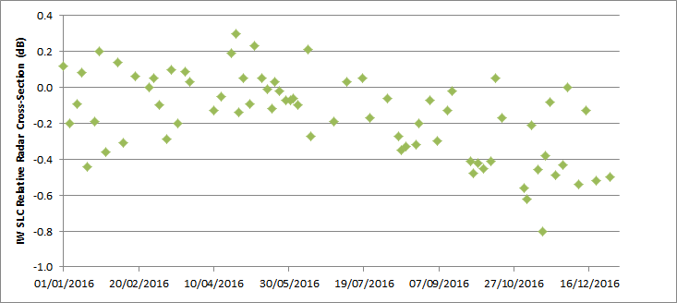

**Figure 24: IW SLC Relative Radar Cross-Section for the BAE Corner Reflector**

An array of 40 corner reflectors has been deployed near Brisbane, Australia as a component of the Australian Geophysical Observing System (AGOS) – see [S1-RD-04], [S1-RD-06] for further details. The CRs of are size 1.5m (34), 2.0m (3) and 2.5m (3) with fixed orientations. Given that these corner reflectors have a fixed elevation and azimuth orientation they will not be pointing directly at S1-A. However, for IW acquisitions the reduction in radar cross-section compared to the case of a perfect orientation is small at less than 0.05dB. Table 12 gives the radiometric accuracy and stability for all corner reflector measurements during 2016 together with results for IW1 and IW2 sub-swaths and for VV and HH polarisations. The numbers in brackets refer to the number of measurements. The results indicate an accuracy close to zero while the stability is less than 0.5dB but larger than derived from the DLR transponders above.

|  |  |  |  |  |  |  |
| --- | --- | --- | --- | --- | --- | --- |
| All | IW1 | IW2 | IW1 VV | IW1 HH | IW2 VV | IW2 HH |
| -0.13±0.48 (721) | -0.12±0.49 (425) | -0.13±0.48 (296) | -0.19±0.37 (73) | -0.11±0.51 (352) | -0.14±0.44 (53) | -0.13±0.49 (243) |

Table 12: IW SLC Relative Radar Cross-Section for the Australian Corner Reflectors (dB)

#### Permanent Scatter Calibration

Figure 25 shows a recent IW VV Permanent Scatter Calibration series over Paris. The series covers the whole 2016 and includes the tile 11 issue (June 2016). after the issue only a small reduction of the calibration constant can be observed (about 0.1 dB), meaning that the TX power reduction for half tile 11 is well captured by the internal calibration PG product. Overall S1A shows a good radiometric stability.

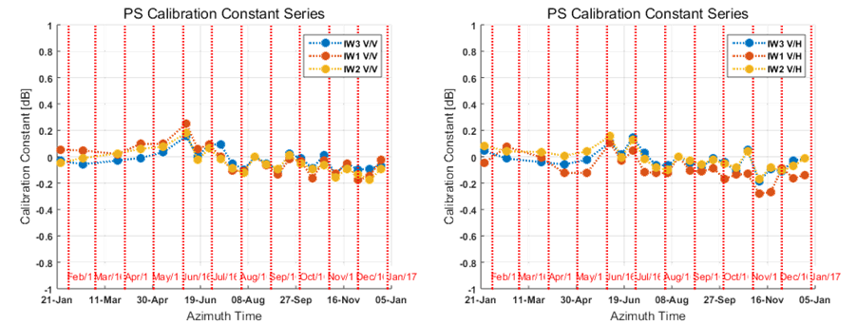

**Figure 25 Permanent Scatter Calibration time series for TopSAR IW V/V (left) and V/H (right) over Paris.**

### Geometric Validation



In 2016, S1-A geolocation quality was monitored during the S1-B commissioning and calibration phase. Trihedral corner reflectors (CRs) whose positions were surveyed with cm-level accuracy were used as reference targets. StripMap (SM) products have the best resolution and represent the native sensor characteristics more closely than other product types, which is why they are also used for sensor calibration. Geolocation accuracy was estimated for IW SLC products as well, also acquired over the same two test sites in 2016.

For a particular CR visible in an S1-A image product, its predicted azimuth and slant range image pixel position was calculated as follows:

• The surveyed CR position was adjusted for acquisition-time “epoch” plate **tectonic drift** and **solid Earth tide** (SET), as described in [S1-RD-06].

• The relevant timing annotations were extracted from the product annotations; these included the azimuth zero-Doppler time stamps, the orbital state vectors, the near-range fast time, and the range and azimuth sample spacings.

• Range-Doppler geolocation was performed for the CR coordinate as described e.g. in [S1-RD-08], giving range and azimuth times as the output.

• The slant range prediction was corrected by adding the modelled **atmospheric path delay**, and the azimuth time was corrected by subtracting the **bistatic** residual. These effects and their associated corrections are described in more detail in [S1-RD-06].

The above steps resulted in a range-azimuth *predicted* position for each target that could be compared to the position of the peak intensity in the image raster itself, i.e., the *measured* CR position. The differences between predicted and measured positions were then plotted, with the results shown for the SM and IW SLC product time series in **Figure 26**, with product date ranges indicated. Please refer to [S1-RD-06] and [S1-RD-07] for details on the evolution of the standard IPF processing and the geolocation methodology.

The ALE estimates were originally made using SM data acquired and processed during the S1-A commissioning phase. The initial geolocation results based on SM SLC products served as a basis for an update to the Sampling Window Start Time (SWST) bias annotation in the instrument auxiliary files ingested by the S1 processor. The plots shown in **Figure 26** show the ALE estimates as they appear *after* accounting for the respective SWST biases (either in the S1 processor itself, or during post-processing). Note that no analogous azimuth timing correction has yet been incorporated into the processor.

**Figure 26**(a) shows the SM SLC ALE plot for S1-A. Although the mean range offset is small (~3.8 cm), it is not exactly zero even though the official SWST bias was applied during geolocation estimation. This is due to improvements made to the atmospheric path delay model *after* the original SWST bias estimate had been incorporated into the IPF. As a result, the slant range estimates for the targets in **Figure 26**(a) products changed, corresponding to an updated range ALE.

The S1-A IW SLC plot is shown in **Figure 26**(b). The clear grouping of the points by subswath is a known issue under continued investigation. Some indication of a similar beam-specific grouping can be seen in the SM SLC plot as well (**Figure 26**(a)).

The ALE plots in **Figure 26** indicate that given bias compensations, the localisation performance was well within the original requirements (according to sections 5.5.2.1 and 5.5.2.2 in [S1-RD-09]). The observed beam/subswath-dependent azimuth ALE remains under investigation. A method for integrating azimuth bias compensation annotations in the IPF is under study.

|  |  |
| --- | --- |
|  |  |
| (a) S1-A SM SLC (2014.06.07 – 2015.01.07) | (b) S1-A IW SLC (2016.04.26 – 2016.12.30) |
| **Figure 26: ALE estimates for S1-A StripMap and IW SLC product time series acquired over the Swiss test sites using precise state vectors (AUX\_POEORB). Product date ranges are given in brackets (N.B. no S1-A SM acquisitions were made over Switzerland during the 2016 campaign). Point colours represent beam/subswath. The S1-A SWST (range) bias (output of the commissioning and calibration phase) was applied in both cases.** | |

### Polarimetric Calibration

#### Gain Imbalance

The DLR transponders have also been used to calculate the gain imbalance (the difference in radar cross-section between the two polarisations of dual polarisation products). Table 13 gives a summary of the gain imbalance for the SM, IW and EW modes. The majority of the measurements are for IW mode for which the mean gain imbalance is close to zero.

|  |  |
| --- | --- |
|  | Gain Imbalance (dB) |
| SM | -0.59±0.30 (14) |
| IW | -0.10±0.20 (238) |
| EW | -0.51±0.44 (3) |

**Table 13: Gain Imbalance using the DLR transponders**

The following results show the gain imbalance split between the two possible polarisation of VH/VV and HH/HV. Table 14 give the gain imbalance for SM, IW and EW for acquisitions during 2016 while Figure 27 shows the gain imbalance for IW.

|  |
| --- |
|  |

**Figure 27: IW Gain Imbalance using the DLR transponders.**

|  |  |  |
| --- | --- | --- |
|  | VH/VV | HV/HH |
| SM | -0.75±0.23 (8) | -0.37±0.23 (6) |
| IW | 0.12±0.17 (224) | 0.31±0.18 (14) |
| EW | -0.51±0.44 (3) |  |

**Table 14: Gain Imbalance using the DLR transponders**

#### Phase Imbalance

The DLR transponders have been used to calculate the phase imbalance (the difference in peak phase between the two polarisations of dual polarisation products). Figure 28 and Table 15 give the gain imbalance for SM, IW and EW for acquisitions during 2016. As expected the phase difference is close to zero.

|  |
| --- |
|  |

**Figure 28: Phase Imbalance using the DLR transponders.**

|  |  |
| --- | --- |
|  | Phase Difference (°) |
| SM | -1.02±0.49 (14) |
| IW | -1.20±0.65 (238) |
| EW | -1.96±0.74 (3) |

**Table 15: Phase Imbalance using the DLR transponders**

#### Coregistration

The DLR transponders both provide an impulse response in both polarisations of dual polarisation imagery which enables coregistration to be performed between the two polarisation images. Table 16 below shows that the average measured polarimetic co-registration derived from SLC products acquired during 2016 is very small (the IRF peak position is measured to a 1/8 of a pixel).

|  |  |  |  |
| --- | --- | --- | --- |
| **Mode/Swath** | **Range Co-registration Accuracy (m)** | **Azimuth Co-registration Accuracy (m)** | **Number of Measurements** |
| SM | 0.04±0.11 | 0.00±0.00 | 28 |
| IW | 0.02±0.07 | 0.07±0.35 | 477 |
| EW | 0.00±0.00 | 0.00±0.00 | 6 |

Table 16 Polarimetric Calibration Measurements

#### Cross-talk

No specific cross-talk measurements were performed during 2016.

### Elevation Antenna Patterns

There were no updates to the S1-A elevation antenna patterns during 2016.

### Azimuth Antenna Patterns

There were no updates to the S1-A azimuth antenna patterns during 2016.

### Noise Equivalent Radar Cross-section

S1-A imagery with low ocean backscatter can be used to estimate the Noise Equivalent Radar Cross-Section (NESZ). In Figure 29 and Figure 30 show NESZ measurements for IW and EW mode derived from data acquired in 2016. The requirement that the NESZ should be below -22 dB is met at all sub-swaths. For IW the measurements are slightly better than the prediction (red curves) while for EW the measurements are slightly worse than the prediction.

|  |
| --- |
|  |
| S1A\_IW\_GRDH\_1SDV\_20160126T054425\_20160126T054450\_009661\_00E15D\_9DC9.SAFE |
| **Figure 29: NESZ measures for IW. Blue is the measured NESZ and the red lines are the predicted NESZ at minimum orbital altitude.** |

|  |
| --- |
|  |
| S1A\_EW\_GRDH\_1SDH\_20160124T055528\_20160124T055632\_009632\_00E084\_2194.SAFE |
| **Figure 30: NESZ measures for EW. Blue is the measured NESZ and the red lines are the predicted NESZ at minimum orbital altitudes.** |

### S1-A Tile 11 Failure

As described in Section 3.1, a problem with the transmit power supply on tile 11 occurred on 16th June 2016 led to reduced power for rows 1 to 10 in Tx H and Tx V. The resumption of operations occurred on 27th June 2016. An assessment on the impact on Level 1 products were performed [S1-RD-08]. Analysis was performed using the Amazon Rainforest (for changes on elevation antenna pattern) and calibration point targets (for changes on absolute calibration). This showed either no or small (~0.1dB) changes in radiometry. This indicates that the internal calibration is correctly compensating for the reduction in transmit power caused by the Tile 11 issue. Results from various point targets (the Australian CR array, the DLR transponders and corner reflectors and the BAE corner reflector) do not show any systematic reduction in relative RCS.

### S1-A Debris Collision

The Sentinel-1A solar panel was hit by a small piece of space debris or micrometeoroid on 23rd August 2016 at 17:07 UT. As shown in Figure 31 and Figure 32 the location and size of the debris image is clearly visible from an on-board camera. The size of the affected area is about 40cm in diameter caused by a particle just a few mm in diameter. No unusual behaviour in either the spacecraft attitude or Doppler was found and no implications were found for processed Level 1 products. Further information can be found in [S1-RD-09].

|  |
| --- |
|  |

Figure 31: S1-A solar panel before and after debris collision on 23 August 2016 (red arrow indicates panel damage).

|  |  |
| --- | --- |
|  |  |

Figure 32: S1-A solar panel before and after debris collision on 23 August 2016 (detail).

### Summary of Anomalies

#### Radio Frequency Interference

As small percentage of Sentinel-1A imagery is affected by the presence of Radio Frequency Interference from the ground. An example from 2016 is shown below over Japan. Usually RFI only affects a few range lines of raw data.

|  |
| --- |
|  |
| S1A\_IW\_SLC\_\_1ASV\_20160401T092152\_20160401T092219\_010626\_00FD16\_3336.SAFE |

**Figure 33: An example of Radio Frequency Interference over Japan**

#### Radarsat-2/Sentinel1-A Mutual Interference

Although the orbit altitude of Radarsat-2 and Sentinel1-A are quite different (789 km and 693 km respectively) their repeat periods are a multiple of each other (24 days and 12 days respectively) and their equatorial crossing times are almost the same (~18:00 hrs at the ascending node). Another similarity is that both SARs operate at the same frequency.

The repeat period and crossing times mean that every 24 days, Radarsat-2 will be directly above Sentinel-1 and hence both may be imaging the region of the Earth’s surface at the same time. If this occurs then mutual interference is detected. Further examples of such mutual interference occurred during 2016 as indicated in Table 17.

|  |  |  |  |  |  |  |  |
| --- | --- | --- | --- | --- | --- | --- | --- |
| **Satellite** | **Orbit** | **Relative Orbit** | **Acquisition Date** | **Start Time (UT)** | **End Time (UT)** | **Approx. Latitude** | **Approx.**  **Location** |
| S1-A | 9391 | 44 | 7th January 2016 | 16:56 | 17:04 | 62° N | Sweden |
| S1-A | 9741 | 44 | 31st January 2016 | 16:58 | 17:04 | 62° N | Sweden |
| S1-A | 10091 | 44 | 24th February 2016 | 17:03 | 17:04 | 63° N | Norway |
| S1-A | 12441 | 119\* | 3rd August 2016 | 20:40 | 20:41 | 73° N | NE Russia |
| S1-A | 12741 | 69\* | 24th August 2016 | 10:24 | 10:24 | 70° N | Greenland |
| S1-A | 13091 | 69\* | 17th September 2016 | 10:22 | 10:24 | 74° N | Greenland |
| S1-A | 13223 | 35\* | 27th September 2016 | 04:10 | 04:11 | 53° N | Belarus/Russia |
| S1-A | 13441 | 69\* | 11th October 2016 | 10:22 | 10:26 | 74° N | Greenland |

Table 17 S1-A/Radarsat-2 Mutual Interference during 2016

#### Other S1-A/Satellite Interference

Another type of interference between S1-A and another satellite was seen on 8th December 2016 over Florida, USA as shown in Figure 34. The interference is approximately 1200 km in azimuth extent and it has a visual appearance that is quite different from the S1-A/Radarsat-2 interference [S1-RD-01]. It occurred between 23:27:09 and 23:30:22 UT. No other occurrences of this type of interference have been observed and the source of the interference has not been identified.

|  |
| --- |
|  |

**Figure 34: S1-A/Satellite Interference 8th December 2016 over Florida, USA**

### Quality Disclaimers

S1-A Quality disclaimers issued during 2016 are given in Appendix H.

## S1-A Level 2 products

### Wind measurement

#### Image Mode (SM-IW-EW)

The SAR wind measurement is strongly dependant of the product calibration accuracy. Thus, its quality has improved during 2015 as the calibration of the products has improved. It takes benefit from the efforts made on the SAR Level1 products to improve the calibration constant and align the gamma profile as the function of the elevation angle over Rain Forest. These improvements reduce the wind measurements error belong the subswath and subswath by subswath.

Statement of the wind measurements accuracy:

The strategy to assess the accuracy of the wind retrieval is to compare it with an auxiliary wind source which is used as a reference. This source could be in-situ data from buoy, other satellite data (ex: scatterometer) or atmospherical model outputs. It is important to outline the importance to multiple the types and the number of the data used as reference, due to their coverage, resolution or possible bias. In this scope, Ifremer has performed systematic collocations with such data (model: ECMWF (global), Arome, Arpege (European), hundreds of buoys, etc.) with L2 products generated by the ESA-IPF by PDGS.

|  |  |  |  |  |  |
| --- | --- | --- | --- | --- | --- |
| F:\CalValS1\sentinel-1a\coloc_aromev2\201610_11_12_13\IW_VV\speed_speed\spd_vs_spd_all_incidence_angles.png   1. Arome | F:\CalValS1\sentinel-1a\coloc_arpegeHR\201610_11_12_13\IW_VV\speed_speed\spd_vs_spd_all_incidence_angles.png  b) Arpege HR | | | | |
| F:\CalValS1\sentinel-1a\coloc_ecmwf-0125\201610_11_12_13\IW_VV\speed_speed\spd_vs_spd_all_incidence_angles.png  c) ECMWF |  |  |  |  |  |
|  |  | bias | Rms |  |
|  | Arome | -0.49 m/s | 1.90 m/s |  |
|  | Arpege | -0.61 m/s | 2.01 m/s |  |
|  | ECMWF | -0.27m/s | 1.66 m/s |  |
|  |  |  |  |  |
|  |  |  |  |  |



**Figure 35** presents the performances achieved on the month of December 2015 for IW mode in VV polarisation of the retrieved wind compared to model references (Arome, Arpege and ECMWF). It can be noticed the strong correlation of the SAR-derived wind speeds with the wind references. The bias and the RMS are less important for ECMWF re-analysis since the wind inversion is based on the ECMWF forecast as an a priori wind input. As expected, at low wind speeds, the NESZ impacts the SAR wind measurement (over-estimation). At high wind speeds, the SAR tends to under-estimate the wind speed; however the number of samples is low, and may not be sufficient to conclude. A typical RMS of 1.5m/s to 2m/s is observed. The quality of the wind product derived for this mode is fairly good. Same kind of performances (bias nearly equal to zero and RMS of about 2m/s) is achieved on EW HH mode. Other modes such as SM, IW in HH and EW in VV are rarely acquired or processed up to Level 2 products.

|  |  |  |  |  |  |
| --- | --- | --- | --- | --- | --- |
| F:\CalValS1\sentinel-1a\coloc_aromev2\201610_11_12_13\IW_VV\speed_speed\spd_vs_spd_all_incidence_angles.png   1. Arome | F:\CalValS1\sentinel-1a\coloc_arpegeHR\201610_11_12_13\IW_VV\speed_speed\spd_vs_spd_all_incidence_angles.png  b) Arpege HR | | | | |
| F:\CalValS1\sentinel-1a\coloc_ecmwf-0125\201610_11_12_13\IW_VV\speed_speed\spd_vs_spd_all_incidence_angles.png  c) ECMWF |  |  |  |  |  |
|  |  | bias | Rms |  |
|  | Arome | -0.49 m/s | 1.90 m/s |  |
|  | Arpege | -0.61 m/s | 2.01 m/s |  |
|  | ECMWF | -0.27m/s | 1.66 m/s |  |
|  |  |  |  |  |
|  |  |  |  |  |

**Figure 35: SAR Wind speed compared with reference wind speed for IW mode VV polarization.**

Improvement performed during 2016:

Some improvements have been conducted during 2016.

1. Correction of the wind direction:

A little bug concerning the wind direc

1. Attempt to improve the IceMask

In the IPF 270 (IDL), as the initial implementation in the LOP of the ice mask estimation was not performing well, a correction for taking into account the ice border instead of the ice concentration mask was introduced.

Whenever located in OSISAF ice region, the ice border is well taken into account and the filtering in the wind inversion behaves well.

On the opposite, when no ice is present, a side effect is produced and the ice border interpolation on the wind field grid introduces a large margin to the coast, of sometimes 5 to 10 km which is especially an issue in island vicinity. This is illustrated in Figure 36. To correct for this effect, a patch will be proposed has part of next IPF python release.

**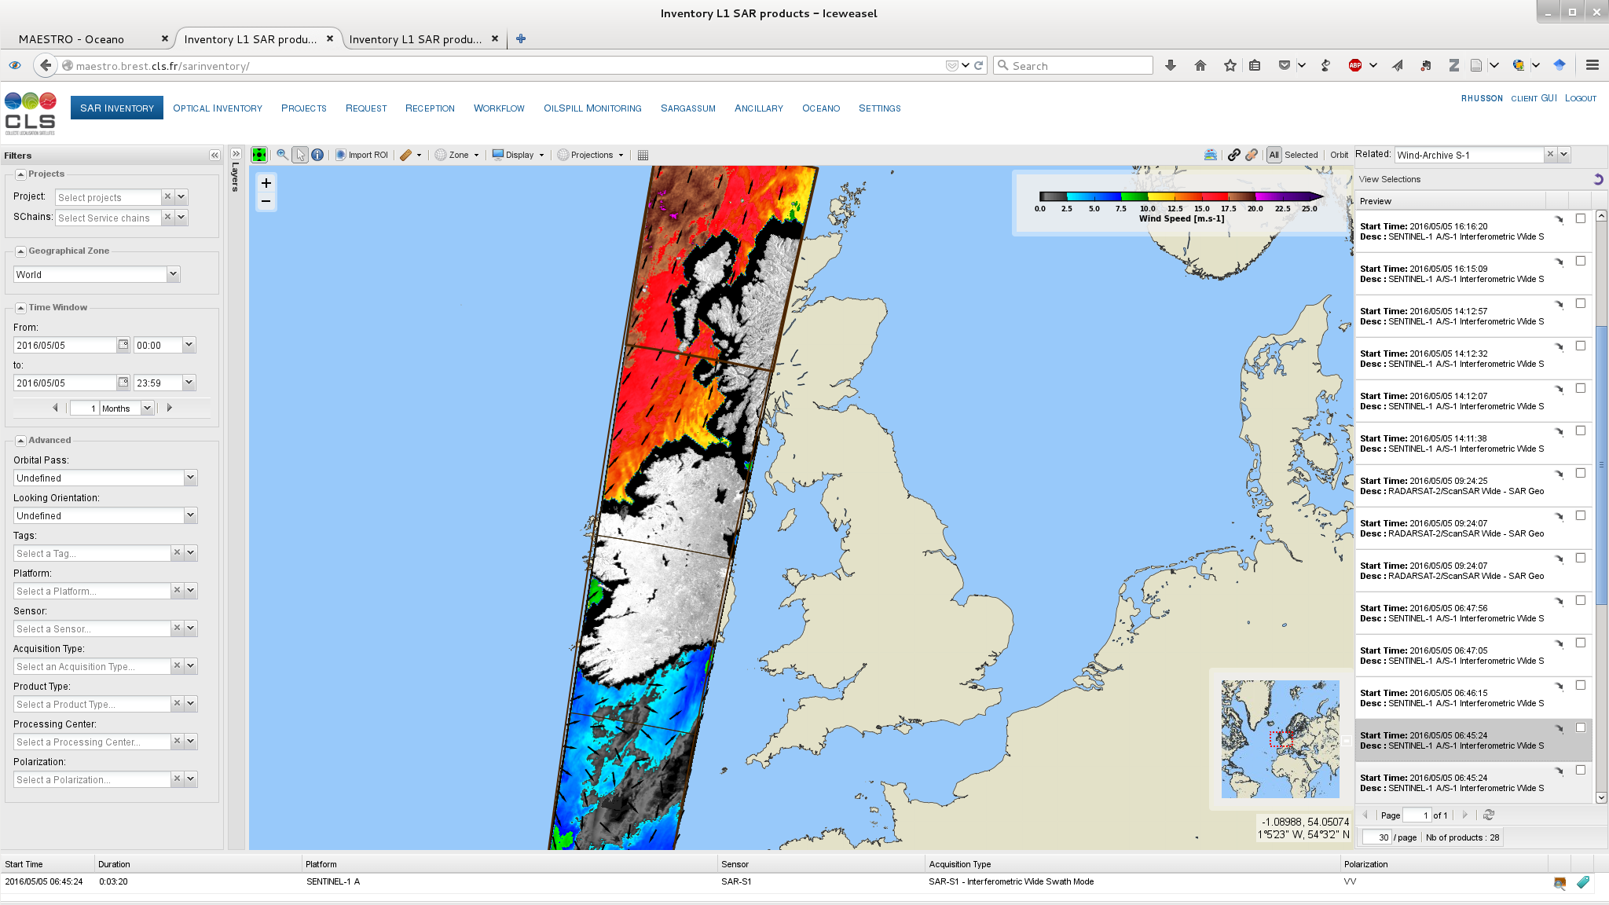**

Figure 36: SAR-derived wind estimation provided in the Level-1 OWI products showing the coastal margin introduced by the ice mask update. This margin is a side effect of the raw coastal polygon used in the ice border information provided in the ancillary ice information.

1. Preparation for the noise removal:

All the elements have been put in place in order to allow the activation of the use of annotated noise vector in order to ‘denoise’ the measured NRCS before computing the wind measurement. This would allow reducing the impact of the NESZ on the wind measurements, in particular for low to moderate wind speeds (under-estimation + impact of the antenna lobes with respect to the elevation angle). Indeed, a new field in the AUX\_PP2 has been introduced in order to trigger the activation. However, the current noise annotations have been considered not accurate enough for the systematic activation of the denoising for 2016.

1. Adding of Noise information

As part of the preparation of the denoising, the new variable OwiNesz is computed (interpolation of the annotated noise vector on the OWI grid) and extracted in the L2 product, from IPF 2.7 and latter ones. This is a new-information variable which was not present in the previous products.

1. Development of a python version of the L2 processor

During 2015/2016, a new version of the LOP has been developed and consolidated using python rather than IDL. This new version is not currently on-production; it has no impact on the current wind retrieval performances.

Coming Improvements for 2017:

Some improvements of the SAR retrieved wind measurement remains in the scope of 2017.

1. Python version of the LOP

During 2015/2016, a new version of the LOP has been developed and consolidated using python rather than IDL. The start of the production using this version is planned for 2017. This should not impact the quality of the wind measurements. However the number of products processed to OCN level could increase.

1. Issue with Ice mask

The issue identified in the ice mask estimation mentioned in the previous paragraphs has been identified and a correction was developed in order to better take into account the presence/absence of ice indicated in the ancillary ice files. This correction is not yet implemented in the current operational IPF version.

The new correction takes into account the sea ice border information, whose information is not originally given in coastal regions (about 10km), but can be extended to the coast when judged relevant using image processing methods, as illustrated in . The coastal margin shown in Figure 36 is removed from this processing when no ice is detected.

|  |  |
| --- | --- |
| F:\Images\Screenshot from 2016-06-14 14:27:56.png | F:\Images\Screenshot from 2016-06-14 14:28:23.png |

Figure 37: Sea surface roughness of a Sentinel-1 product acquired over Greenland on 2016/04/29 (left) and the associated ice masked OWI product with background ice concentration (right).

1. Issue with the Bright Target
2. The aim of the Pbright algorithm is to remove bright targets (such as the ships, oil rigs, offshore wind farms for example) from the averaging of the scattering level (normalized radar cross section) on the cell where the wind retrieval is performed to avoid their contribution. First quantitative inspection indicate that the results of the Pbright algorithm are not optimal and tend to over-estimate the number of bright targets in the wind cell. It means that it reduces the number of points for the averaging, and then could result in a less-confident and underestimated SAR-retrieved wind speed. Since the processing parameters used in the Pbright algorithm have not been re-adjusted after Sentinel-1 launch, a quantitative estimation of the algorithm performances will be performed for the different acquisition modes and processing levels and adjustments will be proposed if necessary. Activation of the noise removal

The activation of the noise removal will allow to reduce the impact of the NESZ on the wind measurements especially for low-to-moderate wind speed and for wind measurements performed at high incidence angle, resulting on an over-estimation of the SAR derived wind speed and possible modulation of the measured wind speed profiles by the antenna lobe. The noise vectors of the L1 product will be updated during 2017, to be more accurate. Once this activity and after performance assessment, it could be decided to activate the noise removal for wind retrieval production.

1. GMF change

GMF is the theoretical function from which a wind situation and observation configuration gives the measured sea-surface-backscattered level. SAR wind monitoring has outlined some deficiencies in the current GMF (Cmod-Ifr2). An activity on the assessment of the performances of several candidate GMFs of the Cmod5 family will be conducted during 2017. Then if benefit of using another GMF is demonstrated, the action will be taken to update this GMF.

#### Wave Mode

Figure 38 and Figure 39 show the monthly performances with respect to time in 2016 for WV1 resp. WV2. Top panel presents the bias and the standard deviation for the wind speed. Bottom panel presents the number of acquisitions and bottom panel the mean and median wind speed from ECMWF model. The bias is computed by comparing the wind speed from Sentinel-1 and the wind speed from ECMWF analysis (3 hours and 0.125 degrees). An example for December 2016 is shown on Figure 40 and Figure 41. Figure 38 shows a significant change in the wind speed bias after May 2016. This corresponds to a change in the processing gain coefficients. We observe that after May 2016 bias remain lower than -0.5 m/s and 0.1 m/s, respectively for WV1 and WV2. Standard deviation values are lower than 1.6 m/s and 1.7 m/s, respectively for WV1 and WV2. These results are within the specifications. The standard deviation of wind speed remains constant whereas a slight trend is observed for the bias decreasing from -0.1m/s in June to 0.41 m/s in December 2016.

|  |  |
| --- | --- |
| Figure 38 S1A WV1 wind speed performances as function of time | Figure 39 S1A WV2 wind speed performances as function of time |

*Ocean surface wind monthly performances for WV1 (top-left) and WV2 (top-right) and number of acquisitions co-located to reference data for validation for WV1 (bottom-left) and WV2 (bottom- right). For top panels, colored thick solid lines stand for the mean difference between Sentinel-1 and ECMWF model wind speeds. Colored thin solid lines are for standard deviation.*

|  |  |
| --- | --- |
| Figure 40 scatter plot of wind speed from S1A WV1 versus ECMWF Dec 2016 | Figure 41 scatter plot of wind speed from S1A WV2 versus ECMWF Dec 2016 |

*Sentinel-1A wind speed versus ECMWF wind speed. Results for WV1 are on the left panel whereas results for WV2 are on the right panel*

**Coming improvements for 2017:**

* The observed trend will be further monitored to check if this is a drift in the performances due to L1 quality issue or a season variation. An explanation will be proposed.
* Massive acquisitions are foreseen in HH polarization to assess the wind product component performances in this configuration.

### Swell Measurement

#### Wave Mode

2016 is the first complete year with a nominal use of the wave mode for Sentinel-1 A. wave mode has been activated at global scale over the oceans (excepted for June), producing a comprehensive and constant number (~25000 for WV1 and ~25000 for WV2 each month) acquisitions every cycle. This enables to investigate the stability of the Level-2 products performances with respect to time (e.g. seasonal variations) for the first time. In 2016, only acquisitions in VV polarization have been done. Results are strictly based on VV in this report.

For level-2 products as measured by Sentinel-1 A, the major changes are:

* Stabilization of processing parameters for cross- and co-spectra computation. This mostly impacts performances on swell energy in the ocean swell spectrum (oswPolSpec) and the significant wave height for each partition (oswHs).
* update of the processing gains coefficients. This mostly impacts performances on ocean surface wind speed (owiWindSpeed).

As shown on Figure 42 and Figure 43 , the number of acquisitions is significantly lower in June comparing to other months. Indeed, in June Sentinel-1A suffered from a severe issue with the transmit power supplier on antenna tile 11. Operations were stopped between the 16th and the 27th of June 2016.

|  |  |
| --- | --- |
| Figure 42 S1A WV1 Swell measurement performances as function of time | Figure 43 S1A WV2 Swell measurement performances as function of time |

*Ocean swell monthly performances for WV1 (top-left) and WV2 (top-right) and number of acquisitions co-located to reference data for validation for WV1 (bottom-left) and WV2 (bottom- right). For top panels, colored thick solid lines stand for the mean difference between effective significant wave height from Sentinel-1 and from WW3 model. Colored thin solid lines are for standard deviation.*

|  |  |
| --- | --- |
| Figure 44 scatter plot of effective significant wave height from S1A WV1 versus WW3 Dec 2016 | Figure 45 scatter plot of effective significant wave height from S1A WV2 versus WW3 Dec 2016 |

*Sentinel-1A effective significant wave height versus WW3 significant wave height. Results for WV1 are on the left panel whereas results for WV2 are on the right panel*

**Coming improvements for 2017:**

* The observed trend will be further monitored to check if this is a drift in the performances due to L1 quality issue or a season variation. An explanation will be proposed.
* Massive acquisitions are foreseen in HH polarization to assess the wind product component performances in this configuration.

### Radial Velocity Measurement

#### Wave Mode

The radial velocity measurement is derived from the Geophysical Doppler anomaly. In the S-1 IPF, this geophysical Doppler is estimated by:



where:

* FdcSAR is estimated from the SAR data
* FdcOcean is the component related to the ocean radial velocities.
* FdcAttitude is estimated from the geometry knowledge (quaternion based)
* Fdcantenna is the antenna contribution related to TRM drifts, failures, misalignements, etc

At global scale, the expected relationship between the geophysical Doppler and the sea state (or ocean surface wind vector) is well known since Envisat/ASAR. The performances of the geophysical Doppler are assessed by estimating the bias between the expected Doppler given the sea state conditions (provided by ECMWF) and the geophysical Doppler as included in the Level 2 products.

Statement of the ocean surface radial velocities measurements accuracy:

Figure 46 shows the geophysical Doppler as included in the Level 2 products as a function of radial wind speed (wind speed projected in the line of sight of the radar). The colour code indicates the latitude. As observed, the Doppler and the radial wind speed are strongly correlated for both WV1 and WV2. However, the colour code indicates a clear and non-geophysical dependence to the latitude. In addition, Doppler is not 0 Hz (as it should be) when radial wind speed is 0 m/s for WV1 and WV2. This shows that the Doppler shift as processed at PDGS is not only related to ocean surface radial velocities. This prevents us for getting any quantitative geophysical signature such as ocean surface currents in the product.

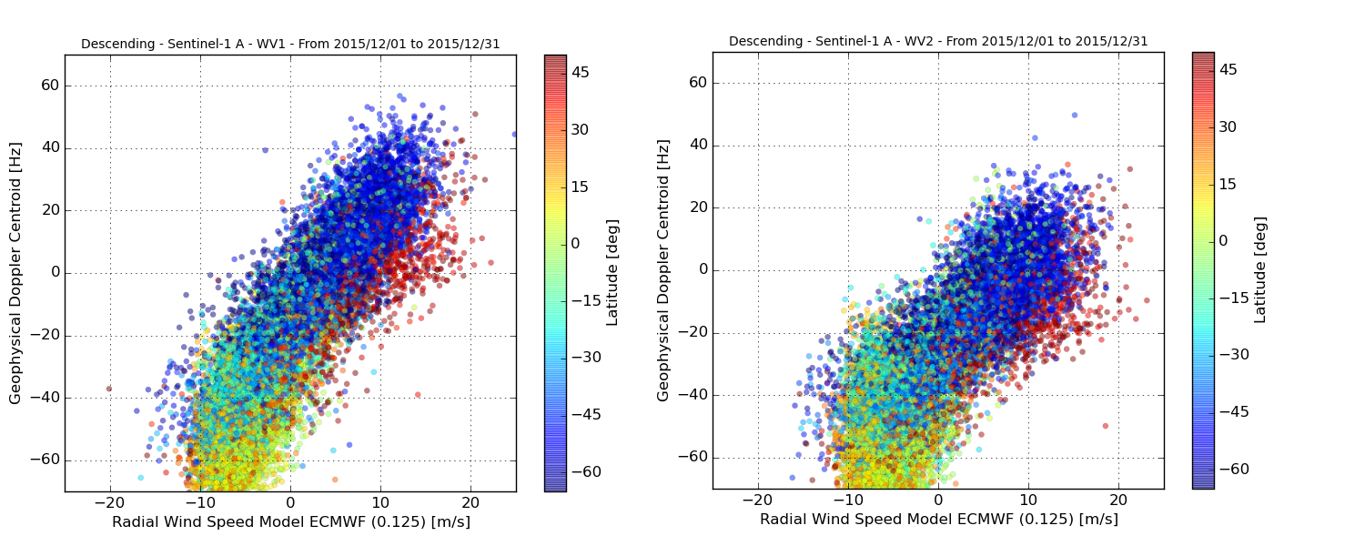

**Figure 46: Geophysical Doppler as included in the Level 2 products as a function of radial wind speed (wind speed projected in the line of sight of the radar) for WV1 (left) and WV2 (right). The colour code indicates the latitude.**

Improvement performed during 2015:

In 2015 the daily monitoring of this relationship allowed us to show the residual Doppler from the instrument/platform contribution (FdcAttitude and/or Fdcantenna) in geophysical Doppler. In particular, our systematic analysis revealed a contamination with respect to latitude in the geophysical Doppler. Complementary acquisition in WM over land where the geophysical Doppler is expected to be zero showed the same results. Figure 47 shows the bias as a function of latitude estimated both over ocean (blue) and land (brown). In spite of the low number of available acquisitions over land, both show Doppler variation up to 30 Hz. As observed on Figure 6, expected the geophysical signature is expected to be between -60 and 60 Hz. 30 Hz of contamination is thus far too much for ocean current applications.

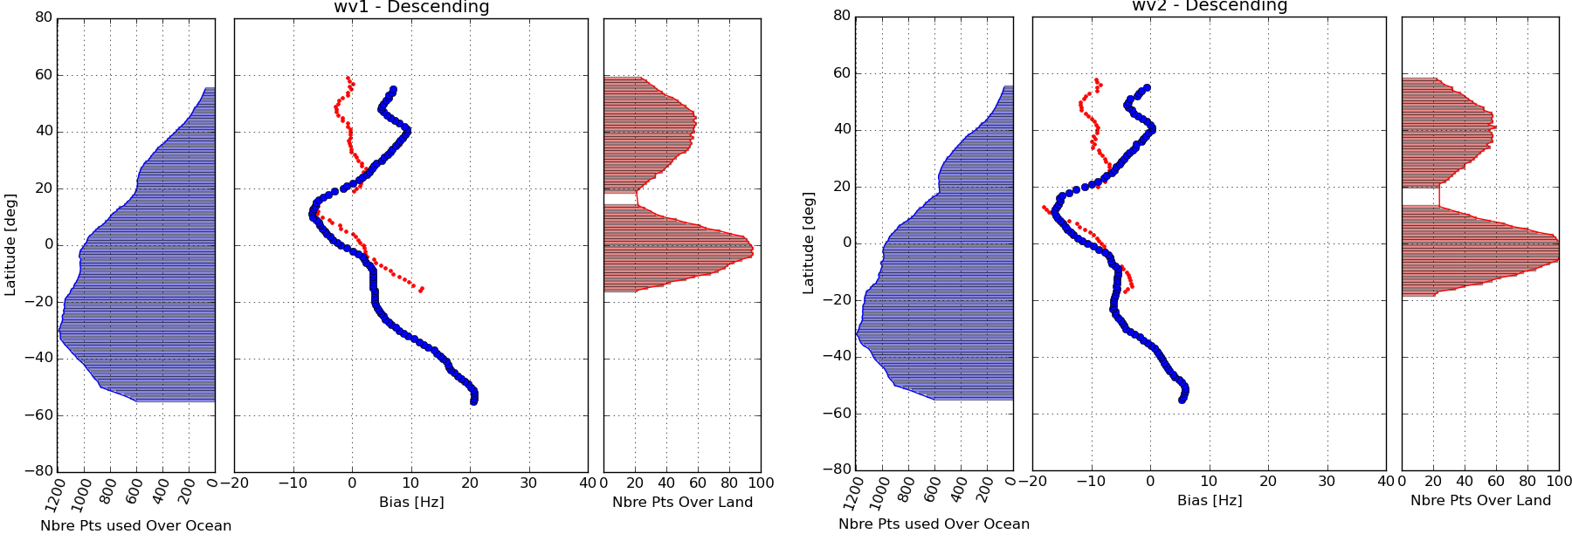

**Figure 47**: **Doppler bias as a function of latitude estimated over ocean (blue) and land (brown).**

The differences (around 10Hz) observed in the land Doppler between wv1 and wv2 can be well predicted by the recent antenna model as shown in **Erreur ! Source du renvoi introuvable.**.

Coming Improvements for 2016:

In 2016, we will pursue the careful monitoring of the Doppler calibration using geophysical calibration. We recommend continuing acquisitions over land as there are still differences between analysis over land and ocean. Moreover a strategy to replace acquisition over land will be proposed and evaluated.

#### TOPS Mode

Statement of the ocean surface radial velocities measurements accuracy:

As for Wave Mode, the contamination of the geophysical Doppler by the geometry knowledge (quaternion based) and the antenna contribution prevents us for getting any quantitative geophysical signature such as ocean surface currents in the product. Nevertheless, in cases where land areas are present in the image an ad-hoc calibration has been performed, and the results shown are promising (see Figure 48). A limited number of S1a IW and EW data from Agulhas were recalibrated using this approach followed by converting the radial velocity to surface current using CDOP, and validated against surface drifters. Results are shown in Figure 48 c.

|  |  |  |
| --- | --- | --- |
| S1A_IW_RVL__0SDV_20160312T164409_rvldoppler.pnga) | S1A_IW_RVL__0SDV_20160312T164409_rvlradvel.pngb) | s1a_osc_agulhas1.png  c) |

**Figure 48: a) Doppler anomaly and b) radial velocity field from Sentinel 1A IW RVL product acquired over Agulhas in ascending mode. Here land areas are used to calibrate the Doppler anomaly before computing the radial velocity. C) Scatterplot of radial surface current component derived from S1A data and surface drifters acquired over Agulhas.**

Improvement performed during 2016:

Efforts are undertaken to better predict and compensate the measured Doppler for the electromagnetic (EM) Doppler bias introduced by the skewness of the antenna elevation pattern. A new version of the antenna model parameters has been ingested into the Level 2 processor and the EM Doppler bias over IW and EW swaths are compared with the data driven Doppler estimated over rain forest areas (see Figure 49).

Although the relative trends over swaths are predicted well, a significant Doppler bias is observed between the model and data. Compared to previous results, the model and data are better aligned and the jumps between swaths are better predicted. Still we see that VV-polarization performance better than HH – polarisation.

|  |  |
| --- | --- |
| S1A_EW_RVL__0SHH_20160106T223733_dcObsRaProfiles.png  a) | S1A_EW_RVL__0SVV_20151228T230205_dcObsRaProfiles.png  b) |
| S1A_IW_RVL__0SDH_20160111T224540_dcObsRaProfiles.png  c) | S1A_IW_RVL__0SSV_20160111T102907_dcObsRaProfiles.png  d) |
|  |  |

**Figure 49: S1A EM DC offset computed from antenna model (full line) with error matrix corresponding to the day of acquisition, and estimated from rain forest data using the Level 2 processor (\*\*\*). A) EW mode in HH-polarisation, B) EW mode in VV-polarisation, C) IW mode in HH-polarisation, D) IW mode in VV-polarisation**

Coming Improvements for 2017:

A further refinement of the de-scalloping will be investigated without increasing the processing time.

### Geophysical Calibration

#### Wave Mode

|  |
| --- |
| Figure 50 Sentinel-A geophysical calibration constant given by CMOD-IFRv2 for WV1 VV polarization between 50° and -50° latitude. Panel 1 shows the mean bias between ECMWF and Sentinel-1A. Panel 2 shows the bias standard deviation. Panel 3 shows the number of SAFE used to perform the analysis. |
| Figure 51 Sentinel-A geophysical calibration constant given by CMOD-IFRv2 for WV2 VV polarization between 50° and -50° latitude. Panel 1 shows the mean bias between ECMWF and Sentinel-1A. Panel 2 shows the bias standard deviation. Panel 3 shows the number of SAFE used to perform the analysis. |

As shown in Figure 59 and Figure 60 after the processing configuration change occurred in May, the Sentinel-1A geophysical calibration for WV1 seems to drift about 0.05dB/month on the last 6 months of 2016. On the other hand WV2 does not show any drift (bias near 0dB after May). The standard deviation increases of about 0.2 dB for WV1 and 0.1dB for WV2 during July-August-October-November. This increase is not explained (hypothesis of ice contamination discard with sub-setting dataset between -50° and +50° latitude) and will be addressed in 2017.

# S1-B Instrument Status

Here the status of the S1-B instrument since the start of the routine phase in September 2016:

## S1-B Antenna Status

The Antenna status is routinely monitored using the dedicated RFC calibration mode. The RFC products are processed in order to generate the Antenna Error Matrix from which it is possible to retrieve the failure and drift of each TRM.

The Figure below shows the antenna Transmit/Receive Module (TRM) status at the end of 2016. Six (6) failures are counted in total among TX-RX and H-V. All the failed TRMs are connected to a single EFE, which probably failed during the S1B launch. A full list of all TRM failures during 2016 is given in Appendix K.

The impact of the failures on the antenna patterns shape is modelled by the antenna model and the data products are compensated accordingly within the level-1 processor.

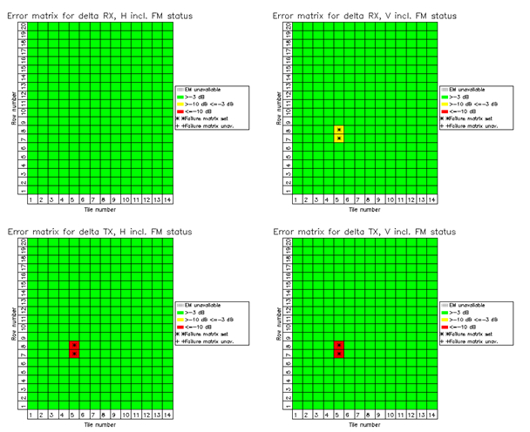

Figure 52 S1B antenna status on the 31/12/2016. The top charts refer to RX elements and the bottom charts refer to TX elements

The following figures show the TX and RX excitation coefficients (averaged per tile) stability since the begin of the S1B Commissioning Phase (CP) on 14th June 2016. Note that, during the CP, many RFC products per day were available to assess instrument stability. The overall antenna behaviour is very stable.

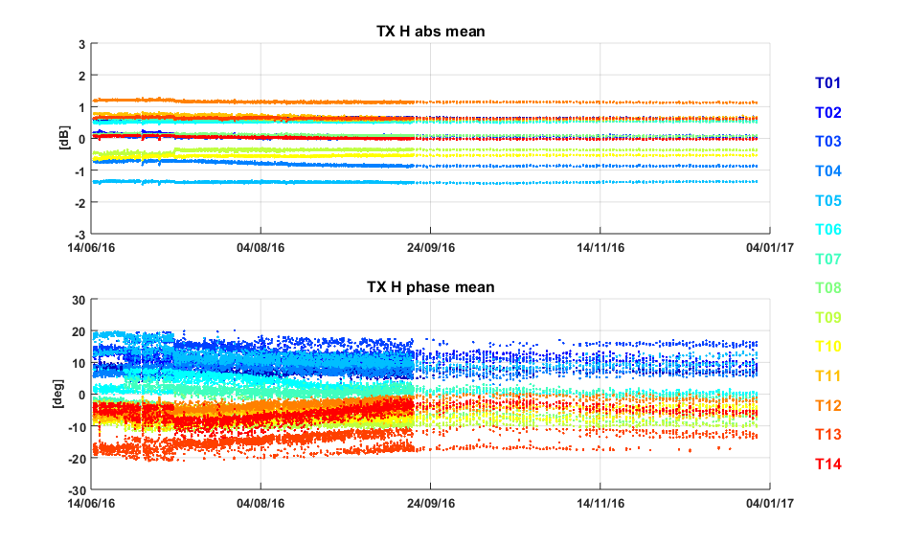

Figure 53 Gain (*top)* and phase (*bottom)* stability of the SAR antenna tiles (average of the RFC coefficients in TX H over rows).

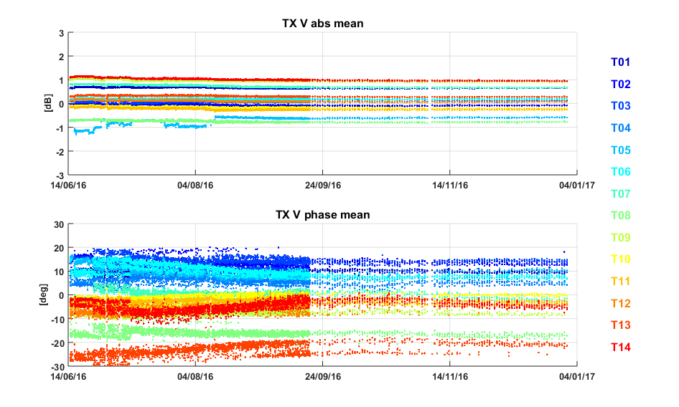

Figure 54 Gain (top) and phase (bottom) stability of the SAR antenna tiles (average of the RFC coefficients in TX V over rows).

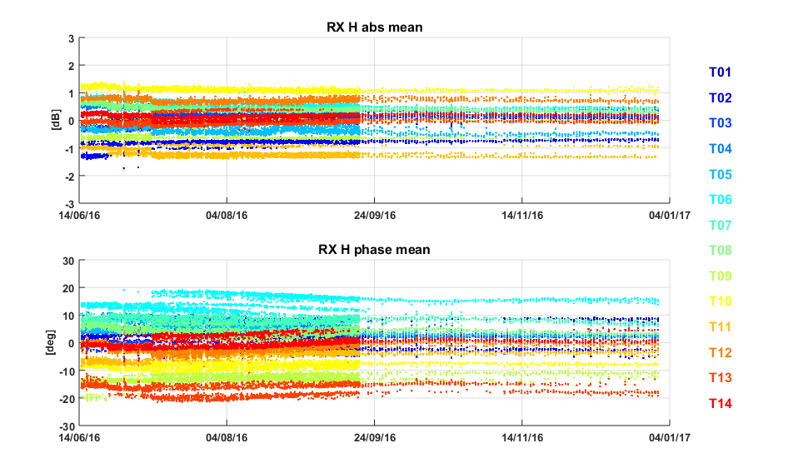

Figure 55 Gain (top) and phase (bottom) stability of the SAR antenna tiles (average of the RFC coefficients in RX H over rows).

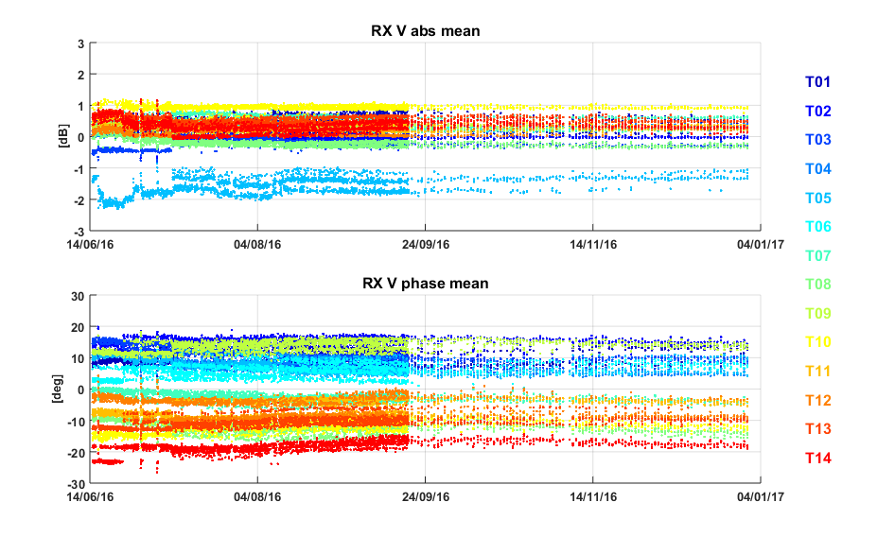

Figure 56 Gain (top) and phase (bottom) stability of the SAR antenna tiles (average of the RFC coefficients in RX V over rows).

## S1-B Instrument Unavailability

A list of S1-B instrument unavailabilities since the start of the routine phase in September 2016 is given in Appendix L.

## S1-B Auxiliary Date File Updates

A list of S1-B Auxiliary Data Files (ADFs) updates since the start of the routine phase in September 2016 is given in Appendix M.

## S1-B Radar Data Base Updates

A summary of S1-B Radar Data Base (RDB) updates is provided in the following Table.

|  |  |  |
| --- | --- | --- |
| **RDB ID** | **Date of endorsement** | **Update reason** |
| RDB #1 |  | Launch version |

**Table 18 Radar Data Base Changes History.**

## S1-B Orbit Manoeuvres

A list of all S1-B orbit manoeuvres since the start of the routine phase in September 2016 is given in Appendix N.

## S1-B Burst synchronization

The burst synchronization between repeat pass interferometric acquisitions is relevant for the TOPSAR modes (IW and EW) to provide an indication of the quality of the interferometric phase that can be expected. The SAR acquisition start time is planned over a discrete set of points round orbit with precision down to milliseconds. The performance of the synchronization is monitored by the PDGS OBS tool.

Figure 57 shows the burst synchronization over time for IW and EW mode. Each dot represents a repeat pass acquisition, considering as reference the first cycle after the end of the CP (number 19, 18-30 September 2016). Note that, as for S1A, there seems to be a small burst synchronization reduction during November and December, probably due to some slow orbital aberration.

Figure 58 shows the burst synchronization distribution for IW and EW separately. It can be noticed that the synchronization is above 99% for most of the acquisitions.

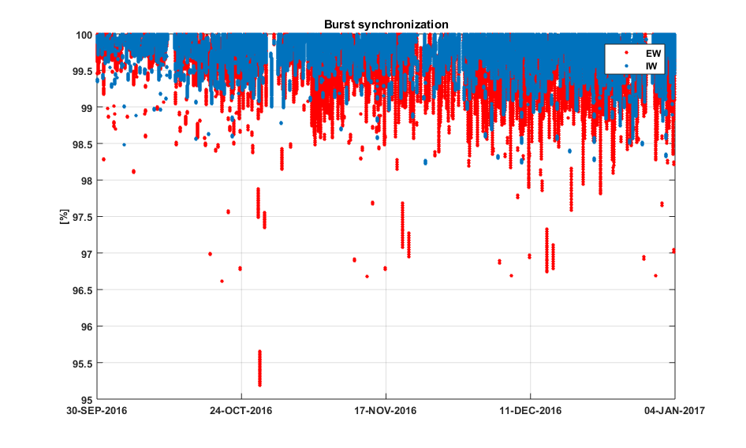

Figure 57 S1B burst synchronization since the end of the Commissioning Phase.

|  |  |
| --- | --- |
|  |  |



**Figure 58 Burst synchronization statistics for IW (left) and EW (right).**

## S1-B Internal Calibration

### PG monitoring

The instrument stability over time is monitored through the internal calibration signals. The following plots show the main parameters monitored: PG gain and phase, instrument delay and Rx gain offset. In Figure 59 the colour represents the sub-swath whereas in Figure 60 the colour represents the polarization.

All the monitored parameters are quite stable in the reporting period. Figure 61 and Figure 62 show a in detail the PG gain evolution for EW DH and IW DV acquisitions. No particular trends can be identified during the reporting period even if some long slow fluctuations can be observed in particular for RX H beams (EW HH and IW VH). Such fluctuations are in any case quite small with a peak to peak variation around 0.1 dB.

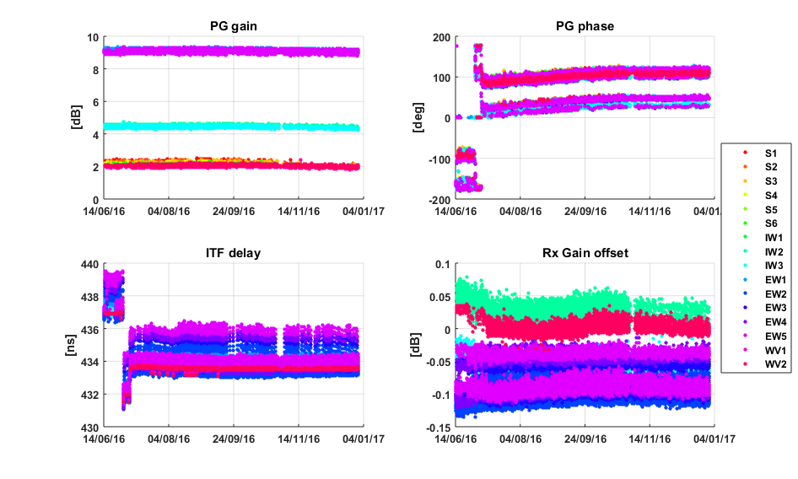

Figure 59 Internal calibration parameters over time. The color represents the sub-swath.

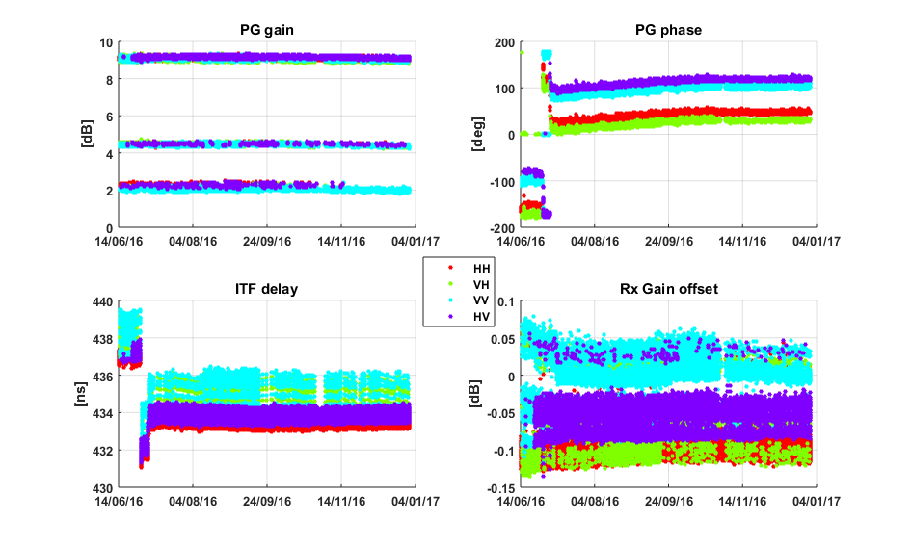

Figure 60 Internal calibration parameters over time. The color represents the polarization.

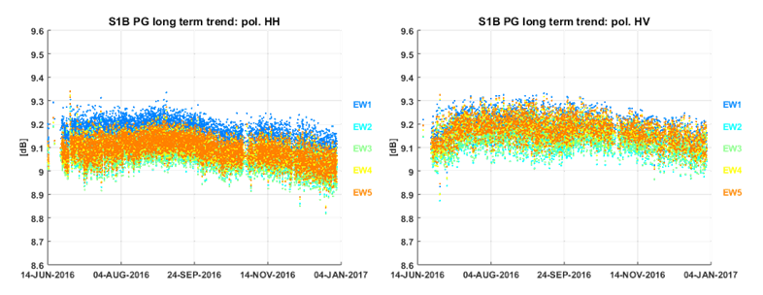

Figure 61 EW HH (left) and HV (right) PG gain divided by sub-swath.

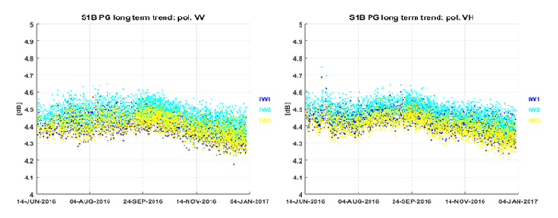







Figure 62 IW VV (left) and VH (right) PG gain divided by sub-swath.

### Noise power monitoring

The noise power is monitored through the dedicated internal calibration pulses processing embedded at the start/stop of each data-take. Figure below shows the noise power versus time since the begin of the Commissioning Phase. Overall, the noise power has a good stability, with a standard deviation of approximately 1 dB in the short term. Table below reports the noise power stability (3σ) averaged over the full reporting period. The number in the parenthesis represents the number of products considered. Note that the considerations on the noise bi-modality, reported in Section 3.7.2, are applicable for S1B as well.

|  |  |
| --- | --- |
| **Acquisition mode** | **Noise power stability [dB]** |
| SM | HH: 6.2±1.2 (1011) VV: 6.0±1.0 (1105) HV: 6.2±1.0 (684) VH: 6.0±1.3 (763) |
| IW | HH: 7.7±1.3 (3363) VV: 8.0±1.3 (24207) HV: 7.8±1.2 (1263) VH: 7.9±1.6 (20643) |
| EW | HH: 6.4±1.1 (64892) VV: 6.4±1.1 (5950) HV: 6.5±1.0 (30645) VH: 6.4±1.4 (5030) |
| WV | HH: 7.3±1.4 (72) VV: 7.0±0.7 (25670) |

**Table 19 Noise power stability (3-sigma): period JUN 2016 – DEC 2016**

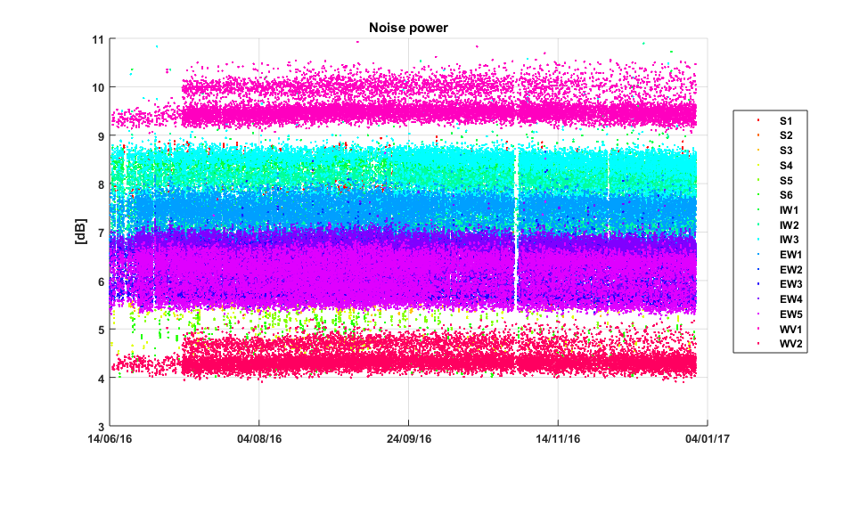



Figure **63** Noise power versus time. The colour represents the different beams.

# S1-B Products Status

## S1-B Level 0 Products

### Timeline and missing lines

The L0 quality monitoring is carried out as a routine task within the QCSS. The checks on the timeline and missing lines have not detected significant problems.

### I/Q statistics

The analysis of I/Q bias and standard deviation allow to state that the L0 data quality is nominal. Figure shows the channel imbalance analysis for IW, showing the standard deviation that the two channels are very well aligned along the bisector of the I/Q plane.



Figure 64 I/Q channel imbalance.

### FDBAQ

The FDBAQ quantization scheme performs nominally. A detailed analysis of the FDBAQ behaviour for the first year can be found in [S1-RD-10].

The long-term statistics over the acquired data show that the average Mbit/s are reported in the following table:

|  |  |
| --- | --- |
| **Acquisition mode/swath** | **Average bitrate [Mbit/s]** |
| S1 | 271.5 |
| S2 | 213.36 |
| S3 | 222.56 |
| S4 | 188.58 |
| S5 | 208.04 |
| S6 | 178.39 |
| IW | 194.89 |
| EW | 62.32 |
| WV1 | 11.8 |
| WV2 | 6.7 |

**Table 20 Average bitrate for each acquisition mode.**

### Instrument Pointing

The instrument pointing in elevation has been calibrated during the commissioning phase exploiting the availability of the elevation notch acquisitions over the Amazonian rain forest. The results of estimated roll mis-pointing are reported in the following table, referring only to the EN acquired before STT alignment on 28th July.

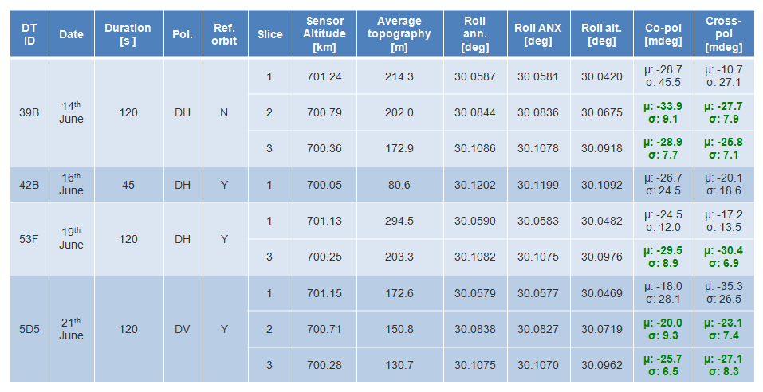

Table 21: Pointing results on Elevation Notch products

The analysis was repeated after STT alignment over a new set of Elevation Notch products. The obtained results are reported in the following table.

The processing of the available EN notches resulted in the following considerations:

* Before STT alignment the (weighted) average roll mispointing was around -26 mdeg. After including in the computation the expected tree height for the Rain Forest (30 m) a value around -22 mdeg is obtained.
* After STT alignment the (weighted) average roll mispointing (including tree height) is around -10 mdeg. The value was obtained considering only the available ascending acquisitions (DT 2380 discarded).
* The STT alignment led to an improvement of the roll mispointing of about 10 mdeg.
* The only available descending acquisition shows an average roll mispointing around 0 mdeg. This is compatible with the fact that the aberration correction is not performed on board. This results in an orbit oscillation with a maximum roll deviation around the Equator (EN case).

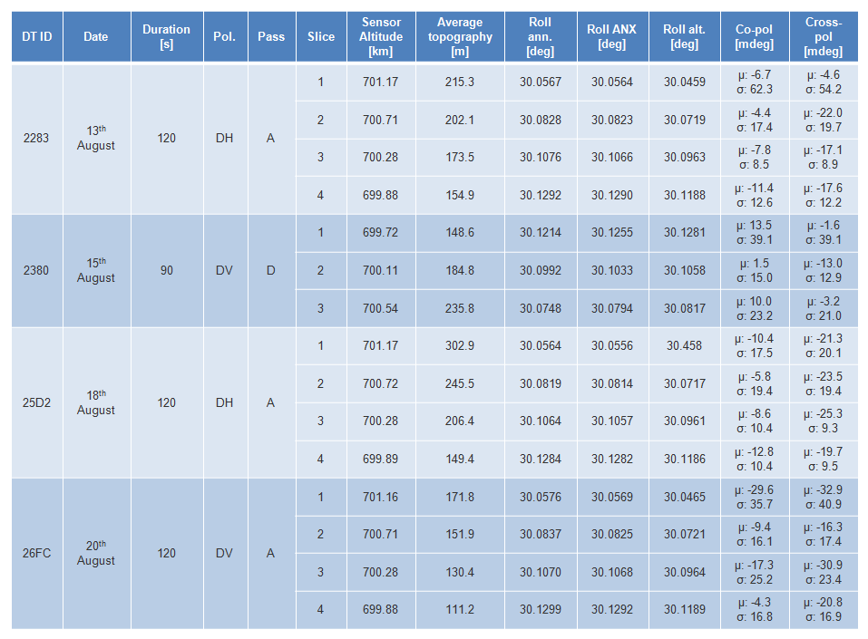

Table 22: Pointing results on Elevation Notch products

Given the previous considerations and, the accuracy of the roll estimation method (around 10 mdeg) and the requirement on roll pointing (±10 mdeg) it was decided to not perform any roll calibration after the Commissioning Phase. The roll pointing verification will be repeated after the on board implementation of the relativistic aberration correction, with a dedicated set of EN acquisitions.

Plots of the spacecraft attitude (yaw, pitch and roll) are shown in Appendix I.

The stability of the pointing in azimuth can be monitored through the Doppler Centroid, estimated directly from SAR data. The following figure shows the average Doppler Centroid on a data-take basis (dots) and on a daily basis (red line) versus time since the end of S1B Commissioning Phase. The reported values are in line with expected S1B pointing performances. The dashed vertical line represent the only star tracker configuration change occurred in the reporting period. Note that the DC jump corresponding to the star tracker configuration change is much smaller than those observed for S1A, thanks to the star tracker calibration activities performed during S1B Commissioning Phase.

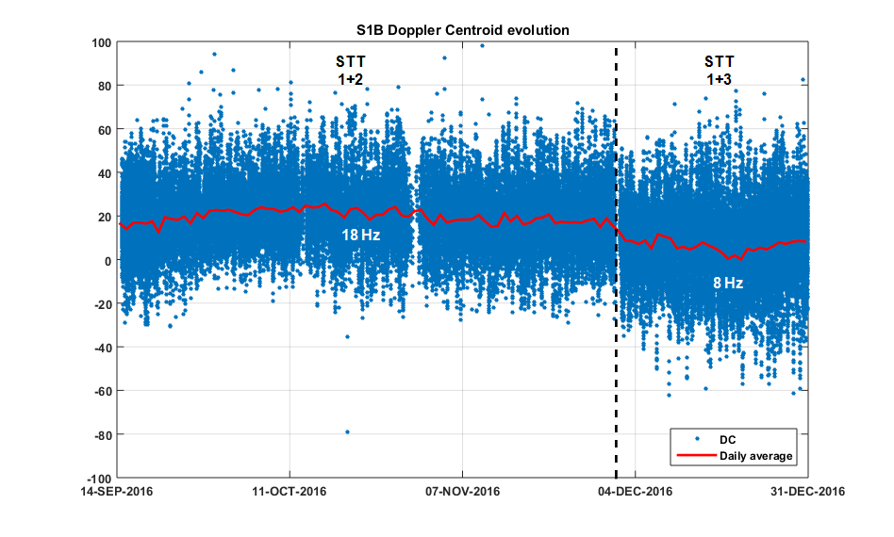



Figure 65 Doppler Centroid versus time. Average on a data-take basis (dots) and daily average (red line). The star-trackers reconfigurations events are marked by the vertical black lines.

## S1-B Level 1 Products

A general summary of status of S1-B Level 1 products was presented at several conferences and workshops (see [S1-RD-03], [S1-RD-05] and [S1-RD-07]).

### Level 1 Processor Updates

The main improvements introduced in the Level-1 Processor and impacting data quality are here below described, classified according to the release in which they have been included.

**IPF v2.4.3 (09/03/2015)**

* Improved Stripmap and Topsar radiometric normalization
* Improved management of SWST and SWL variations along orbit, in order to avoid issues (gaps, …) during merging of Topsar sub-swaths into GRD products

**IPF v2.5.0 (30/06/2015)**

* Support to slicing mode processing, adding the possibility to process L0S products also when the associated L0A/C/N ones are not available (e.g. in NRT scenarios)
* Improved management or orbital information contained in L0S products (better propagation accuracy), in order to support NRT processing
* Verification, improvement and calibration of de-noising step and related annotations
* Optimization of L1 SAFE products generation routine performances, in particular for the writing of measurement TIFF files

**IPF v2.6.0 (09/10/2015)**

* Improved orbital information annotation, reporting in the output L1 products the values really used for processing (e.g. external Restituted or Precise Orbit Files)
* Improved terrain height management during EAP correction, using one height value per sub-swath instead of only one for all the data
* Improved Quick Look scheme for dual polarization data, making it independent from the content of the acquired scene

In addition to the described L1 Processor upgrades, a summary of S1-A Auxiliary Data Files (ADFs) updates during the reporting period is provided, together with an explanation of the updates, in Appendix F. The main ones are here below summarized:

**AUX\_INS**

* Range-variant RxGain correction coefficients refinement
* Activation of SWST bias compensation
* Internal calibration default settings (time delay, PG model and reference) refinement
* Support to Stripmap modes without interleaved calibration pulses

**AUX\_PP1**

* Activation of range-variant RxGain correction
* Activation of internal calibration (i.e. PG) correction
* Processing gains and SAFE scaling LUT refinement

**AUX\_CAL**

* Introduction of complex EAP
* AAP update after TRM failures
* Noise calibration factors refinement

### Image Quality

The DLR Transponders & Corner Reflectors, the BAE Corner Reflector and the Australian Corner Reflector array have been used to assess various impulse response function parameters as described below. The products analysed were acquired during the commissioning phase and/or acquired since the start of the routine phase in September 2016 and processed with the Sentinel-1 IPF v2.71 and v2.72.

#### Spatial Resolution

The Figures and Tables below give the azimuth and range spatial resolutions derived from SM, IW and EW SLC data. The numbers in brackets indicate the number of measurements.

|  |  |
| --- | --- |
|  |  |

Figure 66 SM Azimuth and Slant Range Spatial Resolutions

|  |  |  |
| --- | --- | --- |
| **Mode/Swath** | **Azimuth Spatial Resolution (m)** | **Slant Range Spatial Resolution (m)** |
| S1 | 4.34±0.01 (34) | 1.72±0.01 (34) |
| S2 | 4.86±0.02 (40) | 2.02±0.01 (40) |
| S3 | 3.61±0.01 (8) | 2.52±0.00 (8) |
| S4 | 4.77±0.04 (8) | 2.96±0.01 (7) |
| S5 | 3.99±0.09 (29) | 3.35±0.01 (29) |
| S6 | 4.87±0.02 (4) | 3.56±0.01 (4) |

Table 23 SM Azimuth and Slant Range Spatial Resolutions

|  |  |
| --- | --- |
|  |  |

Figure 67 IW Azimuth and Slant Range Spatial Resolutions

|  |  |  |
| --- | --- | --- |
| **Mode/Swath** | **Azimuth Spatial Resolution (m)** | **Slant Range Spatial Resolution (m)** |
| IW1 | 21.84±0.22 (113) | 2.64±0.03 (113) |
| IW2 | 21.87±0.20 (74) | 3.10±0.02 (74) |
| IW3 | 21.64±0.08 (22) | 3.51±0.01 (22) |

Table 24 IW Azimuth and Slant Range Spatial Resolutions

|  |  |
| --- | --- |
|  |  |

Figure 68 EW Azimuth and Slant Range Spatial Resolutions

|  |  |  |
| --- | --- | --- |
| **Mode/Swath** | **Azimuth Spatial Resolution (m)** | **Slant Range Spatial Resolution (m)** |
| EW1 | 41.94±0.33 (59) | 7.96±0.07 (59) |
| EW2 | 42.87±0.34 (40) | 10.01±0.11 (40) |
| EW3 | 43.58±0.38 (60) | 11.73±0.11 (60) |
| EW4 | 44.09±0.26 (42) | 13.43±0.10 (42) |
| EW5 | 42.43±0.43 (23) | 14.57±0.10 (23) |

Table 25 EW Azimuth and Slant Range Spatial Resolutions

The measured spatial resolutions match the predicted resolutions as indicated by the red horizontal lines.

#### Sidelobe Ratios

The table below gives the measured impulse response function sidelobe ratios derived from SM, IW and EW SLC data – these indicate acceptable values.

|  |  |  |  |
| --- | --- | --- | --- |
| **Mode/Swath** | **Integrated Sidelobe Ratio (dB)** | **Peak Sidelobe Ratio (dB)** | **Spurious Sidelobe Ratio (dB)** |
| SM | -13.31±0.53 | -20.56±0.53 | -27.25±1.28 |
| IW | -11.67±3.57 | -19.64±0.99 | -21.81±2.90 |
| EW | -13.81±2.90 | -20.80±3.57 | -23.74±5.28 |

Table 26 SM & IW Sidelobe Ratios

#### ENL and Radiometric Resolution

No specific Equivalent Number of Look (ENL) and Radiometric Resolution measurements were performed on S1-B products. However, given that no changes have been made to the processing parameters that impact the ENL/RR since the commissioning phase of S1-A, the ENL/RR measurement for S1-B will be similar to those for S1-A [S1-RD-01].

#### Ambiguity Analysis

No specific ambiguity measurements were performed since the start of the S1-B routine phase in September 2016. Measurements below are re-produced from the S1-B MPC Commissioning Phase Report [S1-RD-02].

##### Azimuth Ambiguities

Azimuth ambiguities fall into two types: azimuth and range. Example azimuth ambiguities are shown in Figure 69 to Figure 71 for SM, IW and EW modes for the ESA ESTEC transponder, which in these examples is located over dark ocean backscatter. During the commissioning of S-1A, additional azimuth ambiguities like features were observed on IW and EW modes on both side of mainlobe. The source of features was identified after the S-1A commissioning phase and is related to a processing artifact of the TOPS products. This was solved by increasing the length of the UFR (Unfolding and Resampling filter) while deploying IPF 2.7x. Those features are not observed since then and are not observed on S-1B products.

|  |  |  |
| --- | --- | --- |
|  |  |  |
| Early Ambiguity | IRF | Late Ambiguity |

Figure 69: SM SLC Early Azimuth Ambiguity, DLR Transponder IRF and Late Ambiguity

|  |  |  |  |
| --- | --- | --- | --- |
|  |  | |  |
| Early Ambiguity | | IRF | Late Ambiguity |

Figure 70: IW Early Azimuth Ambiguity, DLR Transponder IRF and Late Ambiguity

|  |  |  |
| --- | --- | --- |
|  |  |  |
| Early Ambiguity | IRF | Late Ambiguity |

Figure 71: IW Early Azimuth Ambiguity, ESTEC Transponder IRF and Late Ambiguity

The table below gives mean azimuth ambiguity ratios for DLR transponder targets for SM, IW and EW modes. Note that for EW it can be hard to detect the azimuth ambiguities and so the values given should be considered as upper limits to the ambiguity ratio.

|  |  |  |  |
| --- | --- | --- | --- |
|  | SM | IW | EW |
| Early Azimuth Ambiguity Ratio (dB) | -29.16±5.80 | -29.49±3.65 | -30.58±1.58 |
| Late Azimuth Ambiguity Ratio (dB) | -28.98±3.12 | -28.60±3.88 | -30.11±4.41 |

Table 27: Azimuth Ambiguity Ratios

##### Range Ambiguities

Range ambiguities have been identified in one IW scene to date and that being IW acquisitions over the BAE corner reflector that includes the North Sea (relative orbit 59). This scene from 5th August 2016 is shown in Figure 72 together with the region where range ambiguities are present (purple box). Figure 73 shows the ambiguity box where an extensive region of range ambiguities are seen together with non-ambiguous point targets including a wind farm. The western part of the range ambiguity is shown in Figure 74 together with the source of the range ambiguities located in the city of Rotterdam, The Netherlands, some 150km away to the east (taken from a S1-A image). The source of these range ambiguities is at higher slant ranges than the ambiguities (the first far range ambiguity).

|  |
| --- |
|  |

**Figure 72: S1-B IW Image of SE England and N France with the location of range ambiguities indicated (acquisition 5th August 2016, 17:40:17 UT).**

|  |
| --- |
|  |

**Figure 73: Extract of ambiguity region showing various range ambiguities plus other point targets.**

|  |
| --- |
|  |

**Figure 74: Detail of ambiguity region (left) and the source of the ambiguity in Rotterdam (right).**

### Radiometric Calibration

The DLR Transponders & Corner Reflectors, the BAE Corner Reflector and the Australian Corner Reflector array have been used to measure their radar cross-section as described below. The products analysed were acquired in 2015 and processed with the Sentinel-1 IPF v2.36, v2.43, v2.52, v2.53 and v2.60. As described in Section **Erreur ! Source du renvoi introuvable.** a major re-calibration was performed during 2015 for IW and EW mode acquisitions. All the radiometric measurements below have been corrected following this re-calibration.

#### Absolute Radiometric Calibration

DLR Transponders, ESA transponders & corner reflectors and the BAE corner reflector have been used to calculate the relative radar cross-section for SM, IW and EW modes during the S1-B commissioning phase. The results per mode are shown in Table 7 where mean (radiometric accuracy) and standard deviation (radiometric stability) of the relative radar cross-section in dB are given. Note that the radiometric accuracy is close to zero while the radiometric stability is 0.5dB or better. The number of measurements is given in brackets.

|  |  |  |
| --- | --- | --- |
| SM | IW | EW |
| -0.04±0.44 (122) | 0.01±0.29 (149) | 0.00±0.47 (78) |

**Table 28: SLC Relative Radar Cross-Section for the DLR transponders (dB)**

Figure 75 to Figure 77 while Table 29 gives the mean relative RCS values per mode and polarisation.

|  |
| --- |
|  |

Figure 75: Post IOCR SM SLC Relative Radar Cross-Section

|  |
| --- |
|  |

Figure 76: Post IOCR IW SLC Relative Radar Cross-Section

|  |
| --- |
|  |

Figure 77: Post IOCR EW SLC Relative Radar Cross-Section

|  |  |  |  |  |  |
| --- | --- | --- | --- | --- | --- |
| **Mode/Swath** | **Relative Radar Cross-Section (dB)** | | | | |
| **All** | **VH** | **VV** | **HH** | **HV** |
| S1 | -0.27±0.42(34) | -0.60±0.29 (6) | 0.27±0.18 (7) | -0.58±0.21(12) | -0.06±0.28 (9) |
| S2 | 0.14±0.34 (40) | 0.00±0.11 (5) | 0.46±0.17 (7) | 0.02±0.27 (17) | 0.18±0.46 (11) |
| S3 | -0.12±0.22 (8) | -0.45±0.00 (2) | -0.09±0.04 (2) | 0.01±0.09 (2) | 0.07±0.03 (2) |
| S4 | 0.23±0.48 (7) | 0.15 (1) | -0.09±0.41 (3) | 0.38±0.41 (2) | 0.97 (1) |
| S5 | -0.20±0.32(29) | -0.43±0.51 (4) | -0.13±0.40 (7) | -0.23±0.23(12) | -0.06±0.24 (6) |
| S6 | 0.90±0.25 (4) | 0.52 (1) | 1.02 (1) | 1.00 (1) | 1.04 (1) |
| IW1 | -0.04±0.26(64) | -0.12±0.28(11) | -0.11±0.24(19) | 0.09±0.22 (21) | -0.08±0.29(13) |
| IW2 | 0.07±0.25 (23) | 0.12±0.29 (5) | -0.01±0.20 (9) | 0.14±0.29 (6) | 0.09±0.30 (3) |
| IW3 | 0.05±0.32 (62) | 0.11±0.30 (12) | 0.08±0.20 (16) | -0.02±0.37(19) | 0.04±0.38 (15) |
| EW1 | -0.29±0.27(14) | -0.37±0.37 (3) | -0.06±0.34 (3) | -0.46±0.13 (4) | -0.22±0.17 (4) |
| EW2 | -0.40±0.63(14) | -0.03±0.36 (2) | -0.12±0.37 (4) | -0.50±0.88 (5) | -0.84±0.44 (3) |
| EW3 | 0.22±0.36 (28) | 0.31±0.25 (4) | 0.02±0.28 (6) | 0.35±0.47 (11) | 0.11±0.16 (7) |
| EW4 | 0.08±0.29 (16) | -0.03±0.22 (3) | -0.15±0.32 (5) | 0.22±0.14 (4) | 0.30±0.19 (4) |
| EW5 | 0.39±0.25 (6) | 0.25 (1) | 0.16 (1) | 0.41±0.28 (2) | 0.57±0.32 (2) |

Table 29: Post IOCR SLC Relative Radar Cross-Section

The radiometric calibration results using the BAE Corner Reflector and IW SLC products are shown in Figure 24 from imagery acquired the start of the routine phase in September 2016 (VV polarisation only). The derived relative radar cross-section is -0.17±0.20dB.

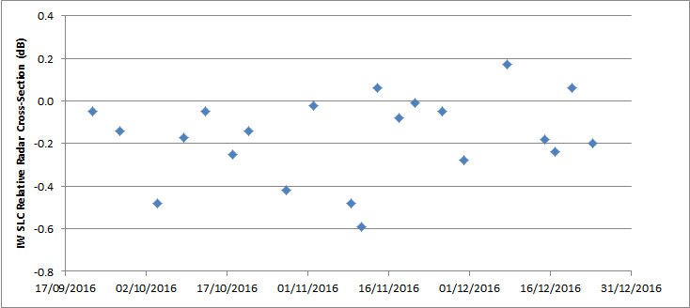

**Figure 78: IW SLC Relative Radar Cross-Section for the BAE Corner Reflector**

An array of 40 corner reflectors has been deployed near Brisbane, Australia as a component of the Australian Geophysical Observing System (AGOS) – see [S1-RD-04], [S1-RD-06] for further details. The CRs of are size 1.5m (34), 2.0m (3) and 2.5m (3) with fixed orientations. Given that these corner reflectors have a fixed elevation and azimuth orientation they will not be pointing directly at S1-B. However, for IW acquisitions the reduction in radar cross-section compared to the case of a perfect orientation is small at less than 0.05dB. Table 12 gives the radiometric accuracy and stability for all corner reflector measurements during 2016 together with results for IW1 and IW2 sub-swaths and for VV and HH polarisations. The numbers in brackets refer to the number of measurements. The results indicate an accuracy close to zero while the stability is less than 0.5dB.

|  |  |  |  |  |  |  |
| --- | --- | --- | --- | --- | --- | --- |
| All | IW1 | IW2 | IW1 VV | IW1 HH | IW2 VV | IW2 HH |
| 0.14±0.43 (164) | 0.23±0.40 (98) | 0.01±0.45 (66) |  | 0.23±0.40 (98) |  | 0.01±0.45 (66) |

Table 30: IW SLC Relative Radar Cross-Section for the Australian Corner Reflectors (dB)

#### Permanent Scatter Calibration

No Permanent Scatter Calibration series have been generated yet due to the limit number of S1B acquisitions so far.

### Geometric Calibration

Geometric calibration of S1-B was performed by the University of Zurich (UZH) on the basis of a time series of products acquired between June and September 2016 over two test sites in Switzerland: *Torny-le-Grand* and *Dübendorf*. Trihedral corner reflectors (CRs) whose positions were surveyed with cm-level accuracy were used as reference targets. For calibration purposes, we initially focussed on StripMap (SM) products, as these have the best resolution and represent the native sensor characteristics more closely than other product types. Geolocation accuracy was estimated for IW and EW SLC products as well, also acquired over the same two test sites in 2016. For comparison, S1-A product geolocation estimates were made as well, during the S1-B commissioning. The S1-A results are shown and discussed in 4.2.4.

For a particular CR visible in an S1-B image product, its predicted azimuth and slant range image pixel position was calculated as follows:

• The surveyed CR position was adjusted for acquisition-time “epoch” plate **tectonic drift** and **solid Earth tide** (SET), as described in [S1-RD-06].

• The relevant timing annotations were extracted from the product annotations; these included the azimuth zero-Doppler time stamps, the orbital state vectors, the near-range fast time, and the range and azimuth sample spacings.

• Range-Doppler geolocation was performed for the CR coordinate as described e.g. in [S1-RD-08], giving range and azimuth times as the output.

• The slant range prediction was corrected by adding the modelled **atmospheric path delay**, and the azimuth time was corrected by subtracting the **bistatic** residual. These effects and their associated corrections are described in more detail in [S1-RD-06].

The above steps resulted in a range-azimuth *predicted* position for each target that could be compared to the position of the peak intensity in the image raster itself, i.e., the *measured* CR position. The differences between predicted and measured positions were then plotted, with the results shown for the SM, IW and EW SLC product time series in **Figure 79**, with product date ranges indicated. Please refer to [S1-RD-06] and [S1-RD-07] for details on the evolution of the standard IPF processing and the geolocation methodology.

The ALE estimates were originally made using StripMap data acquired and processed during the S1-B commissioning phase. The initial geolocation result based on SM SLC products served as a basis for an update to the Sampling Window Start Time (SWST) bias annotation in the instrument auxiliary files ingested by the S1 processor. All S1-B products processed after September 21, 2016 used the updated SWST bias. The plots shown in **Figure 79** show the ALE estimates as they appear *after* accounting for the respective SWST biases (either in the S1 processor itself, or during post-processing). Note that no analogous azimuth timing correction has yet been incorporated into the processor.

**Figure 79**(a) shows the SM SLC ALE plots for S1-B. Although the mean range offset is very small, is not exactly zero even though the official SWST bias was applied during geolocation estimation. This is because six products were acquired *after* the original SWST bias estimation, and contributed to the ~6 mm range offset in **Figure 79**(a).

The SM SLC azimuth offset is ~1.9 m. Two apparent outliers in the S1-B plot in **Figure 79**(a) can be seen with larger azimuth offsets than expected. No convincing explanation for the offset positions of these two points – from July 2016 products just two days apart – could be found.

The S1-B IW SLC plot is shown in **Figure 79**(b). The clear grouping of the points by subswath is a known issue under continued investigation. Some indication of a similar beam-specific grouping can be seen in the SM SLC plots as well (**Figure 79**(a)).

**Figure 79**(c) shows the EW SLC ALE scatter. In spite of the higher spread caused by the coarser sample spacing, a similar pattern emerges to the IW case: subswath-specific azimuth offsets, and relatively consistent range geolocation.

The ALE plots in **Figure 79** indicate that given bias compensations, the localisation performance was well within the original requirements (according to sections 5.5.2.1 and 5.5.2.2 in [S1-RD-09]). The observed beam/subswath-dependent azimuth ALE remains under investigation. A method for integrating azimuth bias compensation annotations in the IPF is under study.

|  |  |
| --- | --- |
|  |  |
| (a) S1-B SM SLC (2016.06.17 – 2016.09.16) | (b) S1-B IW SLC (2016.05.17 – 2016.12.29) |
|  | |
| (c) S1-B EW SLC (2016.06.25 – 2016.12.21) | |
| **Figure 79: ALE estimates for S1-B StripMap, IW and EW SLC product time series acquired over the Swiss test sites using precise state vectors (AUX\_POEORB). Product date ranges are given in brackets. Point colours represent beam/subswath. The SWST (range) bias (output of the commissioning and calibration phase) was applied in all cases.** | |



### Polarimetric Calibration

#### Gain Imbalance

The DLR transponders and acquisitions since the start of the routine phase in September 2016 have been used to calculate the gain imbalance (the difference in radar cross-section between the two polarisations of dual polarisation products). Table 13 give a summary of the gain imbalance for the IW and EW modes (there were no SM acquisitions).

|  |  |
| --- | --- |
|  | Gain Imbalance (dB) |
| IW | 0.01±0.18 (8) |
| EW | -0.03±0.25 (74) |

**Table 31: Gain Imbalance using the DLR transponders**

The following results show the gain imbalance split between the two possible polarisation of VH/VV and HH/HV. Figure 27 and Table 14 give the gain imbalance for IW and EW modes.

|  |
| --- |
|  |
|  |

**Figure 80: Gain Imbalance using the DLR transponders.**

|  |  |  |
| --- | --- | --- |
|  | VH/VV | HV/HH |
| IW | 0.01±0.18 (8) |  |
| EW | -0.08±0.27 (39) | -0.04±0.22 (35) |

**Table 32: Gain Imbalance using the DLR transponders**

#### Phase Imbalance

The DLR transponders have been used to calculate the phase imbalance (the difference in peak phase between the two polarisations of dual polarisation products). Figure 28 and Table 15 give the gain imbalance for IW and EW for acquisitions start of the routine phase in September 2016. As expected the phase difference is close to zero.

|  |
| --- |
|  |

**Figure 81: Phase Imbalance using the DLR transponders.**

|  |  |
| --- | --- |
|  | Phase Difference (°) |
| IW | 0.54±0.77 (8) |
| EW | -1.76±2.80 (74) |

**Table 33: Phase Imbalance using the DLR transponders**

#### Coregistration

No specific coregistration measurements were performed since the start of the S1-B routine phase in September 2016. Measurements below are re-produced from the S1-B MPC Commissioning Phase Report [S1-RD-02].

The point targets used for the coregistration analysis are either the ESA or DLR transponder as they both provide an impulse response in both polarisations of dual polarisation imagery. Figure 82 shows examples of SM, IW & EW co-registration for ESA and DLR transponders (for the ESA transponder, the images shown are at full resolution while for the DLR transponders, oversampled images are shown). In all three examples the co-registration was zero in both range and azimuth. Table 34 below shows that the average measured polarimetic co-registration derived from SLC products is very small.

|  |  |
| --- | --- |
|  |  |
| ESA T1 (S2 SLC VH) | ESA NLR (S2 SLC VV) |
|  |  |
| DLR D39 (IW SLC HH) | DLR D39 (IW SLC HV) |
|  |  |
| DLR D39 (EW SLC HH) | DLR D39 (EW SLC HV) |

Figure 82: SLC Co-registration Examples

|  |  |  |  |
| --- | --- | --- | --- |
| Mode | Transponder Range Co-registration (m) | Transponder Range Co-registration (m) | Number of Measurements |
| SM | 0.03±0.09 | 0.05±0.16 | 90 |
| IW | 0.01±0.04 | 0.25±0.62 | 110 |
| EW | 0.05±0.19 | 0.49±1.19 | 60 |

Table 34: SLC Polarimetric Co-registration

#### Cross-talk

No specific coregistration measurements were performed since the start of the S1-B routine phase in September 2016. Measurements below are re-produced from the S1-B MPC Commissioning Phase Report [S1-RD-02].

The point targets used for the cross-talk analysis are either the DLR or BAE trihedral corners reflector as they both provide an impulse response in only one polarisations (HH or VV) of dual polarisation imagery. Figure 83 shows examples of SM, IW & EW cross-talk for DLR corner reflector (the images shown are oversampled): the measured cross-talk for SM is -41.3dB, for IW is -34.14dB while for EW no cross-talk IRF could be identified. As shown in Table 35 below, the average measured cross-talk is very low.

|  |  |
| --- | --- |
|  |  |
| DLR CR D38 (S5 SLC HH) | DLR CR D38 (S5 SLC HV) |
|  |  |
| DLR CR D38 (IW SLC HH) | DLR CR D38 (IW SLC HV) |
|  |  |
| DLR CR D42 (EW SLC HH) | DLR CR D42 (EW SLC HV) |

Figure 83: SLC Cross-talk Examples

|  |  |
| --- | --- |
| Corner Reflector Cross-talk (dB) | Number of Measurements |
| -37.4±4.7 | 11 |

Table 35: SLC Cross-talk

### Elevation Antenna Patterns

No new elevation antenna patterns were derived since the start of the S1-B routine phase in September 2016.

### Azimuth Antenna Patterns

No new azimuth antenna patterns were derived since the start of the S1-B routine phase in September 2016.

### Noise Equivalent Radar Cross-section

No specific Noise Equivalent Radar Cross-Section (NESZ) measurements were performed since the start of the S1-B routine phase in September 2016. Measurements below are re-produced from the S1-B MPC Commissioning Phase Report [S1-RD-02].

Examples of S1-B imagery with low ocean backscatter have been used to estimate the NESZ for most modes and swaths. These are shown in Figure 84 to Figure 87 for SM, IW, EW and WV modes respectively. For all but WV mode, the majority of the NESZ estimates have been performed in cross-polarisation (HV or VH) as the ocean backscatter is much lower compared to co-polarisation. For WV mode where the imagettes are only acquired in co-polarisation, suitable data has been selected by the extraction of the I and Q channel standard deviation parameter from the product annotation (a low standard deviation indicates a low radar cross-section). In addition to the measured NESZ, all the plots show the predicted NESZ (at low and high orbital altitudes).

In Figure 84 for SM, the measured NESZ are close to the predicted NESZ. In addition, for many SM swaths the measured NESZ exceeds the NESZ requirements of -22 dB. The main exception is S3 where the measured NESZ is -20dB at mid-swath. For some of the other swaths, the requirement is not met at the edges of the swath.

|  |
| --- |
|  |
| S1B\_S1\_GRDH\_1SDH\_20160826T220944\_20160826T221015\_001794\_002AE1\_451F.SAFE |
|  |
| S1B\_S1\_GRDH\_1SDV\_20160826T142337\_20160826T142402\_001789\_002A9E\_DA91.SAFE |
|  |
| S1B\_S2\_GRDH\_1SDH\_20160905T062039\_20160905T062054\_001930\_00309F\_BAAD.SAFE |
|  |
| S1B\_S3\_GRDH\_1SDH\_20160827T164708\_20160827T164732\_001805\_002B57\_CD0D.SAFE |
|  |
| S1B\_S3\_GRDH\_1SDV\_20160831T061321\_20160831T061330\_001857\_002DA2\_23C0.SAFE |
|  |
| S1B\_S4\_GRDF\_1SDV\_20160831T061339\_20160831T061413\_001857\_002DA3\_720C.SAFE |
|  |
| S1B\_S4\_GRDH\_1SDH\_20160726T061338\_20160726T061412\_001332\_0017C3\_30FD.SAFE |
|  |
| S1B\_S5\_SLC\_\_1SDH\_20160717T174817\_20160717T174851\_001208\_0012BC\_C648.SAFE |
|  |
| S1B\_S5\_SLC\_\_1SDV\_20160729T174816\_20160729T174850\_001383\_001976\_8672.SAFE |
|  |
| S1B\_S6\_GRDH\_1SDH\_20160822T145218\_20160822T145246\_001731\_0027F0\_E9CE.SAFE |
|  |
| S1B\_S6\_GRDH\_1SDV\_20160823T140012\_20160823T140037\_001745\_002899\_FB6D.SAFE |
| Figure 84: NESZ measures for SM. Blue is the measured NESZ and the red lines are the predicted NESZ at minimum and maximum orbital altitudes. |

In **Figure 29** for IW and **Figure 30** for EW, the -22 dB requirement is met at all sub-swaths and all off-boresight angles. For some sub-swaths the measured NESZ is slightly worse than the prediction while for other it is close to the prediction.

|  |
| --- |
|  |
| S1B\_IW\_GRDH\_1SDH\_20160824T173245\_20160824T173305\_001762\_002961\_F24D.SAFE |
|  |
| S1B\_IW\_GRDH\_1SDV\_20160822T174824\_20160822T174849\_001733\_002804\_6DD1 |
| **Figure 85: NESZ measures for IW. Blue is the measured NESZ and the red lines are the predicted NESZ at the minimum orbital altitude.** |

|  |
| --- |
|  |
| S1B\_EW\_GRDH\_1SDH\_20160904T054412\_20160904T054512\_001915\_002FF1\_35D0.SAFE |
|  |
| S1B\_EW\_GRDH\_1SDV\_20160721T060456\_20160721T060611\_001259\_0014E6\_9436.SAFE |
| **Figure 86: NESZ measures for EW. Blue is the measured NESZ and the red lines are the predicted NESZ at the minimum orbital altitude.** |

Figure 87 shows the measured WV VV NESZ met the -22 dB requirement and they are all slightly better than the predicted NESZ. Note the NESZ is significantly higher for imagette WV2 than for WV1. For WV1 VV there is some structure in the imagette which accounts for the structure in the NESZ measurement in the far range portion of the imagette. The number after the file name refers to the imagette number within the product. Note that no HH imagettes were available during the S1-B commissioning phase.

|  |
| --- |
|  |
| S1B\_WV\_SLC\_\_1SSV\_20160814T060509\_20160814T061019\_001609\_0022B2\_3B38.SAFE (17) |
|  |
| S1B\_WV\_SLC\_\_1SSV\_20160815T055021\_20160815T062716\_001623\_00235E\_1623.SAFE (88) |
| **Figure 87: NESZ measures for WV . Blue is e measured NESZ and the red lines are the predicted NESZ at minimum and maximum orbital altitudes.** |

### Summary of Anomalies

#### Radio Frequency Interference

As observed for S1-A, a small percentage of S1-B imagery is affected by the presence of Radio Frequency Interference from the ground. An example is shown below. Usually RFI only affects a few range lines of raw data.

|  |
| --- |
|  |
| S1B\_EW\_GRDM\_1ADH\_20160707T191217\_20160707T191322\_001063\_000CDF\_5F73.SAFE |

**Figure 88: An example of Radio Frequency Interference**

#### Radarsat-2/Sentinel1-A Mutual Interference

Also as observed for S1-A, a small percentage of S1-B imagery is affected by mutual interference between S1-B and Radarsat-2. An example is shown below:

|  |
| --- |
|  |

**Figure 89: An example of Radarsat-2/Sentinel1-A Interference (2nd July 2016)**

### Quality Disclaimers

Quality disclaimers issued during 2015 are given in Appendix H.

## S1-B Level 2 products

### Wind measurement

#### Image Mode (SM-IW-EW)

The SAR wind measurement is strongly dependant of the product calibration accuracy. Before the products delivery to the end user, the L1 processing parameters has been optimized in order to improve beam to beam of set, EAP ... It takes benefit from the efforts made on the SAR Level1 products to improve the calibration constant and align the gamma profile as the function of the elevation angle over Rain Forest. These improvements reduce the wind measurements error belong the subswath and subswath by subswath.

Statement of the wind measurements accuracy:

The strategy to assess the accuracy of the wind retrieval is the same as S1A, consisting in comparing it with an auxiliary wind source (buoys, scaterrometters, atmospherical model...) which is used as a reference.

|  |  |  |  |  |  |
| --- | --- | --- | --- | --- | --- |
| F:\CalValS1\sentinel-1a\coloc_aromev2\201610_11_12_13\IW_VV\speed_speed\spd_vs_spd_all_incidence_angles.png   1. Arome | F:\CalValS1\sentinel-1a\coloc_arpegeHR\201610_11_12_13\IW_VV\speed_speed\spd_vs_spd_all_incidence_angles.png  b) Arpege HR | | | | |
| F:\CalValS1\sentinel-1a\coloc_ecmwf-0125\201610_11_12_13\IW_VV\speed_speed\spd_vs_spd_all_incidence_angles.png  c) ECMWF |  |  |  |  |  |
|  |  | bias | Rms |  |
|  | Arome | -0.49 m/s | 1.90 m/s |  |
|  | Arpege | -0.61 m/s | 2.01 m/s |  |
|  | ECMWF | -0.27m/s | 1.66 m/s |  |
|  |  |  |  |  |
|  |  |  |  |  |



**Figure 35** presents the performances achieved on the last months of 2016 (October/Novemeber/December) for IW mode in VV polarisation of the retrieved wind compared to model references (Arome, Arpege and ECMWF). The statistics are close to the ones observed on S-1A. It can be noticed the strong correlation of the SAR-derived wind speeds with the wind references. The bias and the RMS are less important for ECMWF re-analysis since the wind inversion is based on the ECMWF forecast as an a priori wind input. A typical RMS of 1.5m/s to 2m/s is observed. The quality of the wind product derived for this mode is fairly good. Same kind of performances (bias nearly equal to zero and RMS of about 2m/s) is achieved on EW HH mode.

|  |  |  |  |  |  |  |
| --- | --- | --- | --- | --- | --- | --- |
| F:\CalValS1\sentinel-1b\coloc_aromev2\201610_11_12_13\IW_VV\speed_speed\spd_vs_spd_all_incidence_angles.png   1. Arome | F:\CalValS1\sentinel-1b\coloc_arpegeHR\201610_11_12_13\IW_VV\speed_speed\spd_vs_spd_all_incidence_angles.png  b) Arpege HR | | | | | |
| F:\CalValS1\sentinel-1b\coloc_ecmwf-0125\201610_11_12_13\IW_VV\speed_speed\spd_vs_spd_all_incidence_angles.png  c) ECMWF |  | |  |  |  |  |
|  | |  | bias | Rms |  |
|  | Arome | | -0.65 m/s | 1.74m/s |  |
|  | Arpege | | -0.51 m/s | 1.64 m/s |  |
|  | ECMWF | | -0.41m/s | 1.58 m/s |  |
|  |  | |  |  |  |
|  |  | |  |  |  |

**Figure 90: SAR Wind speed compared with reference wind speed for IW mode VV polarization.**

Improvement performed during 2016:

The data delivery to the end users has happened end September no change in the configuration and processing has been done since.

Coming Improvements for 2017:

No changes specific to S1-B is planned during 2017. The changes described on S-1A Wind measurement assessment paragraph are related to the processor and then will be applied on S-1B as well. Please refer to this section 4.3.1.1 for more details

#### Wave Mode

2016 also offers the first data set for Sentinel-1 B. However, the commissioning phase officially ended 9 months after the launch date, the 25th of November 2016. A preliminary assessment of the Level-2 products performances is thus possible relying on December.

For level-2 products as measured by Sentinel-1 B, the major changes are:

* Update of the processing gains coefficients. This mostly impacts performances on ocean surface wind speed (owiWindSpeed)

As shown on Figure 91 and Figure 92, the wave mode has been activated at global scale over the oceans since July, producing a comprehensive number (between ~20000 and 27000 for both WV1 and WV2 each month) of acquisitions every cycle.

Figure 91 shows the monthly performances with respect to time in 2016 for WV1 and WV2 (Figure 92). Top panel presents the bias and the standard deviation for the wind speed. Bottom panel presents the number of acquisitions and bottom panel the mean and median wind speed from ECMWF model. The bias is computed by comparing the wind speed from Sentinel-1 and the wind speed from ECMWF analysis (3 hours and 0.125 degrees). An example for December 2016 is shown on Figure 93 and Figure 94. Figure 91 shows a significant change in the wind speed bias after September 2016. This corresponds to a change in the processing gain coefficients. We observe that after September 2016 bias remain lower than -0.2 m/s and around 0. m/s, respectively for WV1 and WV2. Standard deviation values are lower than 1.7 m/s for both WV1 and WV2. These results are within the specifications and very consistent with Sentinel-1 A. In the contrary of S1A, no trend can be derived from these analyses as the time serie is too short.

|  |  |
| --- | --- |
| Figure 91 | Figure 92 |

*Monthly performances for WV1 (top-left) and WV2 (top-right) and number of acquisitions co-located to reference data for validation for WV1 (bottom-left) and WV2 (bottom- right). For top panels, colored thick solid lines stand for the mean difference between Sentinel-1 and ECMWF model wind speeds. Color thin solid lines are for standard deviation.*

|  |  |
| --- | --- |
| Figure 93 scatter plot of wind speed for S1B WV1 versus ECMWF | Figure 94 scatter plot of wind speed for S1B WV2 versus ECMWF |

*Sentinel-1 B wind speed versus ECMWF wind speed. Results for WV1 are on the left panel whereas results for WV2 are on the right panel*

**Coming improvements for 2017:**

Further analysis will be conducted to monitor the quality of the wind speed (owiWindSpeed) with respect to time. A complete year will allow to exhibit possible seasonal trend or drift in the performances.

### Swell Measurement

#### Wave Mode

|  |  |
| --- | --- |
| Figure 95 Swell performances S1B WV1 | Figure 96 Swell performances S1B WV2 |

*Ocean swell monthly performances for WV1 (top-left) and WV2 (top-right) and number of acquisitions co-located to reference data for validation for WV1 (bottom-left) and WV2 (bottom- right). For top panels, colored thick solid lines stand for the mean difference between effective significant wave height from Sentinel-1 and from WW3 model. Colored thin solid lines are for standard deviation.*

|  |  |
| --- | --- |
| Figure 97: Significant wave height for the long waves performances for December 2016 in Wave Mode 1. The model outputs from WW3 are considered as reference here. This is only valid from a statistical point of view. | Figure 98: Significant wave height for the long waves performances for December 2016 in Wave Mode 2. The model outputs from WW3 are considered as reference here. This is only valid from a statistical point of view. |

Text to add here

### Radial Velocity Measurement

#### Wave Mode

The radial velocity measurement is derived from the Geophysical Doppler anomaly. In the S-1 IPF, this geophysical Doppler is estimated by:



where:

* FdcSAR is estimated from the SAR data
* FdcOcean is the component related to the ocean radial velocities.
* FdcAttitude is estimated from the geometry knowledge (quaternion based)
* Fdcantenna is the antenna contribution related to TRM drifts, failures, misalignements, etc

At global scale, the expected relationship between the geophysical Doppler and the sea state (or ocean surface wind vector) is well known since Envisat/ASAR. The performances of the geophysical Doppler are assessed by estimating the bias between the expected Doppler given the sea state conditions (provided by ECMWF) and the geophysical Doppler as included in the Level 2 products.

Statement of the ocean surface radial velocities measurements accuracy:

Figure 46 shows the geophysical Doppler as included in the Level 2 products as a function of radial wind speed (wind speed projected in the line of sight of the radar). The colour code indicates the latitude. As observed, the Doppler and the radial wind speed are strongly correlated for both WV1 and WV2. However, the colour code indicates a clear and non-geophysical dependence to the latitude. In addition, Doppler is not 0 Hz (as it should be) when radial wind speed is 0 m/s for WV1 and WV2. This shows that the Doppler shift as processed at PDGS is not only related to ocean surface radial velocities. This prevents us for getting any quantitative geophysical signature such as ocean surface currents in the product.



**Figure 99: Geophysical Doppler as included in the Level 2 products as a function of radial wind speed (wind speed projected in the line of sight of the radar) for WV1 (left) and WV2 (right). The colour code indicates the latitude.**

Improvement performed during 2015:

In 2015 the daily monitoring of this relationship allowed us to show the residual Doppler from the instrument/platform contribution (FdcAttitude and/or Fdcantenna) in geophysical Doppler. In particular, our systematic analysis revealed a contamination with respect to latitude in the geophysical Doppler. Complementary acquisition in WM over land where the geophysical Doppler is expected to be zero showed the same results. Figure 47 shows the bias as a function of latitude estimated both over ocean (blue) and land (brown). In spite of the low number of available acquisitions over land, both show Doppler variation up to 30 Hz. As observed on Figure 6, expected the geophysical signature is expected to be between -60 and 60 Hz. 30 Hz of contamination is thus far too much for ocean current applications.



**Figure 100**: **Doppler bias as a function of latitude estimated over ocean (blue) and land (brown).**

The differences (around 10Hz) observed in the land Doppler between wv1 and wv2 can be well predicted by the recent antenna model as shown in **Erreur ! Source du renvoi introuvable.**.

A dedicated investigation was performed to understand the attitude DC of the Sentinel 1b mission. One month (October 2016) of S1B WV data were used. A data driven approach to simultaneously model and solve for the geophysical and geometric DC were developed, implemented and validated. The model performance shows an accuracy of predicting the attitude DC to around 3Hz when compared to land data (see next plot).

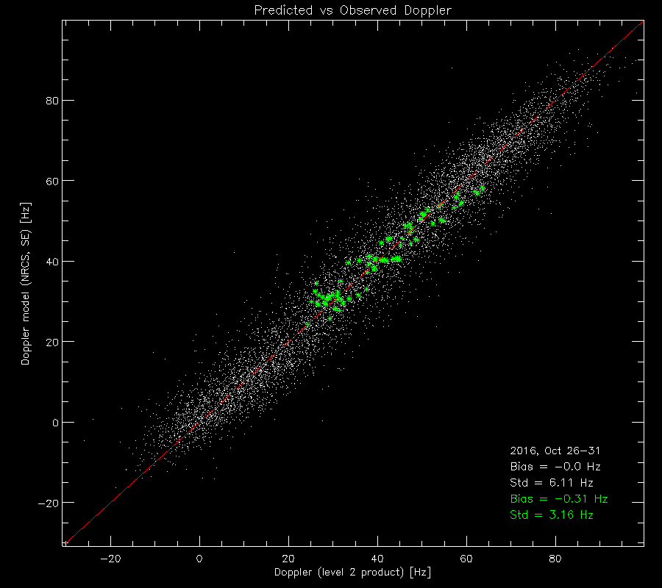

**Figure 101**: Scatterplot of total DC model versus measured DC from the period of 26-31 October 2016 from S1b acquired in WV1. The green dots are data acquired over land areas.

The data driven approach revealed oscillations in the attitude DC on orbit scale with amplitude of up to 20Hz and main period of around 400 sec. The estimated geometric DC has been compared with attitude DC computed directly from restituted quaternions provide by ESA. The comparison is shown in next figure.

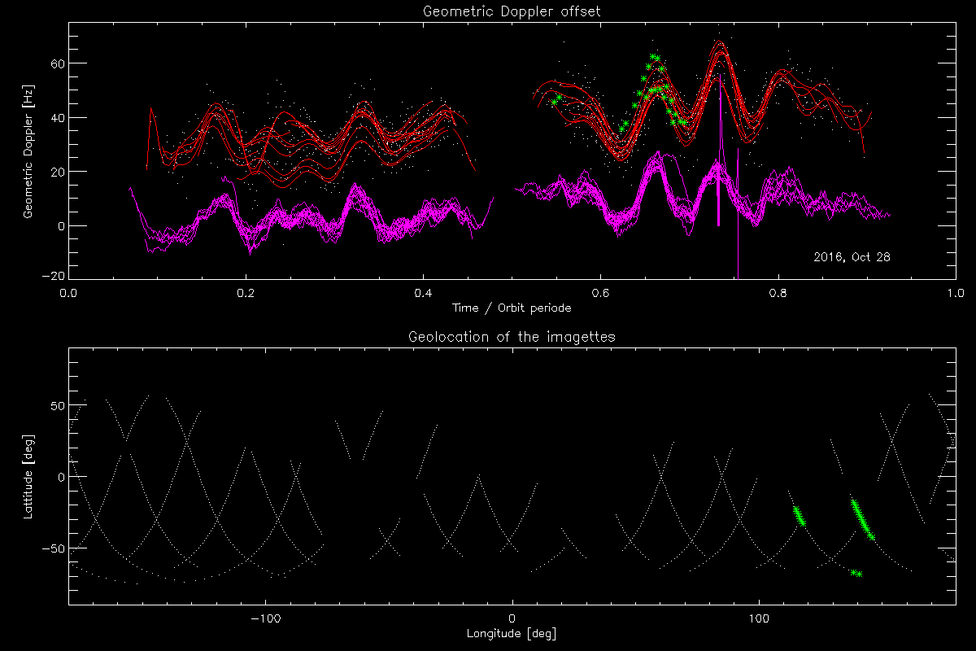

**Figure 102**: Upper: Geometric Doppler computed from data (red) and from restituted attitude data (pink) for 28 October 2016 for Sentinel 1b WV1. Lower: Location of tracks. The green points are data acquired over land areas.

#### TOPS Mode

Statement of the ocean surface radial velocities measurements accuracy:

As for Wave Mode, the contamination of the geophysical Doppler by the geometry knowledge (quaternion based) and the antenna contribution prevents us for getting any quantitative geophysical signature such as ocean surface currents in the product. Nevertheless, in cases where land areas are present in the image an ad-hoc DC calibration has been performed. An example is shown in next figure.

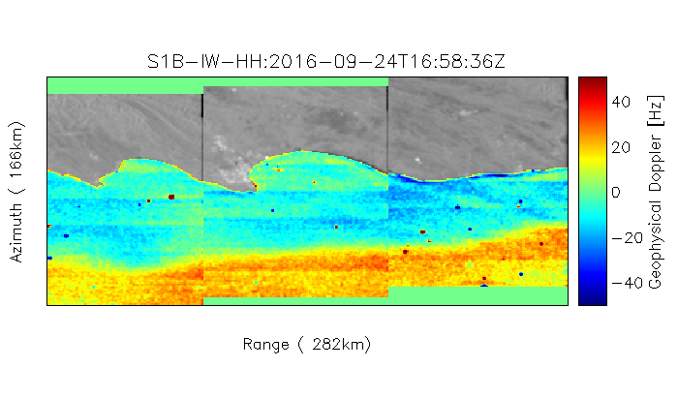

**Figure 103: Doppler anomaly field from Sentinel 1B IW OCN RVL product acquired over Agulhas in ascending mode. Here land areas are used to calibrate the Doppler. A clear signature of the Agulhas current is observed.**

Azimuth scalloping in the DC over the bursts are also observed in S1B. This is similar to what is observed in S1A IW and EW modes. The scalloping is quantified to be around ±5 Hz amplitude as shown in next figure.

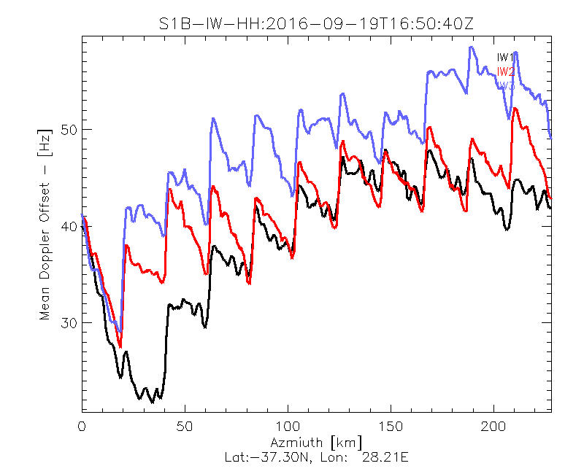

**Figure 104: S1B IW OCN RVL mean DC bias as function of azimuth pixel. Data acquired over ocean areas.**

Improvement performed during 2016:

Efforts are undertaken to better predict and compensate the measured Doppler for the electromagnetic (EM) Doppler bias introduced by the skewness of the antenna elevation pattern. A new version of the antenna model parameters ha been ingested into the Level 2 processor and the EM Doppler bias over IW and EW swaths are compared with the data driven Doppler estimated over rain forest areas (see next figure).

We note that the performance of the antenna model is not as good as for S1A.

|  |  |  |  |  |  |
| --- | --- | --- | --- | --- | --- |
| |  |  | | --- | --- | | S1B_EW_RVL__0SHH_20161005T230131_dcObsRaProfiles.png  a) | S1B_EW_RVL__0SVV_20161004T100321_dcObsRaProfiles.png  b) | | S1B_IW_RVL__0SDH_20161007T224507_dcObsRaProfiles.png  c) | S1B_IW_RVL__0SDV_20161009T101223_dcObsRaProfiles.png  d) | |  |
|  |  |

**Figure 105: S1B EM DC offset computed from antenna model (full line) with error matrix corresponding to the day of acquisition, and estimated from rain forest data using the Level 2 processor (\*\*\*). A) EW mode in HH-polarisation, B) EW mode in VV-polarisation, C) IW mode in HH-polarisation, D) IW mode in VV-polarisation**

Coming Improvements for 2017:

Improve the descalloping of S1B IW and EW OCN DC data.

### Geophysical Calibration

#### Wave Mode

|  |
| --- |
| Figure 106 Sentinel-1B geophysical calibration constant given by CMOD-IFRv2 for WV1 VV polarization between 50° and -50° latitude. Panel 1 shows the mean bias between ECMWF and Sentinel-1B. Panel 2 shows the bias standard deviation. Panel 3 shows the number of SAF SAFE used to perform the analysis. |
| Figure 107 Sentinel-1B geophysical calibration constant given by CMOD-IFRv2 for WV2 VV polarization between 50° and -50° latitude. Panel 1 shows the mean bias between ECMWF and Sentinel-1B. Panel 2 shows the bias standard deviation. Panel 3 shows the number of SAFE used. |

As shown in Figure 106 and Figure 107 , S1B calibration has been corrected during the first 4 months (June-Sept) to reach values around 0dB in December. As for S1A calibration, there is a standard deviation bump (~0.1dB) occurring during Oct-Nov-December. No particular performance differences regarding the incidence angles. Impossible to status on a potential drift since the time series are too short.

# S1-A and S1-B Cross-comparison

## Cross-platform Permanent Scatter Calibration

The following shows a recent IW VV Permanent Scatter Calibration series over Paris. The series covers the whole 2016 and includes both S1A and S1B acquisitions, in order to perform a cross-calibration between the sensors. The blue dots (S1A) show, after the tile 11 issue (June 2016), a small reduction of the calibration constant (about 0.1 dB). The red dots show that the calibration constant for S1B is around 0.05 dB. The S1B calibration constant is well aligned with S1A values before tile 11 issue. After the issue a very small radiometric imbalance can be observed (around 0.15 dB).

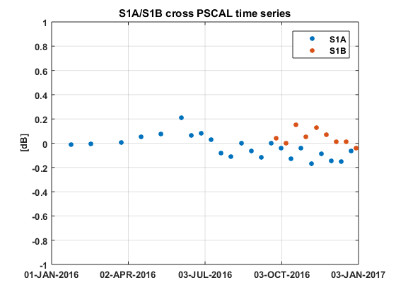

Figure 108 PSCAL time series for IW DV acquisitions over Paris. The color represents the sensor.

## Cross-interferometry burst synchronization

The burst synchronization between repeat pass interferometric acquisitions is relevant for the TOPSAR modes (IW and EW) to provide an indication of the quality of the interferometric phase that can be expected. The SAR acquisition start time is planned over a discrete set of points round orbit with precision down to milliseconds. The performance of the synchronization is monitored by the PDGS OBS tool.

The S1A and S1B constellation offers the possibility to perform repeat pass interferometry at 6 days temporal baseline. The following figure shows the S1B vs. S1A burst synchronization over time for IW and EW mode. Each dot represents a S1B repeat pass acquisition, considering as reference cycle number the S1A cycle number 60 (30 September - 12 October 2015). Note that overall synchronization, even thought slightly worse than single sensor, is still very good.

Figure 110 shows the S1B vs. S1A burst synchronization distribution for IW and EW separately. It can be noticed that the synchronization is above 98% for most of the acquisitions.

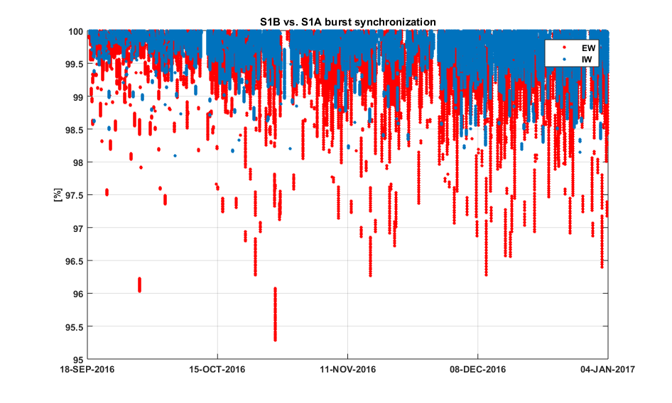

Figure 109 S1B vs. S1A burst synchronization since the end of the Commissioning Phase.

|  |  |
| --- | --- |
|  |  |

**Figure 110 S1B vs. S1A burst synchronization statistics for IW (left) and EW (right).**

## Absolute Calibration

1. List of Acronyms

|  |  |
| --- | --- |
| AD | Applicable Document |
| ADF | Auxiliary Data File |
| RD | Reference Document |
| TBC | To be confirmed |
| TBD | To be defined |
| TRM | Transmit Receive Module |

1. ESA S1-A & S1-B Technical Reports

The following ESA S1-A & S1-B Technical Reports were issued during 2016:

* Sentinel-1A Tile #11 Failure, OI-MPC-OTH-0324, Issue 1.2, October 2016
* Sentinel-1A Debris Collision, DI-MPC-ACR-0352, Issue 1.0, October 2016

1. S1-A Orbit Cycles

The table below gives the cycle number with start and stop acquisition dates during 2016. The start of a cycle is at approximately 18:00 UT on the dates below.

|  |  |  |
| --- | --- | --- |
| **Cycle** | **Start Date** | **End Date** |
| 69 | 16/01/2016 | 28/01/2016 |
| 70 | 28/01/2016 | 09/02/2016 |
| 71 | 09/02/2016 | 21/02/2016 |
| 72 | 21/02/2016 | 04/03/2016 |
| 73 | 04/03/2016 | 16/03/2016 |
| 74 | 16/03/2016 | 28/03/2016 |
| 75 | 28/03/2016 | 09/04/2016 |
| 76 | 09/04/2016 | 21/04/2016 |
| 77 | 21/04/2016 | 03/05/2016 |
| 78 | 03/05/2016 | 15/05/2016 |
| 79 | 15/05/2016 | 27/05/2016 |
| 80 | 27/05/2016 | 08/06/2016 |
| 81 | 08/06/2016 | 20/06/2016 |
| 82 | 20/06/2016 | 02/07/2016 |
| 83 | 02/07/2016 | 14/07/2016 |
| 84 | 14/07/2016 | 26/07/2016 |
| 85 | 26/07/2016 | 07/08/2016 |
| 86 | 07/08/2016 | 19/08/2016 |
| 87 | 19/08/2016 | 31/08/2016 |
| 88 | 31/08/2016 | 12/09/2016 |
| 89 | 12/09/2016 | 24/09/2016 |
| 90 | 24/09/2016 | 06/10/2016 |
| 91 | 06/10/2016 | 18/10/2016 |
| 92 | 18/10/2016 | 30/10/2016 |
| 93 | 30/10/2016 | 11/11/2016 |
| 94 | 11/11/2016 | 23/11/2016 |
| 95 | 23/11/2016 | 05/12/2016 |
| 96 | 05/12/2016 | 17/12/2016 |
| 97 | 17/12/2016 | 29/12/2016 |
| 98 | 29/12/2016 | 10/01/2017 |

1. S1-A Transmit Receive Module Failures

The following S1-A antenna Transmit/Receive Modules (TRMs) failed during 2016 (a full list since launch can be found in Appendix B of any S1-A N-Cyclic Performance Report):

|  |  |  |
| --- | --- | --- |
| **TRM** | **Description** | **Date of Failure** |
| Tile 11, Rows 1 to 10 | Tx H, Tx V | 16 June - 27 June 2016 |

1. S1-A Instrument Unavailability

The S1-A instrument was unavailable during 2015 (a full list since launch can be found in Appendix C of any S1-A N-Cyclic Performance Report):

| **Start Date/Time** | **End Date/Time** | **MPC Reference** | **Summary** |
| --- | --- | --- | --- |
| 20/01/2015 07:30 | 20/01/2015 18:00 | [SOB-112](http://jira.cls.fr:8080/browse/SOB-112) | Sentinel-1A Unavailability - Planned maintenance |
| 01/02/2015 07:50 | 02/02/2015 16:26 | [SOB-116](http://jira.cls.fr:8080/browse/SOB-116) | Sentinel-1A unavailability from 01/02/2015 7h50 to 02/02/2015 16h27 |
| 17/02/2015 19:56 | 18/02/2015 16:02 | [SOB-118](http://jira-ext.cls.fr/browse/SOB-118) | [Sentinel-1A Unavailability - since 17/02/15 evening to 18/02/15 afternoon](http://jira-ext.cls.fr/browse/SOB-118) |
| 19/02/2015 13:29 | 20/02/201510:15 | [SOB-121](http://jira-ext.cls.fr/browse/SOB-121) | [Sentinel-1A unavailability from 19/02/2015 13h29 to 20/02/2015 10h15](http://jira-ext.cls.fr/browse/SOB-121) |
| 14/04/2015 08:30 | 14/04/2015 17:00 | SOB-147 | [Sentinel-1A unavailability planned on 14/04/2015 for maintenance](http://jira-ext.cls.fr/browse/SOB-147) |
| 09/05/2015 23:19 | 10/05/2015 15:39 | SOB-159 | [Sentinel-1A unavailability](http://jira-ext.cls.fr/browse/SOB-147) on 10/05/2015 |
| 19/05/2015 05:00 | 19/05/2015 12:00 | SOB-168 | Sentinel-1A planned unavailability on 19/05/2015 (RDB#4 uplink onboard) |
| 28/05/2015 04:00 | 28/05/2015 14:30 | [SOB-170](http://jira-ext.cls.fr/browse/SOB-170) | [Planned Sentinel-1A unavailability on 28/05/2015 for maintenance purpose](http://jira-ext.cls.fr/browse/SOB-170) |
| 20/06/2015 15:30 | 21/06/2015 13:00 | [SOB-176](http://jira-ext.cls.fr/browse/SOB-176) | [Sentinel-1A unavailability on 20 and 21/06/2015](http://jira-ext.cls.fr/browse/SOB-176) |
| 22/07/2015 06:35 | 22/07/2015 08:21 | [SOB-206](http://jira-ext.cls.fr/browse/SOB-176) | [Sentinel-1A Planned Unavailability](http://jira-ext.cls.fr/browse/SOB-176) (RDB#5) |
| 03/08/2015 02:37 | 03/08/2015 18:33 | SOB-207 | Sentinel-1A Unavailability from orbit 7093 to 7101 |
| 04/08/2015 04:52 | 04/08/2015 13:47 | SOB-208 | Sentinel-1A Unavailability from orbit 7103 to 7114 |
| 04/08/2015 23:44 | 05/08/2015 11:20 | SOB-209 | Sentinel-1A Unavailability from orbit 7120 to 7128 |
| 09/08/2015 21:22 | 10/08/2015 16:14 | SOB-210 | Sentinel-1A Unavailability from orbit 7192 to 7204 |
| 04/09/2015 16:54 | 05/09/2015 11:08 | SOB-214 | Sentinel-1A Unavailability from 04/09 to 05/09/2015 |
| 23/09/2015 07:20 | 23/09/2015 11:56 | SOB-222 | Sentinel-1A Unavailability from orbit 7840 to 7842 |
| 19/10/2015 16:28 | 20/10/2015 07:27 | SOB-226 | Sentinel-1A Unavailability from 19/10 to 20/10/2015 |
| 21/10/2015 14:54 | 22/10/2015 07:12 | SOB-227 | Sentinel-1A Unavailability from 21/10 to 22/10/2015 |
| 05/11/2015 16:50 | 06/11/2015 12:20 | SOB-229 | Sentinel-1A Unavailability from 05/11 to 06/11/2015 |
| 2015-11-07 17:53 | 2015-11-08 12:10 | [SOB-230](http://jira-ext.cls.fr/browse/SOB-230) | [Sentinel-1A Unavailability from 07/11 to 08/11/2015](http://jira-ext.cls.fr/browse/SOB-230) |
| 2015-11-18 07:40 | 2015-11-18 12:28 | [SOB-233](http://jira-ext.cls.fr/browse/SOB-233) | [Sentinel-1A Unavailability on 18/11/2015](http://jira-ext.cls.fr/browse/SOB-233) |
| 29/11/2015 22:54 | 30/11/2015 11:10 | [SOB-251](http://jira-ext.cls.fr/browse/SOB-251) | Sentinel-1A Unavailability from 29/11 to 30/11/2015 |
| 10/12/2015 07:30 | 10/12/2015 13:00 | [SOB-252](http://jira-ext.cls.fr/browse/SOB-252) | Sentinel-1A Planned Unavailability on 10/12/2015 |
| 11/12/2015 02:30 | 11/12/2015 16:00 | [SOB-253](http://jira-ext.cls.fr/browse/SOB-253) | Sentinel-1A Unavailability on 11/12/2015 |

1. S1-A Auxiliary Data Files

The following S1-A Auxiliary Data Files (ADFs) were updated during 2016:

**Instrument ADF (AUX\_INS)**

|  |  |
| --- | --- |
| **ADF** | **Update Reason** |
| S1A\_AUX\_INS\_V20140406T133000\_G20160215T161024.SAFE | Updated PG model and default noise values related to RDB#1. |
| S1A\_AUX\_INS\_V20140616T135500\_G20160215T161549.SAFE | Updated PG model and default noise values related to RDB#2. |
| S1A\_AUX\_INS\_V20140915T100000\_G20160215T161938.SAFE | Updated PG model and default noise values related to RDB#3. |
| S1A\_AUX\_INS\_V20150519T120000\_G20160215T162440.SAFE | Updated PG model and default noise values related to RDB#4. |
| S1A\_AUX\_INS\_V20150722T120000\_G20160215T163523.SAFE | Updated PG model and default noise values related to RDB#5. |

**Calibration ADF (AUX\_CAL)**

|  |  |
| --- | --- |
| **ADF** | **Update Reason** |
|  |  |

**L1 Processor Parameters ADF (AUX\_PP1)**

|  |  |
| --- | --- |
| **ADF** | **Update Reason** |
| S1A\_AUX\_PP1\_V20150722T120000\_G20160413T100954.SAFE | Update of IPF internal configuration parameters (aziFilterLength and aziFftOversampFactor). Related to RDB#5. |
| S1A\_AUX\_PP1\_V20150519T120000\_G20160413T100930.SAFE | Update of IPF internal configuration parameters (aziFilterLength and aziFftOversampFactor). Related to RDB#4. |
| S1A\_AUX\_PP1\_V20140908T000000\_G20160413T100901.SAFE | Update of IPF internal configuration parameters (aziFilterLength and aziFftOversampFactor). Related to RDB#3. |
| S1A\_AUX\_PP1\_V20140616T133700\_G20160413T100821.SAFE | Update of IPF internal configuration parameters (aziFilterLength and aziFftOversampFactor). Related to RDB#2. |
| S1A\_AUX\_PP1\_V20140402T000000\_G20160413T100648.SAFE | Update of IPF internal configuration parameters (aziFilterLength and aziFftOversampFactor). Related to RDB#1. |
| S1A\_AUX\_PP1\_V20150722T120000\_G20160517T085710.SAFE | Update of the processing gains to improve WV calibration on VV polarization. Related to RDB#5. |
| S1A\_AUX\_PP1\_V20150519T120000\_G20160517T085640.SAFE | Update of the processing gains to improve WV calibration on VV polarization. Related to RDB#4. |
| S1A\_AUX\_PP1\_V20140908T000000\_G20160517T085612.SAFE | Update of the processing gains to improve WV calibration on VV polarization. Related to RDB#3. |
| S1A\_AUX\_PP1\_V20140616T133700\_G20160517T085546.SAFE | Update of the processing gains to improve WV calibration on VV polarization. Related to RDB#2. |
| S1A\_AUX\_PP1\_V20140402T000000\_G20160517T085509.SAFE | Update of the processing gains to improve WV calibration on VV polarization. Related to RDB#1. |

**L2 Processor Parameters ADF (AUX\_PP2)**

|  |  |
| --- | --- |
| **ADF** | **Update Reason** |
|  |  |

**Simulated Cross Spectra ADF (AUX\_SCS)**

|  |  |
| --- | --- |
| **ADF** | **Update Reason** |
| S1\_\_AUX\_SCS\_V20150722T120000\_G20160413T105410.SAFE | Introduction of AUX\_SCS. Related to RDB#5. |
| S1\_\_AUX\_SCS\_V20150519T120000\_G20160413T105253.SAFE | Introduction of AUX\_SCS. Related to RDB#4. |
| S1\_\_AUX\_SCS\_V20140908T000000\_G20160413T105124.SAFE | Introduction of AUX\_SCS. Related to RDB#3. |
| S1\_\_AUX\_SCS\_V20140616T133700\_G20160413T104849.SAFE | Introduction of AUX\_SCS. Related to RDB#2. |
| S1\_\_AUX\_SCS\_V20140402T000000\_G20160413T103855.SAFE | Introduction of AUX\_SCS. Related to RDB#1. |

1. S1-A Orbit Manoeuvres

The S1-A orbit manoeuvres during 2015 were:

|  |  |  |  |
| --- | --- | --- | --- |
| **Start Date** | **Start Time** | **Stop Date** | **Stop Time** |
| 14/01/2015 | 23:46:39.692 | 14/01/2015 | 23:47:05.817 |
| 16/01/2015 | 12:30:16.912 | 16/01/2015 | 12:30:44.287 |
| 16/01/2015 | 14:09:01.512 | 16/01/2015 | 14:09:28.887 |
| 16/01/2015 | 15:47:44.900 | 16/01/2015 | 15:48:14.900 |
| 16/01/2015 | 17:26:29.500 | 16/01/2015 | 17:26:59.500 |
| 21/01/2015 | 21:15:52.190 | 21/01/2015 | 21:19:02.940 |
| 22/01/2015 | 00:29:29.776 | 22/01/2015 | 00:29:35.276 |
| 29/01/2015 | 01:08:33.913 | 29/01/2015 | 01:08:54.538 |
| 01/02/2015 | 06:13:38.790 | 01/02/2015 | 06:14:08.915 |
| 02/02/2015 | 23:05:06.821 | 02/02/2015 | 23:05:35.196 |
| 03/02/2015 | 00:43:51.441 | 03/02/2015 | 00:44:19.816 |
| 05/02/2015 | 00:45:32.808 | 05/02/2015 | 00:45:53.433 |
| 05/02/2015 | 01:35:25.984 | 05/02/2015 | 01:35:46.609 |
| 05/02/2015 | 02:25:08.958 | 05/02/2015 | 02:25:29.583 |
| 12/02/2015 | 00:18:53.830 | 12/02/2015 | 00:19:11.955 |
| 12/02/2015 | 01:08:30.526 | 12/02/2015 | 01:08:46.401 |
| 19/02/2015 | 00:22:25.643 | 19/02/2015 | 00:22:30.768 |
| 19/02/2015 | 01:11:52.073 | 19/02/2015 | 01:11:57.448 |
| 26/02/2015 | 00:14:40.517 | 26/02/2015 | 00:14:45.767 |
| 26/02/2015 | 01:04:07.012 | 26/02/2015 | 01:04:29.887 |
| 05/03/2015 | 00:27:27.017 | 05/03/2015 | 00:27:33.142 |
| 05/03/2015 | 01:16:59.510 | 05/03/2015 | 01:17:13.635 |
| 12/03/2015 | 02:00:24.537 | 12/03/2015 | 02:00:31.287 |
| 12/03/2015 | 02:49:57.910 | 12/03/2015 | 02:50:13.285 |
| 19/03/2015 | 02:42:28.208 | 19/03/2015 | 02:42:46.583 |
| 26/03/2015 | 02:35:36.221 | 26/03/2015 | 02:36:02.721 |
| 02/04/2015 | 02:20:52.984 | 02/04/2015 | 02:21:15.984 |
| 09/04/2015 | 02:17:40.555 | 09/04/2015 | 02:18:06.930 |
| 15/04/2015 | 22:05:31.119 | 15/04/2015 | 22:07:58.619 |
| 15/04/2015 | 23:44:15.669 | 15/04/2015 | 23:46:43.294 |
| 16/04/2015 | 00:37:09.300 | 16/04/2015 | 00:37:35.175 |
| 16/04/2015 | 02:16:19.629 | 16/04/2015 | 02:16:46.129 |
| 22/04/2015 | 22:50:41.630 | 22/04/2015 | 22:51:01.505 |
| 23/04/2015 | 00:29:46.074 | 23/04/2015 | 00:30:05.949 |
| 30/04/2015 | 00:21:13.312 | 30/04/2015 | 00:21:35.687 |
| 30/04/2015 | 01:10:53.519 | 30/04/2015 | 01:11:07.519 |
| 06/05/2015 | 23:23:33.049 | 06/05/2015 | 23:23:46.799 |
| 07/05/2015 | 00:13:13.337 | 07/05/2015 | 00:13:43.337 |
| 13/05/2015 | 21:32:37.334 | 13/05/2015 | 21:35:04.709 |
| 13/05/2015 | 23:11:21.905 | 13/05/2015 | 23:13:49.405 |
| 14/05/2015 | 00:04:45.805 | 14/05/2015 | 00:05:08.930 |
| 14/05/2015 | 01:43:53.381 | 14/05/2015 | 01:44:16.756 |
| 14/05/2015 | 03:23:01.176 | 14/05/2015 | 03:23:24.926 |
| 20/05/2015 | 23:56:32.811 | 20/05/2015 | 23:56:46.561 |
| 24/05/2015 | 15:17:21.730 | 24/05/2015 | 15:17:51.855 |
| 24/05/2015 | 16:56:36.234 | 24/05/2015 | 16:57:03.234 |
| 27/05/2015 | 22:58:53.042 | 27/05/2015 | 22:59:13.042 |
| 27/05/2015 | 23:48:39.586 | 27/05/2015 | 23:49:07.461 |
| 03/06/2015 | 22:01:21.633 | 03/06/2015 | 22:01:50.508 |
| 03/06/2015 | 22:51:08.287 | 03/06/2015 | 22:51:24.037 |
| 11/06/2015 | 01:10:37.541 | 11/06/2015 | 01:11:07.666 |
| 11/06/2015 | 02:00:25.457 | 11/06/2015 | 02:00:36.957 |
| 18/06/2015 | 01:18:56.964 | 18/06/2015 | 01:19:27.089 |
| 18/06/2015 | 02:08:47.948 | 18/06/2015 | 02:09:00.323 |
| 24/06/2015 | 23:09:57.273 | 24/06/2015 | 23:10:26.148 |
| 24/06/2015 | 23:59:15.281 | 24/06/2015 | 23:59:31.906 |
| 09/07/2015 | 00:34:58.485 | 09/07/2015 | 00:35:23.860 |
| 15/07/2015 | 22:46:47.993 | 15/07/2015 | 22:49:13.993 |
| 16/07/2015 | 00:26:45.489 | 16/07/2015 | 00:27:19.614 |
| 16/07/2015 | 01:16:37.140 | 16/07/2015 | 01:17:11.765 |
| 23/07/2015 | 00:18:32.522 | 23/07/2015 | 00:18:53.397 |
| 23/07/2015 | 01:08:11.165 | 23/07/2015 | 01:08:26.915 |
| 29/07/2015 | 22:30:21.053 | 29/07/2015 | 22:32:46.303 |
| 30/07/2015 | 00:59:37.163 | 30/07/2015 | 00:59:39.163 |
| 06/08/2015 | 07:07:42.931 | 06/08/2015 | 07:08:06.806 |
| 06/08/2015 | 08:46:51.175 | 06/08/2015 | 08:47:15.050 |
| 06/08/2015 | 10:25:59.440 | 06/08/2015 | 10:26:29.315 |
| 06/08/2015 | 12:05:13.798 | 06/08/2015 | 12:05:43.673 |
| 12/08/2015 | 22:14:23.418 | 12/08/2015 | 22:15:53.168 |
| 19/08/2015 | 22:04:50.322 | 19/08/2015 | 22:08:59.822 |
| 20/08/2015 | 01:18:55.220 | 20/08/2015 | 01:19:04.720 |
| 20/08/2015 | 02:08:22.689 | 20/08/2015 | 02:08:44.439 |
| 27/08/2015 | 01:58:28.564 | 27/08/2015 | 01:58:35.564 |
| 03/09/2015 | 01:30:44.630 | 03/09/2015 | 01:30:48.505 |
| 03/09/2015 | 02:20:10.409 | 03/09/2015 | 02:20:17.284 |
| 10/09/2015 | 02:18:19.571 | 10/09/2015 | 02:18:23.446 |
| 16/09/2015 | 23:11:49.596 | 16/09/2015 | 23:13:43.221 |
| 24/09/2015 | 01:48:24.015 | 24/09/2015 | 01:48:30.640 |
| 01/10/2015 | 01:33:41.045 | 01/10/2015 | 01:33:51.045 |
| 08/10/2015 | 01:18:30.330 | 08/10/2015 | 01:18:37.955 |
| 15/10/2015 | 01:07:31.834 | 15/10/2015 | 01:07:36.834 |
| 22/10/2015 | 00:53:48.720 | 22/10/2015 | 00:54:06.220 |
| 29/10/2015 | 01:14:33.469 | 29/10/2015 | 01:14:43.719 |
| 04/11/2015 | 23:02:36.981 | 04/11/2015 | 23:06:22.481 |
| 05/11/2015 | 00:44:05.468 | 05/11/2015 | 00:44:36.843 |
| 10/11/2015 | 23:33:51.910 | 10/11/2015 | 23:34:09.410 |
| 19/11/2015 | 01:48:37.314 | 19/11/2015 | 01:48:48.064 |
| 26/11/2015 | 01:38:14.345 | 26/11/2015 | 01:38:26.095 |
| 03/12/2015 | 01:29:35.939 | 03/12/2015 | 01:29:46.314 |
| 10/12/2015 | 00:01:10.813 | 10/12/2015 | 00:03:00.063 |
| 10/12/2015 | 01:37:53.733 | 10/12/2015 | 01:38:09.858 |
| 17/12/2015 | 01:25:41.963 | 17/12/2015 | 01:25:59.963 |
| 24/12/2015 | 01:12:36.906 | 24/12/2015 | 01:12:50.656 |
| 31/12/2015 | 00:59:27.754 | 31/12/2015 | 00:59:33.879 |

1. S1-A Quality Disclaimers

S1-A quality disclaimers were issued during 2015:

|  |  |  |  |  |
| --- | --- | --- | --- | --- |
| **Number** | **Description** | **Start Validity Date** | **End Validity Date** | **Issue Status** |
| 1 | S1A\_WV\_SLC\_1S products filled with zero (black products) | 2014-09-30 15:17:26 UT | 2014-10-03 03:34:01 UT | Issued |
| 2 | Failure on tile amplifier #5 of the receiving antenna | 2014-10-18 15:29:30 UT | 2015-01-20 19:04:54 UT | Issued |
| 3 | Level 1 products processed with incorrect gains | 2014-09-30 15:17:26 UT | 2014-10-03 04:07:54 UT | Issued |
| 4 | Incorrect Cycle Number and Relative orbit number in products processed in PAC2/DPA | 2014-12-09 11:45:25 UT | 2015-01-21 03:53:00 UT | Issued |
| 5 | Failure on Tile amplifier #5 of the receiving antenna from 18/03/2015 and 20/03/2015 | 2015-03-18 04:09:00 UT | 2015-03-20 11:46:30 UT | Issued |
| 6 | Failure on Tile amplifier #5 of the receiving antenna from 26/03/2015 to 28/03/2015 | 2015-03-26 16:20:00 UT | 2015-03-28 02:50:30 UT | Issued |
| 7 | Failure on Tile amplifier #5 of the receiving antenna from 18/04/2015 to 24/04/2015 | 2015-04-18 17:40:21 UT | 2015-04-24 17:48:08 UT | Issued |
| 8 | Failure on Tile amplifier #5 of the receiving antenna from 25/04/2015 to 30/04/2015 | 2015-04-25 17:37:37 UT | 2015-04-30 23:01:11 UT | Issued |
| 9 | Failure on Tile amplifier #5 of the receiving antenna from 05/05/2015 to 06/05/2015 | 2015-05-05 05:12:51 UT | 2015-05-06 00:44:43 UT | Issued |
| 10 | Denoising vectors not qualified | 2014-10-03 00:00:00 UT | 2015-07-03 06:33:15 UT | Issued |
| 11 | S-1 L2 OCN product preliminary qualified | 2015-07-02 00:31:03 UT | 2030-01-01 00:00:00 UT | Issued |
| 12 | Failure of TRM #5 between 2015-05-26 and 2015-05-27. | 2015-05-26 21:10:28 UT | 2015-05-27 05:53:00 UT | Issued |
| 13 | Failure of TRM #5 between 2015-06-06 and 2015-07-14 | 2015-06-06 06:44:28 UT | 2015-07-14 07:50:55 UT | Issued |
| 14 | Invalid radiometric calibration of WV L1 and L2 products | 2015-03-19 02:29:22 UT | 2015-07-03 08:09:02 UT | Issued |
| 15 | Failure of TRM #5 from 2015-07-17 to 2015-07-21 | 2015-07-17 18:58:56 UT | 2015-07-21 12:04:57 UT | Issued |
| 16 | Invalid Orbit Number at UPA - before 2014-10-10 | 2014-10-03 00:00:00 UT | 2014-10-10 06:28:50 UT | Issued |

1. S1-A Antenna Pointing

The following plots show trends for yaw, pitch and roll errors during 2016 against ascending node crossing time (ANX). The red horizontal lines show the nominal ±0.01° bounds for these attitude errors. The short duration changes in yaw are due to orbit manoeuvres. The increase in calculated yaw around ANX of 3000 is not an issue with Sentinel1-A itself but with how the yaw is calculated on-ground and consequently there is no impact of the quality of products.

|  |
| --- |
|  |
|  |
|  |
| Cycles 69 & 70 |

|  |
| --- |
|  |
|  |
|  |
| Cycles 71 & 72 |

|  |
| --- |
|  |
|  |
|  |
| Cycles 73 & 74 |

|  |
| --- |
|  |
|  |
|  |
| Cycles 75 & 76 |

|  |
| --- |
|  |
|  |
|  |
| Cycles 77 & 78 |

|  |
| --- |
|  |
|  |
|  |
| Cycles 79 & 80 |

|  |
| --- |
|  |
|  |
|  |
| Cycles 81 & 82 |

|  |
| --- |
|  |
|  |
|  |
| Cycles 83 & 84 |

|  |
| --- |
|  |
|  |
|  |
| Cycles 85 & 86 |

|  |
| --- |
|  |
|  |
|  |
| Cycles 87 & 88 |

|  |
| --- |
|  |
|  |
|  |
| Cycles 89 & 90 |

|  |
| --- |
|  |
|  |
|  |
| Cycles 91 & 92 |

|  |
| --- |
|  |
|  |
|  |
| Cycles 93 & 94 |

|  |
| --- |
|  |
|  |
|  |
| Cycles 95 & 96 |

1. S1-B Orbit Cycles

The table below gives the cycle number with start and stop acquisition dates since the start of the routine phase in September 2016. The start of a cycle is at approximately 18:00 UT on the dates below.

|  |  |  |
| --- | --- | --- |
| **Cycle** | **Start Date** | **End Date** |
| 21 | 12/10/2016 | 24/10/2016 |
| 22 | 24/10/2016 | 05/11/2016 |
| 23 | 05/11/2016 | 17/11/2016 |
| 24 | 17/11/2016 | 29/11/2016 |
| 25 | 29/11/2016 | 11/12/2016 |
| 26 | 11/12/2016 | 23/12/2016 |

1. S1-B Transmit Receive Module Failures

The following S1-B antenna Transmit/Receive Module (TRM) failed since launch in April 2016:

|  |  |  |
| --- | --- | --- |
| **TRM** | **Description** | **Date of Failure** |
| Tile 5, Row 7 | Tx, H - Rx H & V | 13-May-2016 |
| Tile 5, Row 8 | Tx & Rx, H | 13-May-2016 |
| Tile 5, Row 8 | Rx, V | 17-June-2016 |

1. S1-B Instrument Unavailability

The S1-A instrument was unavailable during 2015 (a full list since launch can be found in Appendix C of any S1-A N-Cyclic Performance Report):

| **Start Date/Time** | **End Date/Time** | **MPC Reference** | **Summary** |
| --- | --- | --- | --- |
| 20/01/2015 07:30 | 20/01/2015 18:00 | [SOB-112](http://jira.cls.fr:8080/browse/SOB-112) | Sentinel-1A Unavailability - Planned maintenance |
| 01/02/2015 07:50 | 02/02/2015 16:26 | [SOB-116](http://jira.cls.fr:8080/browse/SOB-116) | Sentinel-1A unavailability from 01/02/2015 7h50 to 02/02/2015 16h27 |
| 17/02/2015 19:56 | 18/02/2015 16:02 | [SOB-118](http://jira-ext.cls.fr/browse/SOB-118) | [Sentinel-1A Unavailability - since 17/02/15 evening to 18/02/15 afternoon](http://jira-ext.cls.fr/browse/SOB-118) |
| 19/02/2015 13:29 | 20/02/201510:15 | [SOB-121](http://jira-ext.cls.fr/browse/SOB-121) | [Sentinel-1A unavailability from 19/02/2015 13h29 to 20/02/2015 10h15](http://jira-ext.cls.fr/browse/SOB-121) |
| 14/04/2015 08:30 | 14/04/2015 17:00 | SOB-147 | [Sentinel-1A unavailability planned on 14/04/2015 for maintenance](http://jira-ext.cls.fr/browse/SOB-147) |
| 09/05/2015 23:19 | 10/05/2015 15:39 | SOB-159 | [Sentinel-1A unavailability](http://jira-ext.cls.fr/browse/SOB-147) on 10/05/2015 |
| 19/05/2015 05:00 | 19/05/2015 12:00 | SOB-168 | Sentinel-1A planned unavailability on 19/05/2015 (RDB#4 uplink onboard) |
| 28/05/2015 04:00 | 28/05/2015 14:30 | [SOB-170](http://jira-ext.cls.fr/browse/SOB-170) | [Planned Sentinel-1A unavailability on 28/05/2015 for maintenance purpose](http://jira-ext.cls.fr/browse/SOB-170) |
| 20/06/2015 15:30 | 21/06/2015 13:00 | [SOB-176](http://jira-ext.cls.fr/browse/SOB-176) | [Sentinel-1A unavailability on 20 and 21/06/2015](http://jira-ext.cls.fr/browse/SOB-176) |
| 22/07/2015 06:35 | 22/07/2015 08:21 | [SOB-206](http://jira-ext.cls.fr/browse/SOB-176) | [Sentinel-1A Planned Unavailability](http://jira-ext.cls.fr/browse/SOB-176) (RDB#5) |
| 03/08/2015 02:37 | 03/08/2015 18:33 | SOB-207 | Sentinel-1A Unavailability from orbit 7093 to 7101 |
| 04/08/2015 04:52 | 04/08/2015 13:47 | SOB-208 | Sentinel-1A Unavailability from orbit 7103 to 7114 |
| 04/08/2015 23:44 | 05/08/2015 11:20 | SOB-209 | Sentinel-1A Unavailability from orbit 7120 to 7128 |
| 09/08/2015 21:22 | 10/08/2015 16:14 | SOB-210 | Sentinel-1A Unavailability from orbit 7192 to 7204 |
| 04/09/2015 16:54 | 05/09/2015 11:08 | SOB-214 | Sentinel-1A Unavailability from 04/09 to 05/09/2015 |
| 23/09/2015 07:20 | 23/09/2015 11:56 | SOB-222 | Sentinel-1A Unavailability from orbit 7840 to 7842 |
| 19/10/2015 16:28 | 20/10/2015 07:27 | SOB-226 | Sentinel-1A Unavailability from 19/10 to 20/10/2015 |
| 21/10/2015 14:54 | 22/10/2015 07:12 | SOB-227 | Sentinel-1A Unavailability from 21/10 to 22/10/2015 |
| 05/11/2015 16:50 | 06/11/2015 12:20 | SOB-229 | Sentinel-1A Unavailability from 05/11 to 06/11/2015 |
| 2015-11-07 17:53 | 2015-11-08 12:10 | [SOB-230](http://jira-ext.cls.fr/browse/SOB-230) | [Sentinel-1A Unavailability from 07/11 to 08/11/2015](http://jira-ext.cls.fr/browse/SOB-230) |
| 2015-11-18 07:40 | 2015-11-18 12:28 | [SOB-233](http://jira-ext.cls.fr/browse/SOB-233) | [Sentinel-1A Unavailability on 18/11/2015](http://jira-ext.cls.fr/browse/SOB-233) |
| 29/11/2015 22:54 | 30/11/2015 11:10 | [SOB-251](http://jira-ext.cls.fr/browse/SOB-251) | Sentinel-1A Unavailability from 29/11 to 30/11/2015 |
| 10/12/2015 07:30 | 10/12/2015 13:00 | [SOB-252](http://jira-ext.cls.fr/browse/SOB-252) | Sentinel-1A Planned Unavailability on 10/12/2015 |
| 11/12/2015 02:30 | 11/12/2015 16:00 | [SOB-253](http://jira-ext.cls.fr/browse/SOB-253) | Sentinel-1A Unavailability on 11/12/2015 |

1. S1-B Auxiliary Data Files

The following S1-B Auxiliary Data Files (ADFs) were updated since launch:

**Instrument ADF (AUX\_INS)**

|  |  |
| --- | --- |
| **ADF** | **Update Reason** |
| S1B\_AUX\_INS\_V20160422T000000\_G20160922T094114.SAFE | First applicable auxiliary file for user released products. Related to RDB#1. |

**Calibration ADF (AUX\_CAL)**

|  |  |
| --- | --- |
| **ADF** | **Update Reason** |
| S1B\_AUX\_CAL\_V20160422T000000\_G20160922T094442.SAFE | First applicable auxiliary file for user released products. Related to RDB#1. |

**L1 Processor Parameters ADF (AUX\_PP1)**

|  |  |
| --- | --- |
| **ADF** | **Update Reason** |
| S1B\_AUX\_PP1\_V20160422T000000\_G20160922T094703.SAFE | First applicable auxiliary file for user released products. Related to RDB#1. |

**L2 Processor Parameters ADF (AUX\_PP2)**

|  |  |
| --- | --- |
| **ADF** | **Update Reason** |
| S1B\_AUX\_PP2\_V20160422T000000\_G20160420T135034.SAFE | First applicable auxiliary file for user released products. Related to RDB#1. |

**Simulated Cross Spectra ADF (AUX\_SCS)**

|  |  |
| --- | --- |
| **ADF** | **Update Reason** |
| S1\_\_AUX\_SCS\_V20140402T000000\_G20160413T103855.SAFE | First applicable auxiliary file for user released products. Related to RDB#1. |

1. S1-B Orbit Manoeuvres

The S1-A orbit manoeuvres during 2015 were:

|  |  |  |  |
| --- | --- | --- | --- |
| **Start Date** | **Start Time** | **Stop Date** | **Stop Time** |
| 14/01/2015 | 23:46:39.692 | 14/01/2015 | 23:47:05.817 |
| 16/01/2015 | 12:30:16.912 | 16/01/2015 | 12:30:44.287 |
| 16/01/2015 | 14:09:01.512 | 16/01/2015 | 14:09:28.887 |
| 16/01/2015 | 15:47:44.900 | 16/01/2015 | 15:48:14.900 |
| 16/01/2015 | 17:26:29.500 | 16/01/2015 | 17:26:59.500 |
| 21/01/2015 | 21:15:52.190 | 21/01/2015 | 21:19:02.940 |
| 22/01/2015 | 00:29:29.776 | 22/01/2015 | 00:29:35.276 |
| 29/01/2015 | 01:08:33.913 | 29/01/2015 | 01:08:54.538 |
| 01/02/2015 | 06:13:38.790 | 01/02/2015 | 06:14:08.915 |
| 02/02/2015 | 23:05:06.821 | 02/02/2015 | 23:05:35.196 |
| 03/02/2015 | 00:43:51.441 | 03/02/2015 | 00:44:19.816 |
| 05/02/2015 | 00:45:32.808 | 05/02/2015 | 00:45:53.433 |
| 05/02/2015 | 01:35:25.984 | 05/02/2015 | 01:35:46.609 |
| 05/02/2015 | 02:25:08.958 | 05/02/2015 | 02:25:29.583 |
| 12/02/2015 | 00:18:53.830 | 12/02/2015 | 00:19:11.955 |
| 12/02/2015 | 01:08:30.526 | 12/02/2015 | 01:08:46.401 |
| 19/02/2015 | 00:22:25.643 | 19/02/2015 | 00:22:30.768 |
| 19/02/2015 | 01:11:52.073 | 19/02/2015 | 01:11:57.448 |
| 26/02/2015 | 00:14:40.517 | 26/02/2015 | 00:14:45.767 |
| 26/02/2015 | 01:04:07.012 | 26/02/2015 | 01:04:29.887 |
| 05/03/2015 | 00:27:27.017 | 05/03/2015 | 00:27:33.142 |
| 05/03/2015 | 01:16:59.510 | 05/03/2015 | 01:17:13.635 |
| 12/03/2015 | 02:00:24.537 | 12/03/2015 | 02:00:31.287 |
| 12/03/2015 | 02:49:57.910 | 12/03/2015 | 02:50:13.285 |
| 19/03/2015 | 02:42:28.208 | 19/03/2015 | 02:42:46.583 |
| 26/03/2015 | 02:35:36.221 | 26/03/2015 | 02:36:02.721 |
| 02/04/2015 | 02:20:52.984 | 02/04/2015 | 02:21:15.984 |
| 09/04/2015 | 02:17:40.555 | 09/04/2015 | 02:18:06.930 |
| 15/04/2015 | 22:05:31.119 | 15/04/2015 | 22:07:58.619 |
| 15/04/2015 | 23:44:15.669 | 15/04/2015 | 23:46:43.294 |
| 16/04/2015 | 00:37:09.300 | 16/04/2015 | 00:37:35.175 |
| 16/04/2015 | 02:16:19.629 | 16/04/2015 | 02:16:46.129 |
| 22/04/2015 | 22:50:41.630 | 22/04/2015 | 22:51:01.505 |
| 23/04/2015 | 00:29:46.074 | 23/04/2015 | 00:30:05.949 |
| 30/04/2015 | 00:21:13.312 | 30/04/2015 | 00:21:35.687 |
| 30/04/2015 | 01:10:53.519 | 30/04/2015 | 01:11:07.519 |
| 06/05/2015 | 23:23:33.049 | 06/05/2015 | 23:23:46.799 |
| 07/05/2015 | 00:13:13.337 | 07/05/2015 | 00:13:43.337 |
| 13/05/2015 | 21:32:37.334 | 13/05/2015 | 21:35:04.709 |
| 13/05/2015 | 23:11:21.905 | 13/05/2015 | 23:13:49.405 |
| 14/05/2015 | 00:04:45.805 | 14/05/2015 | 00:05:08.930 |
| 14/05/2015 | 01:43:53.381 | 14/05/2015 | 01:44:16.756 |
| 14/05/2015 | 03:23:01.176 | 14/05/2015 | 03:23:24.926 |
| 20/05/2015 | 23:56:32.811 | 20/05/2015 | 23:56:46.561 |
| 24/05/2015 | 15:17:21.730 | 24/05/2015 | 15:17:51.855 |
| 24/05/2015 | 16:56:36.234 | 24/05/2015 | 16:57:03.234 |
| 27/05/2015 | 22:58:53.042 | 27/05/2015 | 22:59:13.042 |
| 27/05/2015 | 23:48:39.586 | 27/05/2015 | 23:49:07.461 |
| 03/06/2015 | 22:01:21.633 | 03/06/2015 | 22:01:50.508 |
| 03/06/2015 | 22:51:08.287 | 03/06/2015 | 22:51:24.037 |
| 11/06/2015 | 01:10:37.541 | 11/06/2015 | 01:11:07.666 |
| 11/06/2015 | 02:00:25.457 | 11/06/2015 | 02:00:36.957 |
| 18/06/2015 | 01:18:56.964 | 18/06/2015 | 01:19:27.089 |
| 18/06/2015 | 02:08:47.948 | 18/06/2015 | 02:09:00.323 |
| 24/06/2015 | 23:09:57.273 | 24/06/2015 | 23:10:26.148 |
| 24/06/2015 | 23:59:15.281 | 24/06/2015 | 23:59:31.906 |
| 09/07/2015 | 00:34:58.485 | 09/07/2015 | 00:35:23.860 |
| 15/07/2015 | 22:46:47.993 | 15/07/2015 | 22:49:13.993 |
| 16/07/2015 | 00:26:45.489 | 16/07/2015 | 00:27:19.614 |
| 16/07/2015 | 01:16:37.140 | 16/07/2015 | 01:17:11.765 |
| 23/07/2015 | 00:18:32.522 | 23/07/2015 | 00:18:53.397 |
| 23/07/2015 | 01:08:11.165 | 23/07/2015 | 01:08:26.915 |
| 29/07/2015 | 22:30:21.053 | 29/07/2015 | 22:32:46.303 |
| 30/07/2015 | 00:59:37.163 | 30/07/2015 | 00:59:39.163 |
| 06/08/2015 | 07:07:42.931 | 06/08/2015 | 07:08:06.806 |
| 06/08/2015 | 08:46:51.175 | 06/08/2015 | 08:47:15.050 |
| 06/08/2015 | 10:25:59.440 | 06/08/2015 | 10:26:29.315 |
| 06/08/2015 | 12:05:13.798 | 06/08/2015 | 12:05:43.673 |
| 12/08/2015 | 22:14:23.418 | 12/08/2015 | 22:15:53.168 |
| 19/08/2015 | 22:04:50.322 | 19/08/2015 | 22:08:59.822 |
| 20/08/2015 | 01:18:55.220 | 20/08/2015 | 01:19:04.720 |
| 20/08/2015 | 02:08:22.689 | 20/08/2015 | 02:08:44.439 |
| 27/08/2015 | 01:58:28.564 | 27/08/2015 | 01:58:35.564 |
| 03/09/2015 | 01:30:44.630 | 03/09/2015 | 01:30:48.505 |
| 03/09/2015 | 02:20:10.409 | 03/09/2015 | 02:20:17.284 |
| 10/09/2015 | 02:18:19.571 | 10/09/2015 | 02:18:23.446 |
| 16/09/2015 | 23:11:49.596 | 16/09/2015 | 23:13:43.221 |
| 24/09/2015 | 01:48:24.015 | 24/09/2015 | 01:48:30.640 |
| 01/10/2015 | 01:33:41.045 | 01/10/2015 | 01:33:51.045 |
| 08/10/2015 | 01:18:30.330 | 08/10/2015 | 01:18:37.955 |
| 15/10/2015 | 01:07:31.834 | 15/10/2015 | 01:07:36.834 |
| 22/10/2015 | 00:53:48.720 | 22/10/2015 | 00:54:06.220 |
| 29/10/2015 | 01:14:33.469 | 29/10/2015 | 01:14:43.719 |
| 04/11/2015 | 23:02:36.981 | 04/11/2015 | 23:06:22.481 |
| 05/11/2015 | 00:44:05.468 | 05/11/2015 | 00:44:36.843 |
| 10/11/2015 | 23:33:51.910 | 10/11/2015 | 23:34:09.410 |
| 19/11/2015 | 01:48:37.314 | 19/11/2015 | 01:48:48.064 |
| 26/11/2015 | 01:38:14.345 | 26/11/2015 | 01:38:26.095 |
| 03/12/2015 | 01:29:35.939 | 03/12/2015 | 01:29:46.314 |
| 10/12/2015 | 00:01:10.813 | 10/12/2015 | 00:03:00.063 |
| 10/12/2015 | 01:37:53.733 | 10/12/2015 | 01:38:09.858 |
| 17/12/2015 | 01:25:41.963 | 17/12/2015 | 01:25:59.963 |
| 24/12/2015 | 01:12:36.906 | 24/12/2015 | 01:12:50.656 |
| 31/12/2015 | 00:59:27.754 | 31/12/2015 | 00:59:33.879 |

1. S1-B Quality Disclaimers

S1-A quality disclaimers were issued during 2015:

|  |  |  |  |  |
| --- | --- | --- | --- | --- |
| **Number** | **Description** | **Start Validity Date** | **End Validity Date** | **Issue Status** |
| 1 | S1A\_WV\_SLC\_1S products filled with zero (black products) | 2014-09-30 15:17:26 UT | 2014-10-03 03:34:01 UT | Issued |
| 2 | Failure on tile amplifier #5 of the receiving antenna | 2014-10-18 15:29:30 UT | 2015-01-20 19:04:54 UT | Issued |
| 3 | Level 1 products processed with incorrect gains | 2014-09-30 15:17:26 UT | 2014-10-03 04:07:54 UT | Issued |
| 4 | Incorrect Cycle Number and Relative orbit number in products processed in PAC2/DPA | 2014-12-09 11:45:25 UT | 2015-01-21 03:53:00 UT | Issued |
| 5 | Failure on Tile amplifier #5 of the receiving antenna from 18/03/2015 and 20/03/2015 | 2015-03-18 04:09:00 UT | 2015-03-20 11:46:30 UT | Issued |
| 6 | Failure on Tile amplifier #5 of the receiving antenna from 26/03/2015 to 28/03/2015 | 2015-03-26 16:20:00 UT | 2015-03-28 02:50:30 UT | Issued |
| 7 | Failure on Tile amplifier #5 of the receiving antenna from 18/04/2015 to 24/04/2015 | 2015-04-18 17:40:21 UT | 2015-04-24 17:48:08 UT | Issued |
| 8 | Failure on Tile amplifier #5 of the receiving antenna from 25/04/2015 to 30/04/2015 | 2015-04-25 17:37:37 UT | 2015-04-30 23:01:11 UT | Issued |
| 9 | Failure on Tile amplifier #5 of the receiving antenna from 05/05/2015 to 06/05/2015 | 2015-05-05 05:12:51 UT | 2015-05-06 00:44:43 UT | Issued |
| 10 | Denoising vectors not qualified | 2014-10-03 00:00:00 UT | 2015-07-03 06:33:15 UT | Issued |
| 11 | S-1 L2 OCN product preliminary qualified | 2015-07-02 00:31:03 UT | 2030-01-01 00:00:00 UT | Issued |
| 12 | Failure of TRM #5 between 2015-05-26 and 2015-05-27. | 2015-05-26 21:10:28 UT | 2015-05-27 05:53:00 UT | Issued |
| 13 | Failure of TRM #5 between 2015-06-06 and 2015-07-14 | 2015-06-06 06:44:28 UT | 2015-07-14 07:50:55 UT | Issued |
| 14 | Invalid radiometric calibration of WV L1 and L2 products | 2015-03-19 02:29:22 UT | 2015-07-03 08:09:02 UT | Issued |
| 15 | Failure of TRM #5 from 2015-07-17 to 2015-07-21 | 2015-07-17 18:58:56 UT | 2015-07-21 12:04:57 UT | Issued |
| 16 | Invalid Orbit Number at UPA - before 2014-10-10 | 2014-10-03 00:00:00 UT | 2014-10-10 06:28:50 UT | Issued |

1. S1-B Antenna Pointing

The following plots show trends for yaw, pitch and roll errors since the start of the routine phase in September 2016 against ascending node crossing time (ANX). The red horizontal lines show the nominal ±0.01° bounds for these attitude errors. The short duration changes in yaw are due to orbit manoeuvres. The increase in calculated yaw around ANX of 3000 is not an issue with Sentinel1-B itself but with how the yaw is calculated on-ground and consequently there is no impact of the quality of products.

|  |
| --- |
|  |
|  |
|  |
| Cycles 21 & 22 |

|  |
| --- |
|  |
|  |
|  |
| Cycles 23 & 24 |

|  |
| --- |
|  |
|  |
|  |
| Cycles 25 & 26 |